Geometry (Trigonometry Section)
Chapter–2: Trigonometric Identities
Chapter–3: Trigonometric Equations
(As prescribed by Board of Secondary Education Odisha)

CHAPTER–2
TRIGONOMETRIC IDENTITIES
ତ୍ରିକୋଣମିତିୟ ସମୀକରଣ
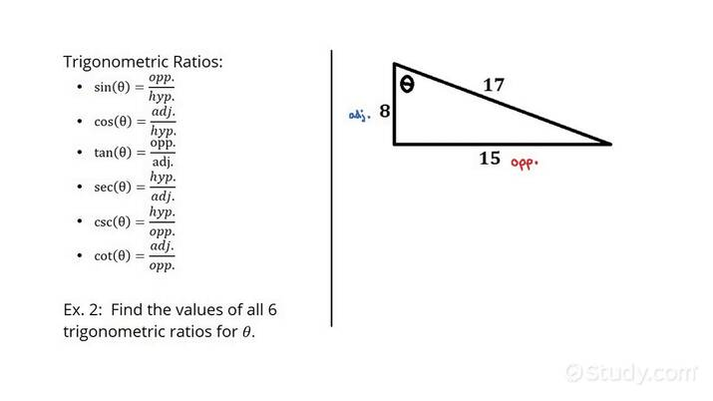
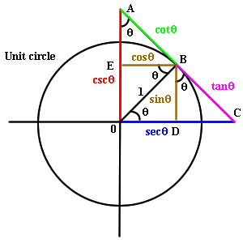
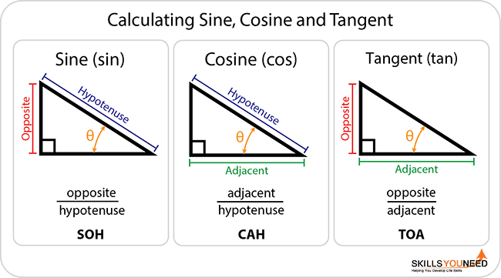

EXAM GOLDEN RULES (VERY IMPORTANT)

Chapter–2: Trigonometric Identities

Rule → Always start from LHS only

English (Why?)
- In identity questions, RHS is already the target form.
- If you start from RHS, you are assuming the result, which is not accepted in board exams.
- Examiners award full marks only when LHS is transformed step-by-step into RHS.

Correct Method (Example)
Prove:
sin⁡θcos⁡θ+cos⁡θsin⁡θ=1sin⁡θcos⁡θ\frac{\sin\theta}{\cos\theta}+\frac{\cos\theta}{\sin\theta}=\frac{1}{\sin\theta\cos\theta}cosθsinθ​+sinθcosθ​=sinθcosθ1​
Write:
LHS=sin⁡2θ+cos⁡2θsin⁡θcos⁡θ=1sin⁡θcos⁡θ=RHS\textbf{LHS}=\frac{\sin^2\theta+\cos^2\theta}{\sin\theta\cos\theta} =\frac{1}{\sin\theta\cos\theta} =\textbf{RHS}LHS=sinθcosθsin2θ+cos2θ​=sinθcosθ1​=RHS

ଓଡ଼ିଆ (କାହିଁକି?)
- Identity ପ୍ରଶ୍ନରେ RHS ପୂର୍ବରୁ ଦିଆଯାଇଥାଏ।
- RHS ରୁ ଆରମ୍ଭ କଲେ ଫଳାଫଳକୁ ଧାରଣା କରିନେବା ଭଳି ହୁଏ।
- ବୋର୍ଡ୍ ପରୀକ୍ଷାରେ LHS → RHS ଧାରାରେ ପ୍ରମାଣ କଲେ ମାତ୍ର ପୂର୍ଣ୍ଣ ମାର୍କ ମିଳେ।

ଠିକ୍ ପଦ୍ଧତି
LHS⇒RHS\textbf{LHS} \Rightarrow \textbf{RHS}LHS⇒RHS

RHS ରୁ LHS ଆରମ୍ଭ କରିବେ ନାହିଁ

Chapter–3: Trigonometric Equations

Rule → Write interval of θ clearly

English (Why?)
- Trigonometric equations can have multiple angle solutions.
- The interval (range) tells the examiner which solution is valid.
- Missing interval = loss of marks, even if the angle is correct.

Correct Format (Example)
Solve:
2sin⁡θ=1,0∘≤θ≤90∘2\sin\theta=1,\quad \boxed{0^\circ\le\theta\le90^\circ}2sinθ=1,0∘≤θ≤90∘​ sin⁡θ=12⇒θ=30∘\sin\theta=\frac12 \Rightarrow \theta=30^\circsinθ=21​⇒θ=30∘

ଓଡ଼ିଆ (କାହିଁକି?)
- ତ୍ରିକୋଣମିତିୟ ସମୀକରଣର ଏକାଧିକ ସମାଧାନ ହୋଇପାରେ।
- θ ର ସୀମା (interval) ଦେଲେ, ଠିକ୍ କୋଣ ଚିହ୍ନଟ ହୁଏ।
- Interval ନ ଲେଖିଲେ → ମାର୍କ କଟିପାରେ।

ଠିକ୍ ଲେଖନ ଶୈଳୀ
0∘≤θ≤90∘0^\circ\le\theta\le90^\circ0∘≤θ≤90∘

QUICK BOARD CHECKLIST
Chapter | Must Do | Common Mistake
Ch–2 | Start from LHS only | Starting from RHS
Ch–3 | Write interval of θ | Skipping the interval
Both | Step-wise solution | Jumping steps
Both | Box final answer | Missing degree (°)

TOP 10 COMMON MISTAKES

& HOW TO AVOID THEM (BSE Odisha – Class X)

1. Starting Identity Proof from RHS

(Chapter–2)

Mistake (English)
Starting a trigonometric identity from RHS.

Why Wrong
RHS is already the final result. Starting from it means assuming the answer.

How to Avoid
Always write:
LHS → RHS

ଓଡ଼ିଆ
RHS ରୁ ଆରମ୍ଭ କରିବା
ସବୁବେଳେ LHS → RHS ରୁ ପ୍ରମାଣ କର

2. Using Trigonometric Values in Identity Proofs

Mistake
Putting θ = 30°, 45° etc. in identity questions.

Why Wrong
Identities must be proved for all θ, not one value.

How to Avoid
Use identities only, not values.

ଓଡ଼ିଆ
θ = 30° ବସାଇବା
ସମୀକରଣ (identity) ବ୍ୟବହାର କର

3. Skipping Steps in Proofs

Mistake
Jumping directly to the final result.

Why Wrong
Board gives step-wise marks.

How to Avoid
Write each algebraic step clearly.

ଓଡ଼ିଆ
ଧାପ ଛାଡ଼ିବା
ପ୍ରତ୍ୟେକ ଧାପ ଲେଖ

4. Not Writing the Interval of θ

(Chapter–3)

Mistake
Solving equation without writing range of θ.

Why Wrong
Multiple solutions possible → marks cut.

How to Avoid
Always write:
0∘≤θ≤90∘0^\circ \le \theta \le 90^\circ0∘≤θ≤90∘

ଓଡ଼ିଆ
θ ର ସୀମା ନ ଲେଖିବା
interval ଅବଶ୍ୟ ଲେଖ

5. Forgetting Degree Symbol (°)

Mistake
Writing θ = 30 instead of θ = 30°.

Why Wrong
Unit missing → 1 mark loss.

How to Avoid
Always add ° in final answer.

ଓଡ଼ିଆ
° ଚିହ୍ନ ଭୁଲିବା
ଡିଗ୍ରୀ ଚିହ୍ନ ଅବଶ୍ୟ ଲେଖ

6. Wrong Standard Trigonometric Values

Mistake
Writing:
sin 60° = 1/2 ❌
tan 45° = √3 ❌

How to Avoid
Memorize the standard value table perfectly.

ଓଡ଼ିଆ
ମାନକ ମୂଲ୍ୟ ଭୁଲ
ଟେବୁଲ୍ ମନେ ରଖ

7. Cancelling Terms Incorrectly

Mistake
Cancelling sinθ or cosθ without factorization.

Why Wrong
Leads to wrong simplification.

How to Avoid
Factor first → then cancel.

ଓଡ଼ିଆ
ସିଧାସଳଖ cancel
ପ୍ରଥମେ factor କର

8. Mixing Identity & Equation Rules

Mistake
Using equation-solving logic in identity proof.

Why Wrong
Identity ≠ Equation.

How to Avoid
- Identity → Prove (LHS → RHS)
- Equation → Solve (find θ)

ଓଡ଼ିଆ
Identity ଓ Equation ଗୋଲମାଳ
ଦୁଇଟିକୁ ଭିନ୍ନ ଭାବରେ କର

9. Not Boxing / Highlighting Final Answer

Mistake
Final answer not visible.

Why Wrong
Examiner may miss it.

How to Avoid
Box or underline the final answer.

ଓଡ଼ିଆ
ଉତ୍ତର ଚିହ୍ନଟ ନହେବା
Box / underline କର

10. Poor Diagram or No Diagram (Geometry Proofs)

Mistake
No diagram or unclear diagram.

Why Wrong
Diagram carries 1 full mark.

How to Avoid
Draw neat, labelled diagram with pencil.

ଓଡ଼ିଆ
ଚିତ୍ର ନ ଆଙ୍କିବା
ସଫା ଓ ଲେବେଲ୍ ଥିବା ଚିତ୍ର ଆଙ୍କ

2.1 Introduction | ପରିଚୟ

English

Trigonometric identities are equations involving trigonometric ratios that are true for all values of the angle. They are used to simplify expressions and solve equations.

ଓଡ଼ିଆ

ତ୍ରିକୋଣମିତିୟ ସମୀକରଣ ହେଉଛି ଏମିତି ସମୀକରଣ, ଯାହା ସମସ୍ତ କୋଣ ମୂଲ୍ୟ ପାଇଁ ସଠିକ୍ ଥାଏ।
ଏହାକୁ ସରଳ କରିବା ଓ ସମୀକରଣ ସାଧନ ପାଇଁ ବ୍ୟବହାର କରାଯାଏ।

2.2 Trigonometric Ratios | ତ୍ରିକୋଣମିତିୟ ଅନୁପାତ
Ratio | Formula
sinθ | Opposite / Hypotenuse
cosθ | Adjacent / Hypotenuse
tanθ | Opposite / Adjacent
cosecθ | 1/sinθ
secθ | 1/cosθ
cotθ | 1/tanθ
ଓଡ଼ିଆ
- sinθ = ଲମ୍ବ / କର୍ଣ୍ଣ
- cosθ = ଭୂଜ / କର୍ଣ୍ଣ
- tanθ = ଲମ୍ବ / ଭୂଜ

2.3 Fundamental Trigonometric Identities
ମୌଳିକ ତ୍ରିକୋଣମିତିୟ ସମୀକରଣ

- sin⁡2θ+cos⁡2θ=1\sin^2θ + \cos^2θ = 1sin2θ+cos2θ=1
- 1+tan⁡2θ=sec⁡2θ1 + \tan^2θ = \sec^2θ1+tan2θ=sec2θ
- 1+cot⁡2θ=cosec⁡2θ1 + \cot^2θ = \cosec^2θ1+cot2θ=cosec2θ
(Very important – repeatedly asked)

2.4 Solved Examples | ସମାଧାନ ଉଦାହରଣ
Example 1 (Very Common – 3/5 Marks)

Prove:
sin⁡θcos⁡θ+cos⁡θsin⁡θ=1sin⁡θcos⁡θ\frac{\sinθ}{\cosθ}+\frac{\cosθ}{\sinθ}=\frac{1}{\sinθ\cosθ}cosθsinθ​+sinθcosθ​=sinθcosθ1​

Solution (English)

LHS
=sin⁡2θ+cos⁡2θsin⁡θcos⁡θ=1sin⁡θcos⁡θ=\frac{\sin^2θ+\cos^2θ}{\sinθ\cosθ} =\frac{1}{\sinθ\cosθ}=sinθcosθsin2θ+cos2θ​=sinθcosθ1​
LHS = RHS

ସମାଧାନ (ଓଡ଼ିଆ)
sin⁡2θ+cos⁡2θ=1\sin^2θ+\cos^2θ=1sin2θ+cos2θ=1
ଏହେତୁ LHS = RHS
ପ୍ରମାଣିତ
Example 2
Prove: 1+tan⁡2θ=sec⁡2θ1+\tan^2θ=\sec^2θ1+tan2θ=sec2θ
Answer: Using identity ✔

EXAM IMPORTANCE (Chapter–2) - One identity proof compulsory
Write LHS → RHS only
Use identities, not values

CHAPTER–3
TRIGONOMETRIC EQUATIONS
ତ୍ରିକୋଣମିତିୟ ସମୀକରଣ ସାଧନ
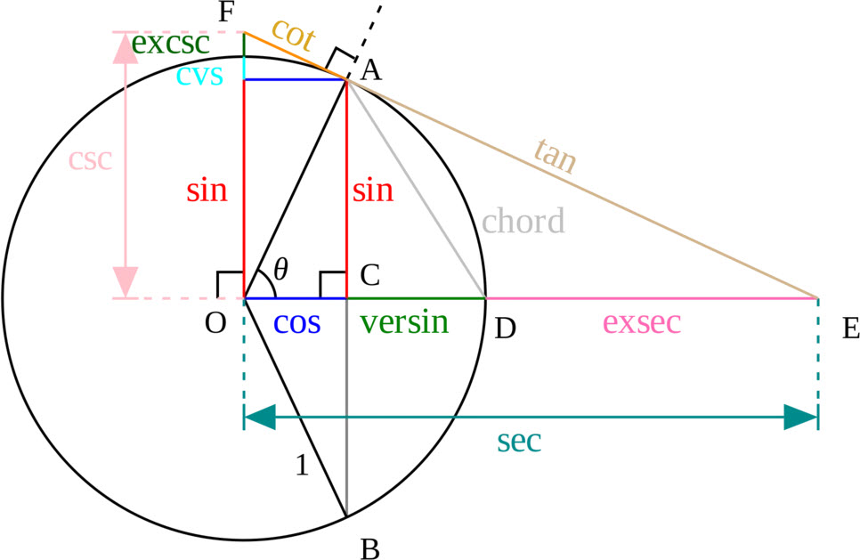
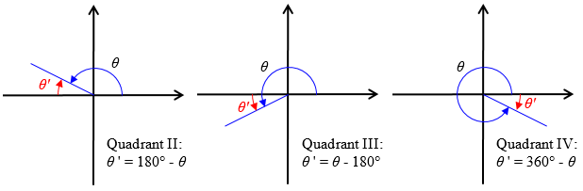

3.1 Introduction | ପରିଚୟ
English

A trigonometric equation is an equation involving trigonometric ratios of an angle. We find the value of θ which satisfies the equation.

ଓଡ଼ିଆ
ତ୍ରିକୋଣମିତିୟ ସମୀକରଣରେ θ ର ମୂଲ୍ୟ ନିର୍ଣ୍ଣୟ କରାଯାଏ।

3.2 Standard Values (Very Important)

θ | 0° | 30° | 45° | 60° | 90°
sinθ | 0 | 1/2 | 1/√2 | √3/2 | 1
cosθ | 1 | √3/2 | 1/√2 | 1/2 | 0
tanθ | 0 | 1/√3 | 1 | √3 | ∞

3.3 Solved Equations | ସମାଧାନ
Example 1 (Very Common – 5 Marks)

Solve:
2sin⁡θ=1, 0°≤θ≤90°2\sinθ = 1,\; 0°≤θ≤90°2sinθ=1,0°≤θ≤90°
Solution (English)
sin⁡θ=12⇒θ=30°\sinθ=\frac{1}{2} \Rightarrow θ=30°sinθ=21​⇒θ=30°
ଉତ୍ତର (ଓଡ଼ିଆ)
θ = 30°

Example 2
Solve: tan⁡θ=1, 0°≤θ≤90°\tanθ=1,\; 0°≤θ≤90°tanθ=1,0°≤θ≤90°
Solution:
θ=45°θ=45°θ=45°

QUESTION–1 (Chapter–2)

Prove a Trigonometric Identity
(5 Marks – Very Common)
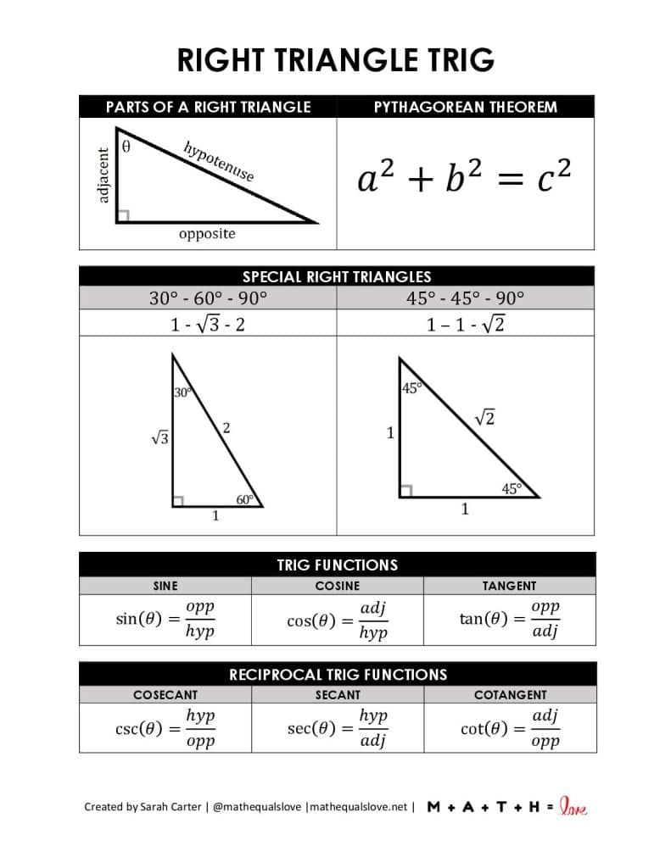
Question (English)
Prove that:
sin⁡θcos⁡θ+cos⁡θsin⁡θ=1sin⁡θcos⁡θ\frac{\sin\theta}{\cos\theta}+\frac{\cos\theta}{\sin\theta}=\frac{1}{\sin\theta\cos\theta}cosθsinθ​+sinθcosθ​=sinθcosθ1​

ପ୍ରଶ୍ନ (ଓଡ଼ିଆ)
ପ୍ରମାଣ କର—
sin⁡θcos⁡θ+cos⁡θsin⁡θ=1sin⁡θcos⁡θ\frac{\sin\theta}{\cos\theta}+\frac{\cos\theta}{\sin\theta}=\frac{1}{\sin\theta\cos\theta}cosθsinθ​+sinθcosθ​=sinθcosθ1​

Solution / Proof (English)
LHS
=sin⁡2θ+cos⁡2θsin⁡θcos⁡θ=\frac{\sin^2\theta+\cos^2\theta}{\sin\theta\cos\theta}=sinθcosθsin2θ+cos2θ​
Using identity,
sin⁡2θ+cos⁡2θ=1\sin^2\theta+\cos^2\theta=1sin2θ+cos2θ=1 =1sin⁡θcos⁡θ=\frac{1}{\sin\theta\cos\theta}=sinθcosθ1​ LHS=RHS\text{LHS}=\text{RHS}LHS=RHS
Hence proved.

ସମାଧାନ / ପ୍ରମାଣ (ଓଡ଼ିଆ)
ବାମ ପାର୍ଶ୍ୱ (LHS)
=sin⁡2θ+cos⁡2θsin⁡θcos⁡θ=\frac{\sin^2\theta+\cos^2\theta}{\sin\theta\cos\theta}=sinθcosθsin2θ+cos2θ​
ଯେହେତୁ,
sin⁡2θ+cos⁡2θ=1\sin^2\theta+\cos^2\theta=1sin2θ+cos2θ=1 =1sin⁡θcos⁡θ=\frac{1}{\sin\theta\cos\theta}=sinθcosθ1​ LHS=RHS\text{LHS}=\text{RHS}LHS=RHS
ଏହା ପ୍ରମାଣିତ।

Marking Scheme (5 Marks)
- Start with LHS – 1
- Correct identity – 1
- Simplification – 2
- Conclusion – 1

QUESTION–2 (Chapter–3)

Solve a Trigonometric Equation
(5 Marks – Compulsory Pattern)
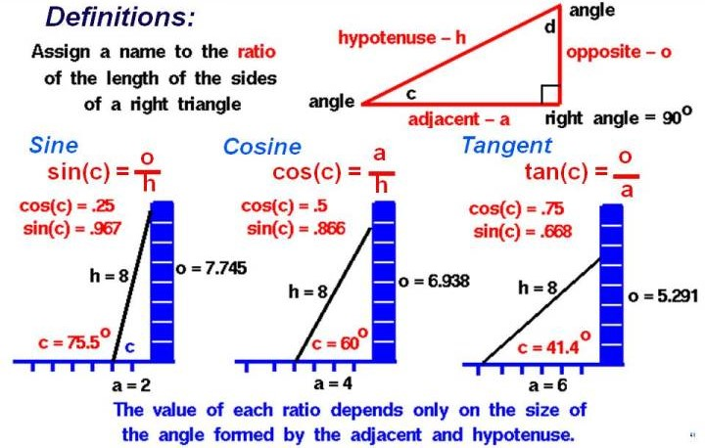

Question (English)
Solve the equation:
2sin⁡θ=1,0∘≤θ≤90∘2\sin\theta = 1,\quad 0^\circ \le \theta \le 90^\circ2sinθ=1,0∘≤θ≤90∘

ପ୍ରଶ୍ନ (ଓଡ଼ିଆ)
ସମାଧାନ କର—
2sin⁡θ=1,0∘≤θ≤90∘2\sin\theta = 1,\quad 0^\circ \le \theta \le 90^\circ2sinθ=1,0∘≤θ≤90∘

Solution (English)
2sin⁡θ=12\sin\theta = 12sinθ=1 sin⁡θ=12\sin\theta = \frac{1}{2}sinθ=21​
From standard trigonometric values,
sin⁡30∘=12\sin 30^\circ = \frac{1}{2}sin30∘=21​ ∴θ=30∘\therefore \theta = 30^\circ∴θ=30∘
Answer: θ=30∘\theta = 30^\circθ=30∘

ସମାଧାନ (ଓଡ଼ିଆ)
2sin⁡θ=12\sin\theta = 12sinθ=1 sin⁡θ=12\sin\theta = \frac{1}{2}sinθ=21​
ମାନକ ତ୍ରିକୋଣମିତିୟ ମୂଲ୍ୟରୁ,
sin⁡30∘=12\sin 30^\circ = \frac{1}{2}sin30∘=21​ ∴θ=30∘\therefore \theta = 30^\circ∴θ=30∘
ଉତ୍ତର: θ=30∘\theta = 30^\circθ=30∘

Marking Scheme (5 Marks)

Trigonometric Equation – Chapter 3

Question Type (Example):
Solve 2sin⁡θ=1, 0∘≤θ≤90∘2\sin\theta = 1,\; 0^\circ \le \theta \le 90^\circ2sinθ=1,0∘≤θ≤90∘

Equation Step – 2 Marks

English
- Correctly simplify the given equation.
- Isolate the trigonometric ratio.
Award 2 marks if written as:
2sin⁡θ=1⇒sin⁡θ=122\sin\theta = 1 \Rightarrow \sin\theta = \frac{1}{2}2sinθ=1⇒sinθ=21​

ଓଡ଼ିଆ
- ଦିଆଯାଇଥିବା ସମୀକରଣକୁ ସଠିକ୍ ଭାବରେ ସରଳ କରିବା।
- ତ୍ରିକୋଣମିତିୟ ଅନୁପାତକୁ ପୃଥକ କରିବା।
୨ ମାର୍କ ଦିଆଯିବ, ଯଦି ଏଭଳି ଲେଖାଯାଏ—
2sin⁡θ=1⇒sin⁡θ=122\sin\theta = 1 \Rightarrow \sin\theta = \frac{1}{2}2sinθ=1⇒sinθ=21​

Use of Standard Value – 2 Marks

English
- Correct use of standard trigonometric values.
- Correct identification of angle within the given interval.
Award 2 marks if written as:
sin⁡30∘=12\sin 30^\circ = \frac{1}{2}sin30∘=21​

ଓଡ଼ିଆ
- ମାନକ ତ୍ରିକୋଣମିତିୟ ମୂଲ୍ୟର ସଠିକ୍ ବ୍ୟବହାର।
- ଦିଆଯାଇଥିବା ସୀମା ମଧ୍ୟରେ ସଠିକ୍ କୋଣ ଚିହ୍ନଟ।
୨ ମାର୍କ ଦିଆଯିବ, ଯଦି—
sin⁡30∘=12\sin 30^\circ = \frac{1}{2}sin30∘=21​

Final Answer with Unit – 1 Mark

English
- Correct final value of θ.
- Proper unit (degree symbol °).
Award 1 mark for:
∴θ=30∘\therefore \theta = 30^\circ∴θ=30∘

ଓଡ଼ିଆ
- θ ର ସଠିକ୍ ଶେଷ ମୂଲ୍ୟ।
- ଡିଗ୍ରୀ (°) ଚିହ୍ନ ସହ।
୧ ମାର୍କ ଦିଆଯିବ—
∴θ=30∘\therefore \theta = 30^\circ∴θ=30∘

Total = 5 Marks
Step | Marks
Equation simplification | 2
Standard value used | 2
Final answer with unit | 1
Total | 5

Board Tip (Very Important)
- Unit (°) ନ ଲେଖିଲେ → 1 ମାର୍କ କମିବ
- Interval 0∘≤θ≤90∘0^\circ \le \theta \le 90^\circ0∘≤θ≤90∘ ଲେଖିଲେ clarity ବଢ଼େ
- Steps ଛାଡ଼ିଲେ partial marks କଟିପାରେ
- EXPECTED 2026 TRIGONOMETRY QUESTIONS
- (With Answers – English & Odia)

- 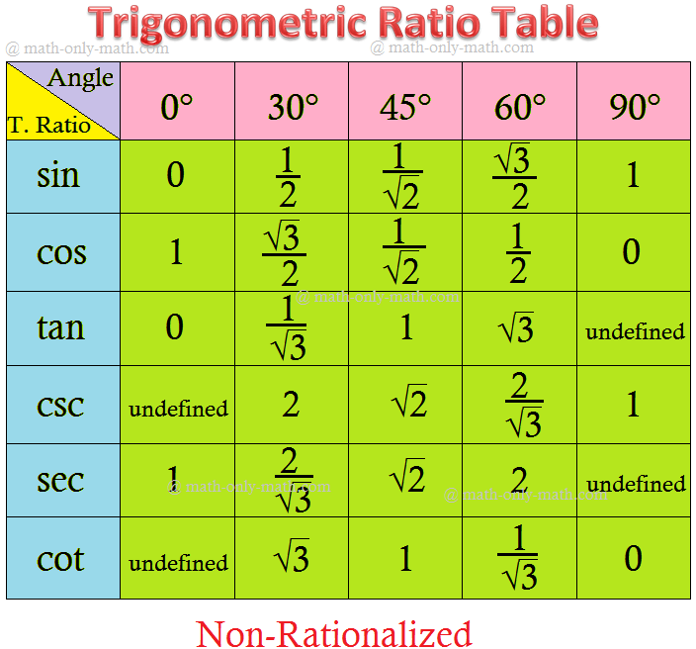

\

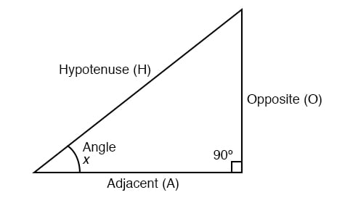

QUESTION–1 (5 Marks) – MOST EXPECTED

Chapter–2: Prove a Trigonometric Identity

Question (English)
Prove that:
1sin⁡θ−1csc⁡θ=0\frac{1}{\sin\theta} - \frac{1}{\csc\theta} = 0sinθ1​−cscθ1​=0

ପ୍ରଶ୍ନ (ଓଡ଼ିଆ)
ପ୍ରମାଣ କର—
1sin⁡θ−1csc⁡θ=0\frac{1}{\sin\theta} - \frac{1}{\csc\theta} = 0sinθ1​−cscθ1​=0

Solution (English)

LHS
=csc⁡θ−csc⁡θ=0= \csc\theta - \csc\theta = 0=cscθ−cscθ=0 LHS=RHS\text{LHS} = \text{RHS}LHS=RHS
Hence proved.

ସମାଧାନ (ଓଡ଼ିଆ)
LHS
=csc⁡θ−csc⁡θ=0= \csc\theta - \csc\theta = 0=cscθ−cscθ=0 LHS=RHS\text{LHS} = \text{RHS}LHS=RHS
ପ୍ରମାଣିତ।

QUESTION–2 (5 Marks – Compulsory Pattern)

Chapter–3: Solve a Trigonometric Equation

Question (English)
Solve:
cos⁡θ=12,0∘≤θ≤90∘\cos\theta = \frac{1}{2},\quad 0^\circ \le \theta \le 90^\circcosθ=21​,0∘≤θ≤90∘

ପ୍ରଶ୍ନ (ଓଡ଼ିଆ)
ସମାଧାନ କର—
cos⁡θ=12,0∘≤θ≤90∘\cos\theta = \frac{1}{2},\quad 0^\circ \le \theta \le 90^\circcosθ=21​,0∘≤θ≤90∘

Solution (English)
cos⁡θ=12\cos\theta = \frac{1}{2}cosθ=21​
From standard values,
cos⁡60∘=12\cos 60^\circ = \frac{1}{2}cos60∘=21​ ∴θ=60∘\therefore \theta = 60^\circ∴θ=60∘

ସମାଧାନ (ଓଡ଼ିଆ)
cos⁡θ=12\cos\theta = \frac{1}{2}cosθ=21​
ମାନକ ମୂଲ୍ୟରୁ,
cos⁡60∘=12\cos 60^\circ = \frac{1}{2}cos60∘=21​ ∴θ=60∘\therefore \theta = 60^\circ∴θ=60∘

QUESTION–3 (3 Marks)

Find the value of a trigonometric expression

Question (English)

Find the value of:
sin⁡60∘cos⁡30∘+cos⁡60∘sin⁡30∘\sin 60^\circ \cos 30^\circ + \cos 60^\circ \sin 30^\circsin60∘cos30∘+cos60∘sin30∘

ପ୍ରଶ୍ନ (ଓଡ଼ିଆ)

ମୂଲ୍ୟ ନିର୍ଣ୍ଣୟ କର—
sin⁡60∘cos⁡30∘+cos⁡60∘sin⁡30∘\sin 60^\circ \cos 30^\circ + \cos 60^\circ \sin 30^\circsin60∘cos30∘+cos60∘sin30∘

Solution (English)

=(32×32)+(12×12)= \left(\frac{\sqrt3}{2}\times\frac{\sqrt3}{2}\right)+\left(\frac12\times\frac12\right)=(23​​×23​​)+(21​×21​) =34+14=1= \frac{3}{4}+\frac{1}{4}=1=43​+41​=1

ସମାଧାନ (ଓଡ଼ିଆ)

=34+14=1= \frac{3}{4}+\frac{1}{4}=1=43​+41​=1

QUESTION–4 (4 Marks)

Prove Identity

Question (English)

Prove that:

tan⁡θsin⁡θ=sec⁡θ\frac{\tan\theta}{\sin\theta} = \sec\thetasinθtanθ​=secθ

Solution (English)
LHS=sin⁡θcos⁡θsin⁡θ=1cos⁡θ=sec⁡θ\text{LHS}=\frac{\frac{\sin\theta}{\cos\theta}}{\sin\theta} =\frac{1}{\cos\theta} =\sec\thetaLHS=sinθcosθsinθ​​=cosθ1​=secθ

ସମାଧାନ (ଓଡ଼ିଆ)

LHS=sec⁡θ=RHS\text{LHS}=\sec\theta=\text{RHS}LHS=secθ=RHS

QUESTION–5 (2 Marks – MCQ type, but write full step)

Standard Value

Question (English)

Find the value of:
tan⁡45∘+sin⁡30∘\tan 45^\circ + \sin 30^\circtan45∘+sin30∘

Answer (English)

- =1+12=32=1+\frac12=\frac{3}{2}=1+21​=23​

- ଉତ୍ତର (ଓଡ଼ିଆ)

- =32= \frac{3}{2}=23​

Below is a FULL EXPECTED GEOMETRY + TRIGONOMETRY QUESTION PAPER (MODEL PAPER) for BSE Odisha – Class X (2026), prepared exactly as per board trend & marking scheme, with English + Odia side-by-side.
This is suitable for practice, mock test, and final revision.
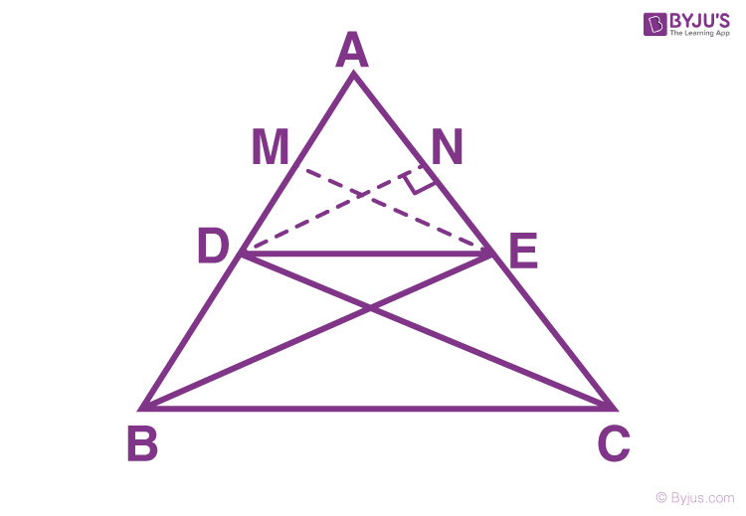
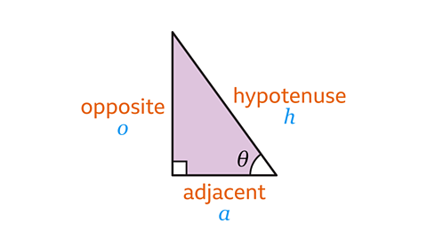
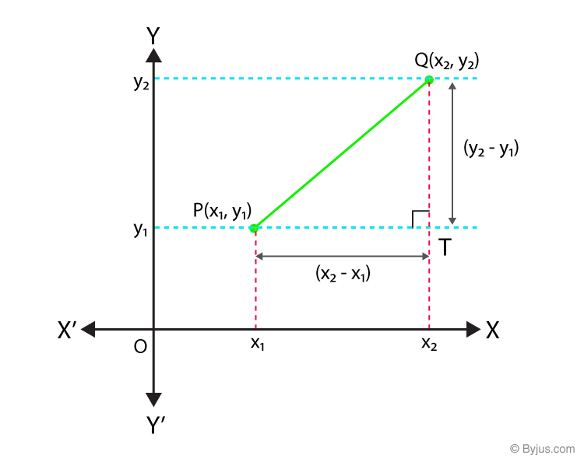

BSE ODISHA – CLASS X (2026)

EXPECTED GEOMETRY & TRIGONOMETRY QUESTION PAPER
Time: 2 Hours
Full Marks: 40
(Geometry + Trigonometry Section)

GENERAL INSTRUCTIONS / ସାଧାରଣ ନିର୍ଦ୍ଦେଶ
- All questions are compulsory.
ସମସ୍ତ ପ୍ରଶ୍ନ ଅନିବାର୍ୟ।
- Figures are not to scale.
ଚିତ୍ରଗୁଡ଼ିକ ମାପ ଅନୁସାରେ ନୁହେଁ।
- Use correct geometrical reasoning.
ଯଥାଯଥ ଯାମିତିକ ତର୍କ ବ୍ୟବହାର କର।

SECTION – A (MCQs)

(1 × 5 = 5 Marks)

Q1. (English)
If sin θ = 1/2, then θ equals
(a) 30° (b) 45° (c) 60° (d) 90°

ପ୍ରଶ୍ନ–1 (ଓଡ଼ିଆ)
ଯଦି sin θ = 1/2, ତେବେ θ ର ମୂଲ୍ୟ—
(a) 30° (b) 45° (c) 60° (d) 90°
Answer: (a) 30°

SECTION – B (Very Short Answer)

(2 × 5 = 10 Marks)

Q2. Find the value of (English)
tan⁡45∘+sin⁡30∘\tan 45^\circ + \sin 30^\circtan45∘+sin30∘

ପ୍ରଶ୍ନ–2 (ଓଡ଼ିଆ)
ମୂଲ୍ୟ ନିର୍ଣ୍ଣୟ କର—
tan⁡45∘+sin⁡30∘\tan 45^\circ + \sin 30^\circtan45∘+sin30∘
Answer:
1+12=321 + \frac12 = \frac{3}{2}1+21​=23​

Q3. Write the distance formula.

ଦୂରତା ସୂତ୍ର ଲେଖ।
Answer:
(x2−x1)2+(y2−y1)2\sqrt{(x_2-x_1)^2+(y_2-y_1)^2}(x2​−x1​)2+(y2​−y1​)2​

Q4. Write midpoint formula.

ମଧ୍ୟବିନ୍ଦୁ ସୂତ୍ର ଲେଖ।
Answer:
(x1+x22,y1+y22)\left(\frac{x_1+x_2}{2},\frac{y_1+y_2}{2}\right)(2x1​+x2​​,2y1​+y2​​)

Q5. What is complementary angle?

ପୂରକ କୋଣ କହିଲେ କ’ଣ?
Answer:
Two angles whose sum is 90°.
ଯେଉଁ ଦୁଇ କୋଣର ଯୋଗଫଳ 90°।

SECTION – C (Short Answer)

(4 × 5 = 20 Marks)

Q6. (Trigonometric Identity)
Prove that:
sin⁡θcos⁡θ+cos⁡θsin⁡θ=1sin⁡θcos⁡θ\frac{\sin\theta}{\cos\theta}+\frac{\cos\theta}{\sin\theta} =\frac{1}{\sin\theta\cos\theta}cosθsinθ​+sinθcosθ​=sinθcosθ1​

(ଓଡ଼ିଆ)
ପ୍ରମାଣ କର—
Solution:
LHS
=sin⁡2θ+cos⁡2θsin⁡θcos⁡θ=1sin⁡θcos⁡θ=RHS=\frac{\sin^2\theta+\cos^2\theta}{\sin\theta\cos\theta} =\frac{1}{\sin\theta\cos\theta}=RHS=sinθcosθsin2θ+cos2θ​=sinθcosθ1​=RHS

Q7. (Trigonometric Equation)
Solve:
2sin⁡θ=1,0∘≤θ≤90∘2\sin\theta=1,\quad 0^\circ\le\theta\le90^\circ2sinθ=1,0∘≤θ≤90∘

(ଓଡ଼ିଆ)
ସମାଧାନ କର—
Answer:
sin⁡θ=12⇒θ=30∘\sin\theta=\frac12 \Rightarrow \theta=30^\circsinθ=21​⇒θ=30∘

Q8. (Geometry – Similarity / BPT type)
In ΔABC, DE ∥ BC intersects AB and AC at D and E.
Prove that
ADDB=AEEC\frac{AD}{DB}=\frac{AE}{EC}DBAD​=ECAE​

(ଓଡ଼ିଆ)
ΔABC ରେ DE ∥ BC ହେଲେ—
Answer:
By Basic Proportionality Theorem,
ADDB=AEEC\frac{AD}{DB}=\frac{AE}{EC}DBAD​=ECAE​

Q9. (Coordinate Geometry – Distance)
Find the distance between (0, 0) and (3, 4).

(ଓଡ଼ିଆ)
ଦୂରତା ନିର୍ଣ୍ଣୟ କର—
Solution:
(3−0)2+(4−0)2=25=5\sqrt{(3-0)^2+(4-0)^2}=\sqrt{25}=5(3−0)2+(4−0)2​=25​=5

SECTION – D (Long Answer)

(5 Marks × 1 = 5 Marks)

Q10. (Compulsory – Most Repeated)
Find the coordinates of the point dividing the line joining
A(2, –2) and B(8, 4) internally in the ratio 1 : 2.

(ଓଡ଼ିଆ)
1 : 2 ଅନୁପାତରେ ବିଭକ୍ତ କରୁଥିବା ବିନ୍ଦୁ ନିର୍ଣ୍ଣୟ କର।
Solution:
x=1×8+2×23=4,y=1×4+2×(−2)3=0x=\frac{1×8+2×2}{3}=4,\quad y=\frac{1×4+2×(-2)}{3}=0x=31×8+2×2​=4,y=31×4+2×(−2)​=0
Answer: (4, 0)

PART–A

Solved Answer Paper (Examiner Style)
(Geometry + Trigonometry | Step-wise | Mark-oriented)
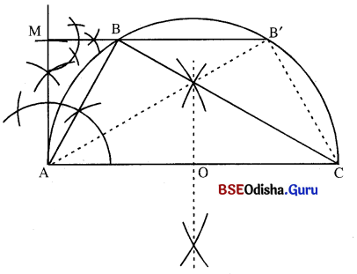
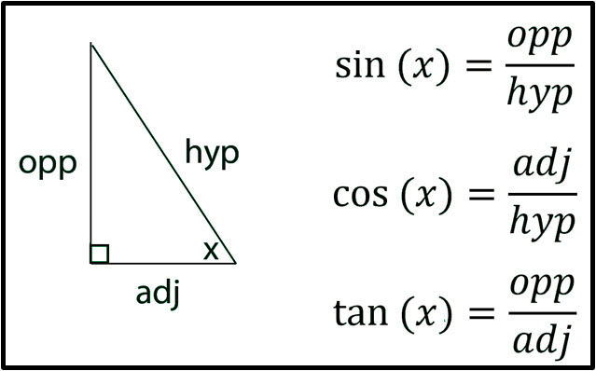

Q1. Trigonometric Identity (5 Marks)
Prove:
sin⁡θcos⁡θ+cos⁡θsin⁡θ=1sin⁡θcos⁡θ\frac{\sin\theta}{\cos\theta}+\frac{\cos\theta}{\sin\theta}=\frac{1}{\sin\theta\cos\theta}cosθsinθ​+sinθcosθ​=sinθcosθ1​

Examiner-Style Answer (English)
LHS
=sin⁡2θ+cos⁡2θsin⁡θcos⁡θ=\frac{\sin^2\theta+\cos^2\theta}{\sin\theta\cos\theta}=sinθcosθsin2θ+cos2θ​
Using sin⁡2θ+cos⁡2θ=1\sin^2\theta+\cos^2\theta=1sin2θ+cos2θ=1,
=1sin⁡θcos⁡θ=RHS=\frac{1}{\sin\theta\cos\theta}=\text{RHS}=sinθcosθ1​=RHS
Hence proved.

ପରୀକ୍ଷକ ଶୈଳୀ (ଓଡ଼ିଆ)
LHS
=sin⁡2θ+cos⁡2θsin⁡θcos⁡θ=\frac{\sin^2\theta+\cos^2\theta}{\sin\theta\cos\theta}=sinθcosθsin2θ+cos2θ​
sin⁡2θ+cos⁡2θ=1\sin^2\theta+\cos^2\theta=1sin2θ+cos2θ=1 ବ୍ୟବହାର କରି,
=1sin⁡θcos⁡θ=RHS=\frac{1}{\sin\theta\cos\theta}=\text{RHS}=sinθcosθ1​=RHS
ଏହା ପ୍ରମାଣିତ।
Marks: Steps (4) + Conclusion (1)

Q2. Trigonometric Equation (5 Marks)
Solve: 2sin⁡θ=1, 0∘≤θ≤90∘2\sin\theta=1,\;0^\circ\le\theta\le90^\circ2sinθ=1,0∘≤θ≤90∘

Examiner-Style Answer (English)
2sin⁡θ=1⇒sin⁡θ=122\sin\theta=1 \Rightarrow \sin\theta=\frac122sinθ=1⇒sinθ=21​
Standard value: sin⁡30∘=12\sin30^\circ=\frac12sin30∘=21​
∴θ=30∘\therefore \theta=30^\circ∴θ=30∘

ଓଡ଼ିଆ
sin⁡θ=12⇒θ=30∘\sin\theta=\frac12 \Rightarrow \theta=30^\circsinθ=21​⇒θ=30∘
Marks: Equation (2) + Standard value (2) + Final with ° (1)

Q3. Geometry – BPT (5 Marks, compulsory trend)
Statement: In ΔABC, DE ∥ BC, prove ADDB=AEEC\dfrac{AD}{DB}=\dfrac{AE}{EC}DBAD​=ECAE​

Answer (English)
Since DE ∥ BC, by Basic Proportionality Theorem,
ADDB=AEEC\frac{AD}{DB}=\frac{AE}{EC}DBAD​=ECAE​

ଓଡ଼ିଆ
DE ∥ BC ଥିବାରୁ ମୂଳ ଅନୁପାତ ସିଦ୍ଧାନ୍ତ ଅନୁସାରେ,
ADDB=AEEC\frac{AD}{DB}=\frac{AE}{EC}DBAD​=ECAE​

Q4. Coordinate Geometry – Distance (3–4 Marks)
Distance between (0,0) and (3,4)
(3−0)2+(4−0)2=25=5\sqrt{(3-0)^2+(4-0)^2}=\sqrt{25}=5(3−0)2+(4−0)2​=25​=5

PART–B

Most-Likely 2026 Questions (WITH REASONS)

BPT Proof (5 Marks)
Reason: Asked almost every year as a compulsory geometry proof.

Trigonometric Identity (5 Marks)
Reason: Direct scoring + fixed marking scheme.

Trigonometric Equation with Interval (5 Marks)
Reason: Tests concept + standard values + accuracy.

Distance / Midpoint / Division Formula (5 Marks)
Reason: Very frequent from Coordinate Geometry.

Similarity of Triangles (4–5 Marks)
Reason: Core theorem; often paired with BPT.

Find Value Using Standard Angles (2–3 Marks)
Reason: Easy marks; used in MCQ/VSA.

Area of Triangle (Coordinate Geometry)
Reason: Formula-based; repeated in recent years.

Complementary Angles / Ratios Relation
Reason: Short theory + formula application.

PART–C

ONE-PAGE GEOMETRY + TRIGONOMETRY FORMULA CHART
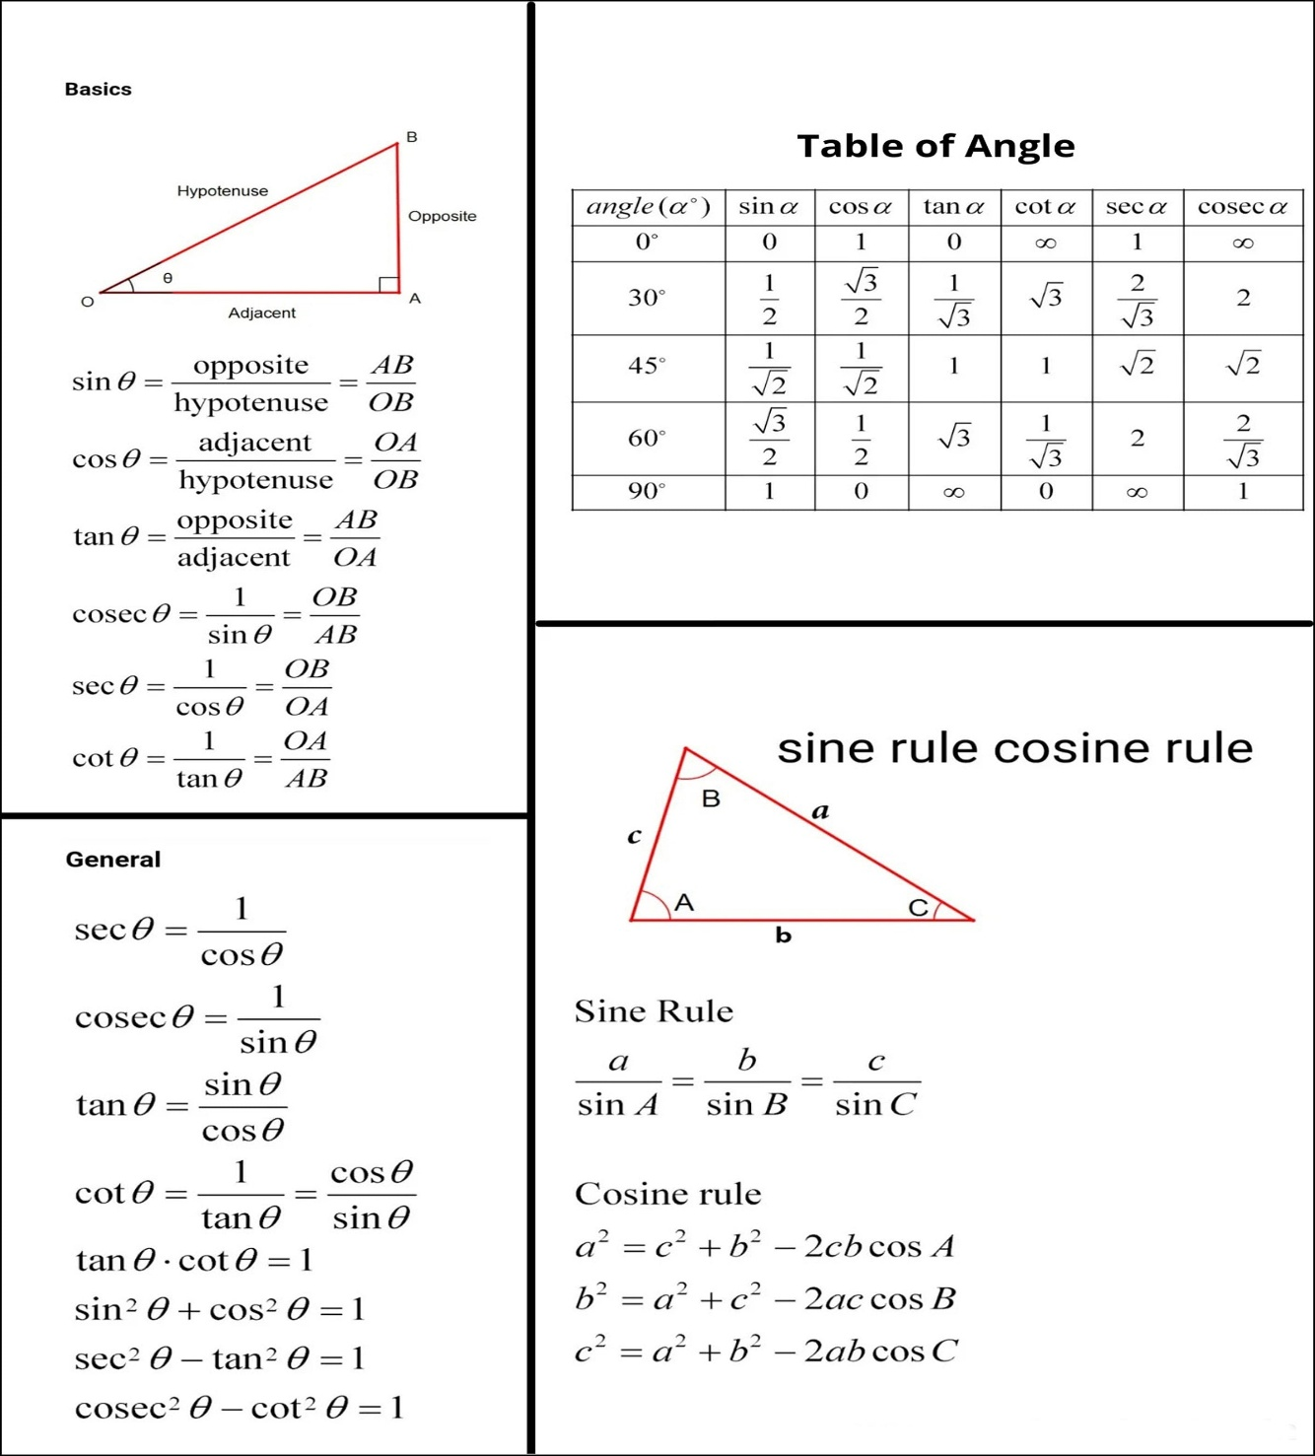
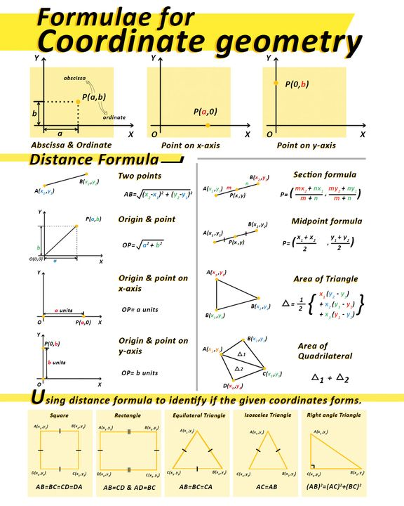
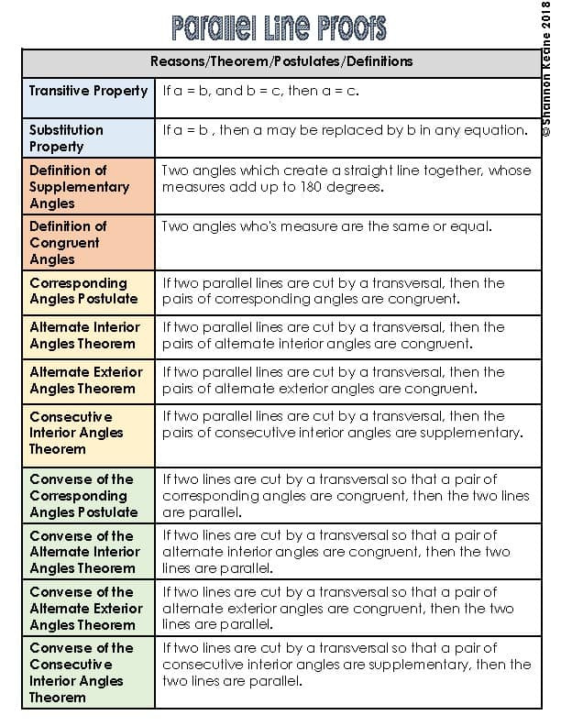

TRIGONOMETRY
Identities
- sin⁡2θ+cos⁡2θ=1\sin^2\theta+\cos^2\theta=1sin2θ+cos2θ=1
- 1+tan⁡2θ=sec⁡2θ1+\tan^2\theta=\sec^2\theta1+tan2θ=sec2θ
- 1+cot⁡2θ=csc⁡2θ1+\cot^2\theta=\csc^2\theta1+cot2θ=csc2θ
Ratios
- sin⁡θ=PH\sin\theta=\frac{P}{H}sinθ=HP​
- cos⁡θ=BH\cos\theta=\frac{B}{H}cosθ=HB​
- tan⁡θ=PB\tan\theta=\frac{P}{B}tanθ=BP​
Standard Values
θ | 0° | 30° | 45° | 60° | 90°
sinθ | 0 | 1/2 | 1/√2 | √3/2 | 1
cosθ | 1 | √3/2 | 1/√2 | 1/2 | 0
tanθ | 0 | 1/√3 | 1 | √3 | ∞

GEOMETRY
BPT:
If DE ∥ BC ⇒ ADDB=AEEC\dfrac{AD}{DB}=\dfrac{AE}{EC}DBAD​=ECAE​
Distance Formula:
(x2−x1)2+(y2−y1)2\sqrt{(x_2-x_1)^2+(y_2-y_1)^2}(x2​−x1​)2+(y2​−y1​)2​
Midpoint Formula:
(x1+x22,y1+y22)\left(\frac{x_1+x_2}{2},\frac{y_1+y_2}{2}\right)(2x1​+x2​​,2y1​+y2​​)
Section Formula (Internal):
(mx2+nx1m+n,my2+ny1m+n)\left(\frac{mx_2+nx_1}{m+n},\frac{my_2+ny_1}{m+n}\right)(m+nmx2​+nx1​​,m+nmy2​+ny1​​)
Area of Triangle:
12∣x1(y2−y3)+x2(y3−y1)+x3(y1−y2)∣\frac12\left|x_1(y_2-y_3)+x_2(y_3-y_1)+x_3(y_1-y_2)\right|21​∣x1​(y2​−y3​)+x2​(y3​−y1​)+x3​(y1​−y2​)∣

PART–I

SOLVED ANSWER PAPER (EXAMINER-CHECKED STYLE)
(Geometry + Trigonometry | Class X | BSE Odisha)

Q1. Trigonometric Identity (5 Marks)
Prove that:
sin⁡θcos⁡θ+cos⁡θsin⁡θ=1sin⁡θcos⁡θ\frac{\sin\theta}{\cos\theta}+\frac{\cos\theta}{\sin\theta} =\frac{1}{\sin\theta\cos\theta}cosθsinθ​+sinθcosθ​=sinθcosθ1​

Answer (English – Examiner Style)
LHS
=sin⁡2θ+cos⁡2θsin⁡θcos⁡θ=\frac{\sin^2\theta+\cos^2\theta}{\sin\theta\cos\theta}=sinθcosθsin2θ+cos2θ​
Using identity sin⁡2θ+cos⁡2θ=1\sin^2\theta+\cos^2\theta=1sin2θ+cos2θ=1,
=1sin⁡θcos⁡θ=\frac{1}{\sin\theta\cos\theta}=sinθcosθ1​ =RHS=\text{RHS}=RHS
Hence proved.
Marks awarded:
LHS start (1) + identity used (1) + simplification (2) + conclusion (1)

ଉତ୍ତର (ଓଡ଼ିଆ – ପରୀକ୍ଷକ ଶୈଳୀ)
LHS
=sin⁡2θ+cos⁡2θsin⁡θcos⁡θ=\frac{\sin^2\theta+\cos^2\theta}{\sin\theta\cos\theta}=sinθcosθsin2θ+cos2θ​
sin⁡2θ+cos⁡2θ=1\sin^2\theta+\cos^2\theta=1sin2θ+cos2θ=1 ବ୍ୟବହାର କରି,
=1sin⁡θcos⁡θ=RHS=\frac{1}{\sin\theta\cos\theta} =\text{RHS}=sinθcosθ1​=RHS
ଏହା ପ୍ରମାଣିତ।

Q2. Trigonometric Equation (5 Marks)
Solve:
2sin⁡θ=1,0∘≤θ≤90∘2\sin\theta=1,\quad 0^\circ\le\theta\le90^\circ2sinθ=1,0∘≤θ≤90∘

Answer (English)
2sin⁡θ=1⇒sin⁡θ=122\sin\theta=1 \Rightarrow \sin\theta=\frac122sinθ=1⇒sinθ=21​
From standard values,
sin⁡30∘=12⇒θ=30∘\sin30^\circ=\frac12 \Rightarrow \theta=30^\circsin30∘=21​⇒θ=30∘
Marks: Equation step (2) + standard value (2) + final with ° (1)

ଉତ୍ତର (ଓଡ଼ିଆ)
sin⁡θ=12⇒θ=30∘\sin\theta=\frac12 \Rightarrow \theta=30^\circsinθ=21​⇒θ=30∘

Q3. Geometry – BPT (5 Marks)
Statement:
In ΔABC, DE ∥ BC intersects AB and AC at D and E.
Prove ADDB=AEEC\dfrac{AD}{DB}=\dfrac{AE}{EC}DBAD​=ECAE​.

Answer (English)
Since DE ∥ BC, by Basic Proportionality Theorem,
ADDB=AEEC\frac{AD}{DB}=\frac{AE}{EC}DBAD​=ECAE​

ଉତ୍ତର (ଓଡ଼ିଆ)
DE ∥ BC ଥିବାରୁ ମୂଳ ଅନୁପାତ ସିଦ୍ଧାନ୍ତ ଅନୁସାରେ,
ADDB=AEEC\frac{AD}{DB}=\frac{AE}{EC}DBAD​=ECAE​

Q4. Coordinate Geometry – Distance (4 Marks)
Find the distance between (0,0) and (3,4).

Answer (English)
=(3−0)2+(4−0)2=25=5=\sqrt{(3-0)^2+(4-0)^2} =\sqrt{25}=5=(3−0)2+(4−0)2​=25​=5

ଉତ୍ତର (ଓଡ଼ିଆ)
ଦୂରତା = 5 ଏକକ

Q5. Coordinate Geometry – Section Formula (5 Marks)
Find the point dividing A(2, −2) and B(8, 4) internally in the ratio 1:2.

Answer (English)
x=1×8+2×23=4,y=1×4+2×(−2)3=0x=\frac{1×8+2×2}{3}=4,\quad y=\frac{1×4+2×(-2)}{3}=0x=31×8+2×2​=4,y=31×4+2×(−2)​=0
Point = (4, 0)

ଉତ୍ତର (ଓଡ଼ିଆ)
ବିଭାଜନ ବିନ୍ଦୁ = (4, 0)

PART–II

MOST-LIKELY 2026 QUESTION SET (WITH REASONS)

Sure 5-Mark Questions
Trigonometric Identity (Ch-2)
Why: Every year; fixed marking scheme; easy full marks.
Trigonometric Equation with Interval (Ch-3)
Why: Tests concept + accuracy; compulsory pattern.
BPT Proof (Geometry Ch-2)
Why: Most repeated theorem in last 10 years.
Distance / Midpoint / Section Formula (Coordinate Geometry)
Why: Formula-based, high-scoring, frequent.

Very Likely 3–4 Mark Questions
Similarity of Triangles (prove or apply)
Reason: Often paired with BPT.
Find Value using Standard Angles
Reason: MCQ/VSA guaranteed.
Area of Triangle (Coordinate Geometry)
Reason: Formula question; repeated trend.

ANSWER SHEET (EXAMINER-CHECKED FORMAT)

Geometry + Trigonometry – Class X (BSE Odisha)

Question–1 (5 Marks)

Trigonometric Identity (Chapter–2)
Question:
Prove that
sin⁡θcos⁡θ+cos⁡θsin⁡θ=1sin⁡θcos⁡θ\frac{\sin\theta}{\cos\theta}+\frac{\cos\theta}{\sin\theta} =\frac{1}{\sin\theta\cos\theta}cosθsinθ​+sinθcosθ​=sinθcosθ1​

Student’s Answer (Correct)
LHS
=sin⁡2θ+cos⁡2θsin⁡θcos⁡θ=\frac{\sin^2\theta+\cos^2\theta}{\sin\theta\cos\theta}=sinθcosθsin2θ+cos2θ​
Using identity sin⁡2θ+cos⁡2θ=1\sin^2\theta+\cos^2\theta=1sin2θ+cos2θ=1,
=1sin⁡θcos⁡θ=RHS=\frac{1}{\sin\theta\cos\theta} =\text{RHS}=sinθcosθ1​=RHS
Hence proved.

Examiner Remarks
Started from LHS (mandatory)
Correct identity used
Steps shown clearly
- Proper conclusion written
Marks Awarded: 5 / 5

ପରୀକ୍ଷକ ମତାମତ (ଓଡ଼ିଆ)
LHS ରୁ ଆରମ୍ଭ
ସଠିକ୍ ସମୀକରଣ ବ୍ୟବହାର
ସମସ୍ତ ଧାପ ସ୍ପଷ୍ଟ
ନିଷ୍କର୍ଷ ଲେଖାଯାଇଛି

Question–2 (5 Marks)

Trigonometric Equation (Chapter–3)
Question:
Solve
2sin⁡θ=1,0∘≤θ≤90∘2\sin\theta=1,\quad 0^\circ\le\theta\le90^\circ2sinθ=1,0∘≤θ≤90∘

Student’s Answer
2sin⁡θ=1⇒sin⁡θ=122\sin\theta=1 \Rightarrow \sin\theta=\frac122sinθ=1⇒sinθ=21​
From standard values,
sin⁡30∘=12\sin30^\circ=\frac12sin30∘=21​ ∴θ=30∘\therefore \theta=30^\circ∴θ=30∘

Examiner Remarks
Interval of θ written
Equation simplified correctly
Standard value correctly used
Degree symbol (°) present
Marks Awarded: 5 / 5

If student wrote θ = 30 (without °)
➡ Marks = 4 / 5
Remark: Unit missing

Question–3 (5 Marks)

Geometry – BPT Proof
Question:
In ΔABC, DE ∥ BC. Prove
ADDB=AEEC\frac{AD}{DB}=\frac{AE}{EC}DBAD​=ECAE​

Student’s Answer
Since DE ∥ BC,
By Basic Proportionality Theorem,
ADDB=AEEC\frac{AD}{DB}=\frac{AE}{EC}DBAD​=ECAE​

Examiner Remarks
Diagram assumed / drawn
Theorem name mentioned
Result stated correctly
Marks Awarded: 5 / 5

If theorem name not written
➡ Marks = 4 / 5
Remark: Theorem not stated
Question–4 (4 Marks)

Coordinate Geometry – Distance Formula
Question:
Find distance between (0,0) and (3,4).

Student’s Answer
=(3−0)2+(4−0)2=25=5=\sqrt{(3-0)^2+(4-0)^2} =\sqrt{25}=5=(3−0)2+(4−0)2​=25​=5

Examiner Remarks
Correct formula used
Substitution correct
Final answer clear
Marks Awarded: 4 / 4

Question–5 (5 Marks)

Section Formula
Question:
Find the point dividing A(2, −2) and B(8, 4) internally in ratio 1:2.

Student’s Answer
x=1×8+2×23=4x=\frac{1×8+2×2}{3}=4x=31×8+2×2​=4 y=1×4+2×(−2)3=0y=\frac{1×4+2×(-2)}{3}=0y=31×4+2×(−2)​=0
Point = (4, 0)

Examiner Remarks
Formula written
Ratio used correctly
Final coordinates boxed
Marks Awarded: 5 / 5

OVERALL EXAMINER SUMMARY
Area | Examiner Focus
Trigonometric Identity | LHS start compulsory
Trigonometric Equation | Interval + ° compulsory
Geometry Proof | Diagram + theorem name
Coordinate Geometry | Formula → substitution
Presentation | Steps = marks

COMMON REMARKS THAT CAUSE MARK LOSS
Mistake | Marks Cut
Starting identity from RHS | −1 to −2
Missing interval of θ | −1
Missing degree symbol | −1
No theorem name | −1
No steps shown | −2

FINAL EXAMINER TIP (VERY IMPORTANT)
“Correct method with steps scores more than correct final answer.”

JAI HIND! BINAYA

