ONE-PAGE TRIGONOMETRY FORMULA CHART (REVISION)
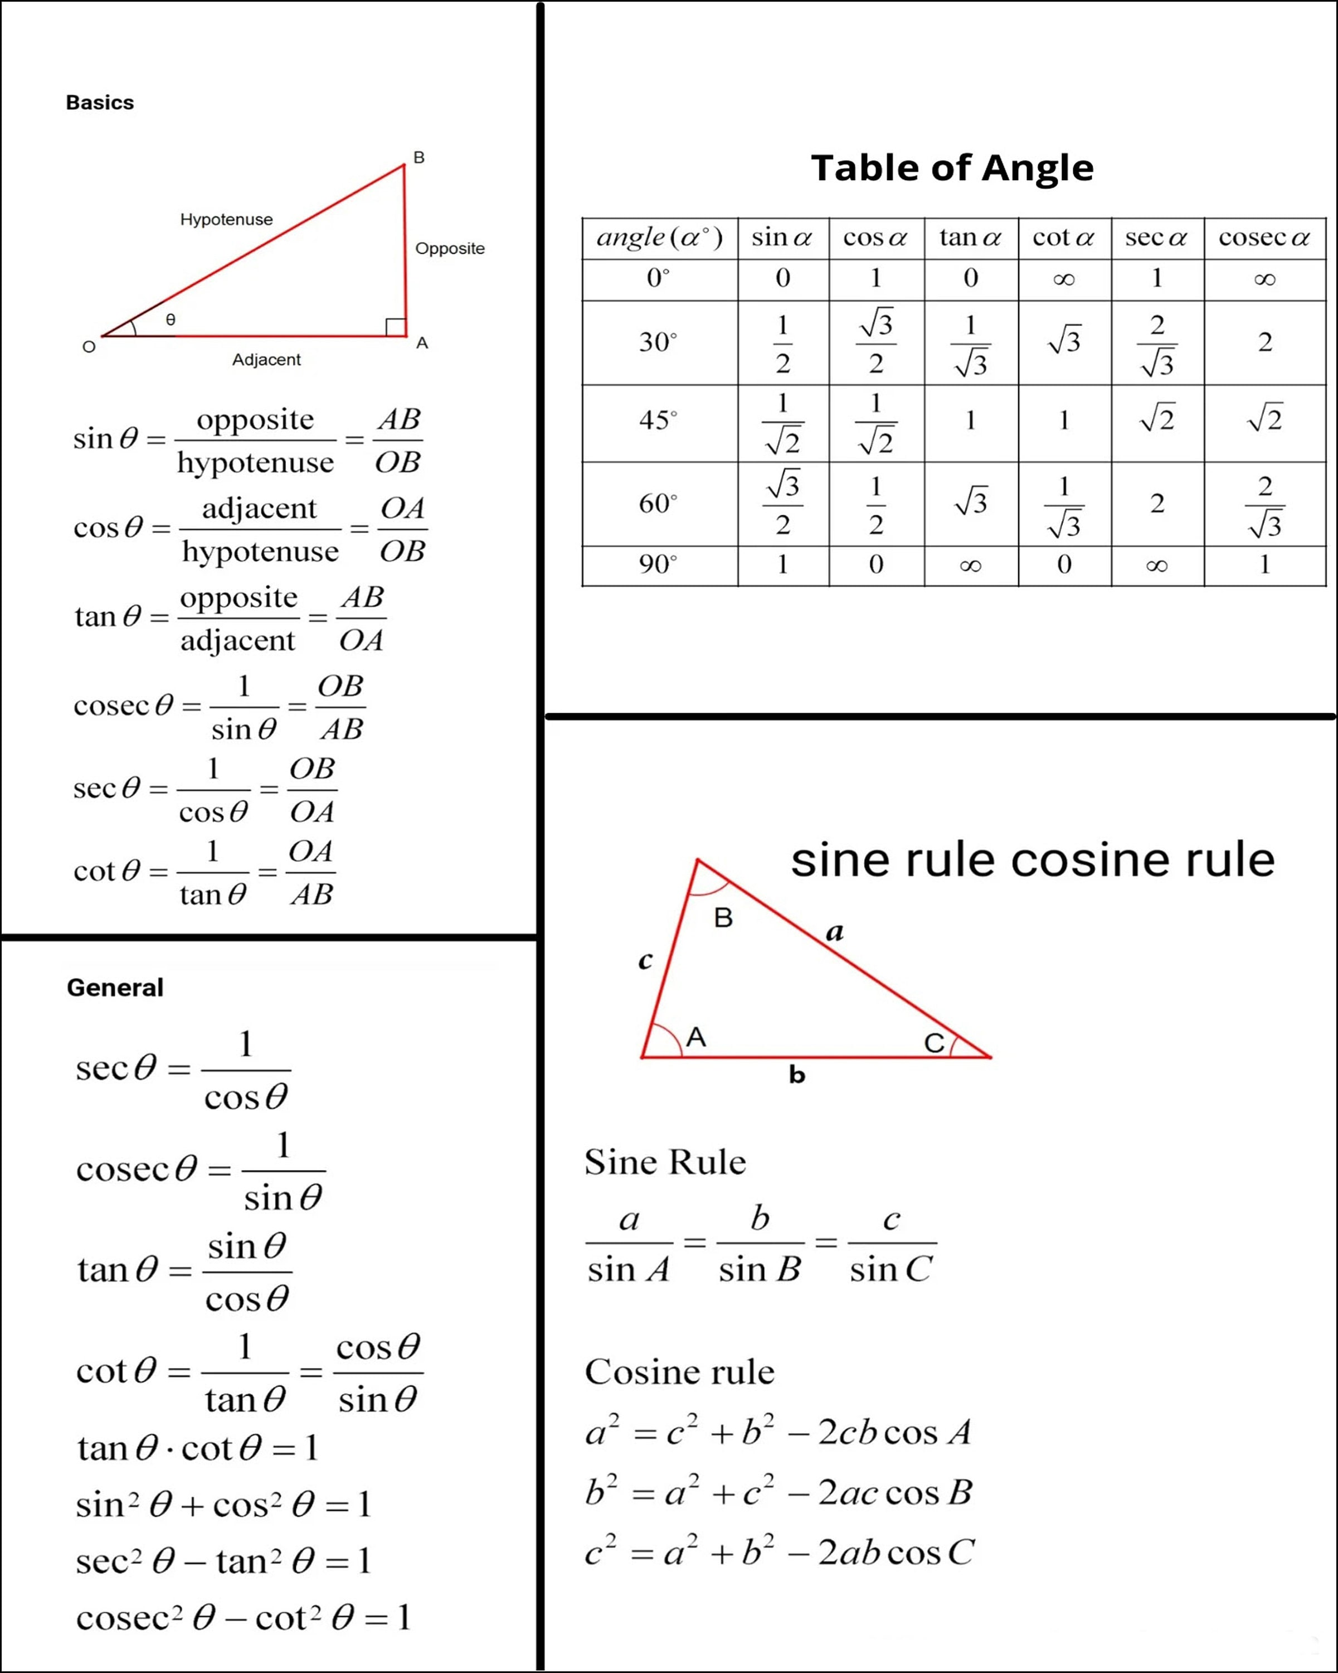
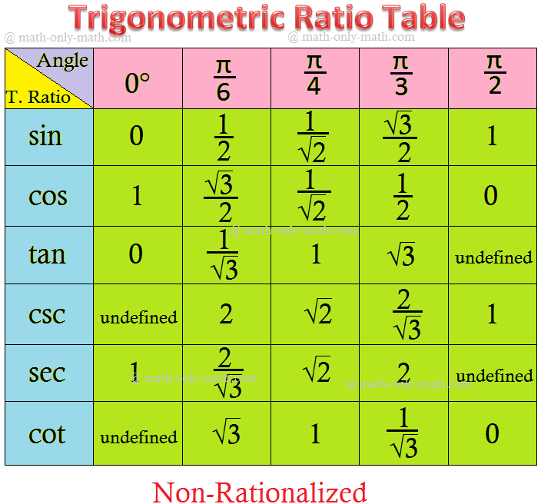
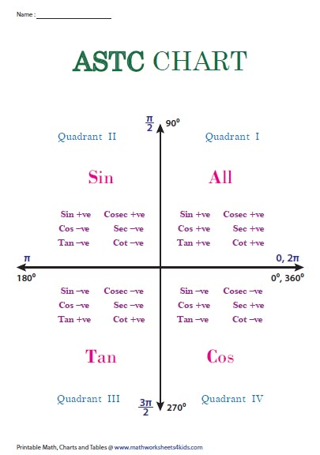

Basic Ratios
- sinθ = P/H
- cosθ = B/H
- tanθ = P/B

Identities
- sin²θ + cos²θ = 1
- 1 + tan²θ = sec²θ
- 1 + cot²θ = cosec²θ

Complementary Angles
- sin(90° − θ) = cosθ
- cos(90° − θ) = sinθ

Allied Angles
- sin(180° − θ) = sinθ
- cos(180° − θ) = −cosθ
- tan(180° − θ) = −tanθ

Standard Values
θ | 0° | 30° | 45° | 60° | 90°
sin | 0 | 1/2 | 1/√2 | √3/2 | 1
cos | 1 | √3/2 | 1/√2 | 1/2 | 0
tan | 0 | 1/√3 | 1 | √3 | ND

GEOMETRY – CHAPTER 4: TRIGONOMETRY
Class X | BSE Odisha

Chapter Overview (What this chapter covers)
English
- Trigonometric ratios
- Complementary angles (90° − θ)
- Allied angles (180° − θ, 90° + θ)
- Trigonometric ratios of angles > 90°
- Standard values of trigonometric ratios
- Simple identities & applications
ଓଡ଼ିଆ
- ତ୍ରିକୋଣମିତିୟ ଅନୁପାତ
- ପୂରକ କୋଣ (90° − θ)
- ସହଯୋଗୀ କୋଣ (180° − θ, 90° + θ)
- 90° ଠାରୁ ବଡ଼ କୋଣର ତ୍ରିକୋଣମିତିୟ ଅନୁପାତ
- ମାନକ ମୂଲ୍ୟ
- ସରଳ ପ୍ରମାଣ ଓ ପ୍ରୟୋଗ

4.1 Introduction | ପରିଚୟ
English
Trigonometry deals with the relationship between the angles and sides of a right-angled triangle.
The six trigonometric ratios are: sin θ, cos θ, tan θ, cot θ, sec θ, cosec θ.
ଓଡ଼ିଆ
ତ୍ରିକୋଣମିତି ହେଉଛି ସମକୋଣୀ ତ୍ରିଭୁଜର କୋଣ ଓ ଭୁଜାମାନଙ୍କ ସମ୍ପର୍କ ଅଧ୍ୟୟନ।
ଛଅଟି ତ୍ରିକୋଣମିତିୟ ଅନୁପାତ ଅଛି—
sin θ, cos θ, tan θ, cot θ, sec θ, cosec θ।

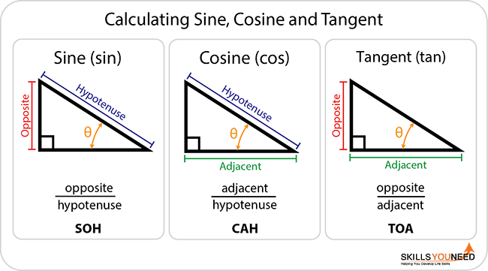

4.2 Trigonometric Ratios | ତ୍ରିକୋଣମିତିୟ ଅନୁପାତ
Ratio | Formula
sin θ | Opposite / Hypotenuse
cos θ | Adjacent / Hypotenuse
tan θ | Opposite / Adjacent
cot θ | Adjacent / Opposite
sec θ | Hypotenuse / Adjacent
cosec θ | Hypotenuse / Opposite
ଓଡ଼ିଆ (ସୂତ୍ର)
- sin θ = ଲମ୍ବ / କର୍ଣ୍ଣ
- cos θ = ଭୂଜ / କର୍ଣ୍ଣ
- tan θ = ଲମ୍ବ / ଭୂଜ

4.3 Complementary Angles (90° − θ)
ପୂରକ କୋଣ (90° − θ)
English
If two angles add up to 90°, they are complementary.
Identities
- sin(90° − θ) = cos θ
- cos(90° − θ) = sin θ
- tan(90° − θ) = cot θ
- sec(90° − θ) = cosec θ
ଓଡ଼ିଆ
ଯଦି ଦୁଇଟି କୋଣର ଯୋଗ 90° ହୁଏ, ସେମାନେ ପୂରକ କୋଣ।
ସମୀକରଣ
- sin(90° − θ) = cos θ
- cos(90° − θ) = sin θ
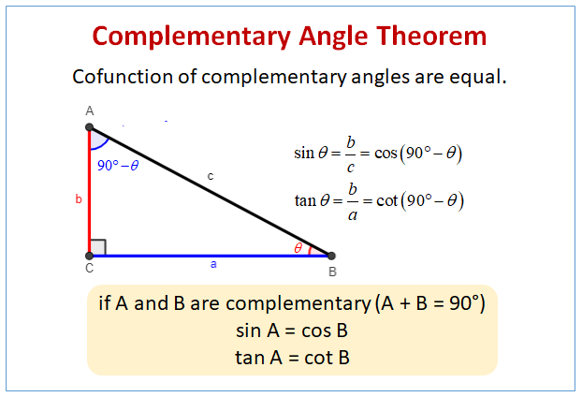
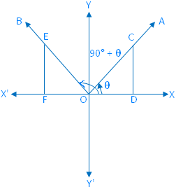

4.4 Allied Angles (180° − θ)
ସହଯୋଗୀ କୋଣ (180° − θ)
English – Identities
- sin(180° − θ) = sin θ
- cos(180° − θ) = −cos θ
- tan(180° − θ) = −tan θ
ଓଡ଼ିଆ
- sin(180° − θ) = sin θ
- cos(180° − θ) = −cos θ
- tan(180° − θ) = −tan θ
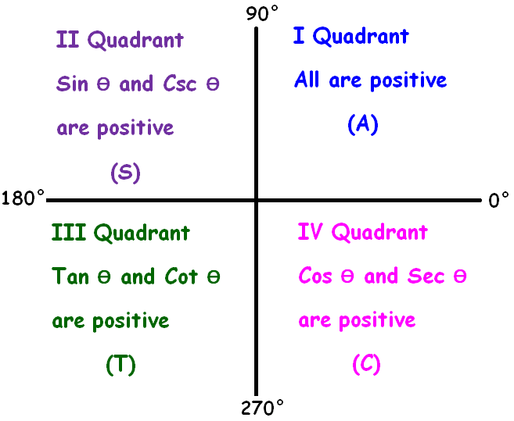
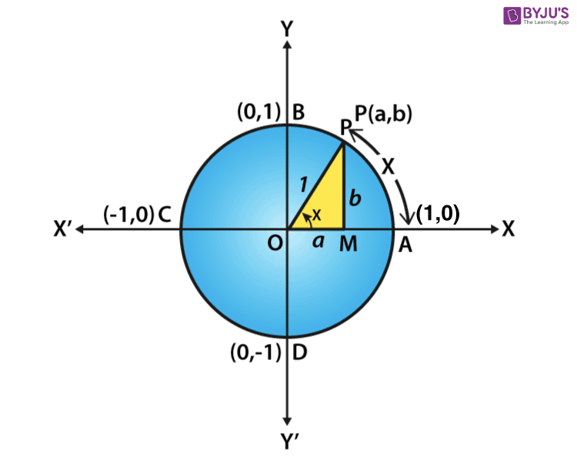

4.5 Angles Greater than 90°
90° ଠାରୁ ବଡ଼ କୋଣ
English
Using identities of 90° ± θ and 180° − θ, trigonometric ratios of angles like 120°, 135°, 150° are found.
Examples
- sin 120° = sin(180° − 60°) = sin 60° = √3/2
- cos 135° = −cos 45° = −1/√2

4.6 Standard Trigonometric Values
ମାନକ ତ୍ରିକୋଣମିତିୟ ମୂଲ୍ୟ
θ | 0° | 30° | 45° | 60° | 90°
sin θ | 0 | 1/2 | 1/√2 | √3/2 | 1
cos θ | 1 | √3/2 | 1/√2 | 1/2 | 0
tan θ | 0 | 1/√3 | 1 | √3 | Not defined

SOLVED QUESTIONS (Board Pattern)

Example–1 (5 Marks – Very Common)
Question (English)
Prove that:
sin⁡(90∘−θ)=cos⁡θ\sin(90^\circ-\theta)=\cos\thetasin(90∘−θ)=cosθ
Solution
In a right-angled triangle, the side opposite (90° − θ) is adjacent to θ.
Hence,
sin⁡(90∘−θ)=cos⁡θ\sin(90^\circ-\theta)=\cos\thetasin(90∘−θ)=cosθ
Proved.
ଓଡ଼ିଆ
ସମକୋଣୀ ତ୍ରିଭୁଜରେ,
sin⁡(90∘−θ)=cos⁡θ\sin(90^\circ-\theta)=\cos\thetasin(90∘−θ)=cosθ
ପ୍ରମାଣିତ।

Example–2 (3 Marks)
Question
Find the value of sin 150°.
Solution
sin⁡150∘=sin⁡(180∘−30∘)=sin⁡30∘=12\sin150^\circ=\sin(180^\circ-30^\circ)=\sin30^\circ=\frac12sin150∘=sin(180∘−30∘)=sin30∘=21​

Example–3 (5 Marks – Equation)
Question
Solve:
sin⁡θ=12, 0∘≤θ≤180∘\sin\theta=\frac12,\;0^\circ\le\theta\le180^\circsinθ=21​,0∘≤θ≤180∘
Solution
θ=30∘, 150∘\theta=30^\circ,\;150^\circθ=30∘,150∘

Example–4 (4 Marks)
Question
Find cos 120°.
Solution
cos⁡120∘=cos⁡(180∘−60∘)=−cos⁡60∘=−12\cos120^\circ=\cos(180^\circ-60^\circ)=-\cos60^\circ=-\frac12cos120∘=cos(180∘−60∘)=−cos60∘=−21​

GEOMETRY – CHAPTER 4: TRIGONOMETRY

SECTION–A : MCQs

(1 × 5 = 5 marks)

Q1. (English)
The value of sin⁡150∘\sin150^\circsin150∘ is
(a) 1 (b) 0 (c) 1/2 (d) √3/2
Answer: (c) 1/2
ଓଡ଼ିଆ
sin⁡150∘\sin150^\circsin150∘ ର ମୂଲ୍ୟ—
ଉତ୍ତର: 1/2

Q2.
cos⁡(180∘−θ)=\cos(180^\circ-\theta)=cos(180∘−θ)=
(a) cosθ (b) −cosθ (c) sinθ (d) −sinθ
Answer: (b) −cosθ

Q3.
Which trigonometric ratio is not defined at 90°?
(a) sin (b) cos (c) tan (d) sec
Answer: (c) tan

Q4.
sin⁡(90∘−θ)=\sin(90^\circ-\theta)=sin(90∘−θ)=
(a) sinθ (b) cosθ (c) tanθ (d) cosecθ
Answer: (b) cosθ

Q5.
The value of cos⁡120∘\cos120^\circcos120∘ is
(a) 1/2 (b) −1/2 (c) √3/2 (d) −√3/2
Answer: (b) −1/2

SECTION–B : VSA (Very Short Answer)

(2 × 5 = 10 marks)

Q6. Write the value of sin 0°.
Ans: 0
ଓଡ଼ିଆ: sin 0° = 0

Q7. Write sin(90° − θ).
Ans: cos θ
ଓଡ଼ିଆ: sin(90° − θ) = cos θ

Q8. What is complementary angle?
Ans: Two angles whose sum is 90°.
ଓଡ଼ିଆ: ଯେଉଁ ଦୁଇ କୋଣର ଯୋଗ 90°।

Q9. Write the value of cos 180°.
Ans: −1
ଓଡ଼ିଆ: cos 180° = −1

Q10. Write tan 45°.
Ans: 1
ଓଡ଼ିଆ: tan 45° = 1

SECTION–C : SA (Short Answer)

(4 × 5 = 20 marks)

Q11. Find the value of sin 120°.
Solution (English)
sin⁡120∘=sin⁡(180∘−60∘)=sin⁡60∘=32\sin120^\circ=\sin(180^\circ-60^\circ)=\sin60^\circ=\frac{\sqrt3}{2}sin120∘=sin(180∘−60∘)=sin60∘=23​​
ଓଡ଼ିଆ
sin⁡120∘=32\sin120^\circ=\frac{\sqrt3}{2}sin120∘=23​​

Q12. Prove: sin⁡(90∘−θ)=cos⁡θ\sin(90^\circ-\theta)=\cos\thetasin(90∘−θ)=cosθ
Solution (English)
In a right-angled triangle, opposite side of (90° − θ) equals adjacent side of θ.
Hence, sin⁡(90∘−θ)=cos⁡θ\sin(90^\circ-\theta)=\cos\thetasin(90∘−θ)=cosθ.
ଓଡ଼ିଆ
ସମକୋଣୀ ତ୍ରିଭୁଜରୁ—
sin⁡(90∘−θ)=cos⁡θ\sin(90^\circ-\theta)=\cos\thetasin(90∘−θ)=cosθ
ପ୍ରମାଣିତ।

Q13. Find cos 135°.
cos⁡135∘=cos⁡(180∘−45∘)=−cos⁡45∘=−12\cos135^\circ=\cos(180^\circ-45^\circ)=-\cos45^\circ=-\frac1{\sqrt2}cos135∘=cos(180∘−45∘)=−cos45∘=−2​1​

Q14. Solve: sin⁡θ=12, 0∘≤θ≤180∘\sin\theta=\frac12,\;0^\circ\le\theta\le180^\circsinθ=21​,0∘≤θ≤180∘
Answer: θ=30∘,150∘\theta=30^\circ,150^\circθ=30∘,150∘
ଓଡ଼ିଆ: θ = 30°, 150°

SECTION–D : LA (Long Answer)

(5 marks × 1)

Q15. Prove:
tan⁡(180∘−θ)=−tan⁡θ\tan(180^\circ-\theta)=-\tan\thetatan(180∘−θ)=−tanθ
Solution (English)
tan⁡(180∘−θ)=sin⁡(180∘−θ)cos⁡(180∘−θ)=sin⁡θ−cos⁡θ=−tan⁡θ\tan(180^\circ-\theta)=\frac{\sin(180^\circ-\theta)}{\cos(180^\circ-\theta)} =\frac{\sin\theta}{-\cos\theta} =-\tan\thetatan(180∘−θ)=cos(180∘−θ)sin(180∘−θ)​=−cosθsinθ​=−tanθ
Hence proved.
ଓଡ଼ିଆ
tan⁡(180∘−θ)=−tan⁡θ\tan(180^\circ-\theta)=-\tan\thetatan(180∘−θ)=−tanθ
ପ୍ରମାଣିତ।

EXPECTED 2026 QUESTIONS – CHAPTER 4 (WITH REASONS)

Sure (5 marks)
- Prove identity using 90° − θ
Reason: Asked every year (direct, scoring)
- Prove identity using 180° − θ
Reason: Sign (+/−) testing – examiner favourite

Very Likely
- Find value of sin120°, cos135°, tan150°
Reason: From standard-value section
- Solve equation: sin⁡θ=12\sin\theta=\frac12sinθ=21​ with interval
Reason: Interval-based compulsory pattern

JAI HIND! BINAYA

