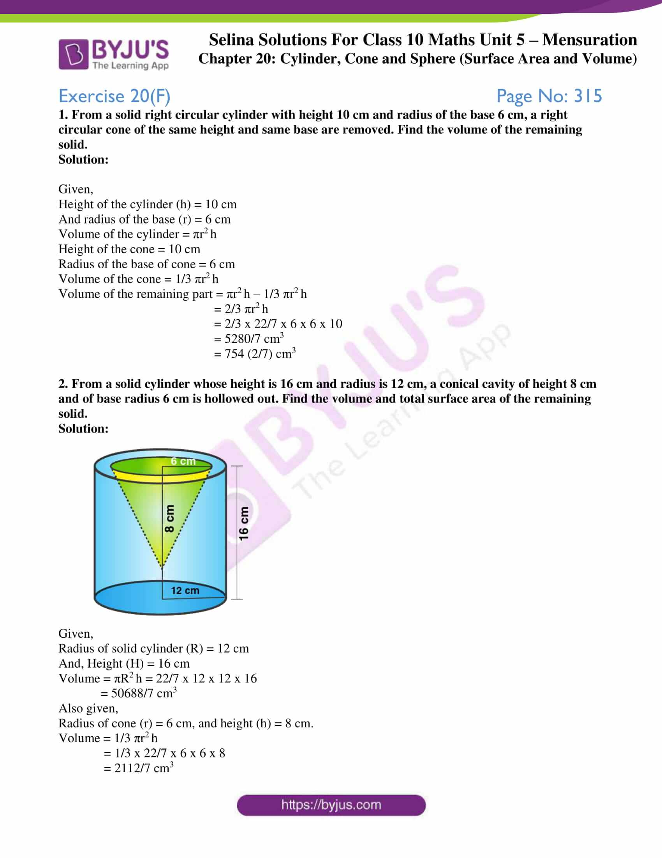

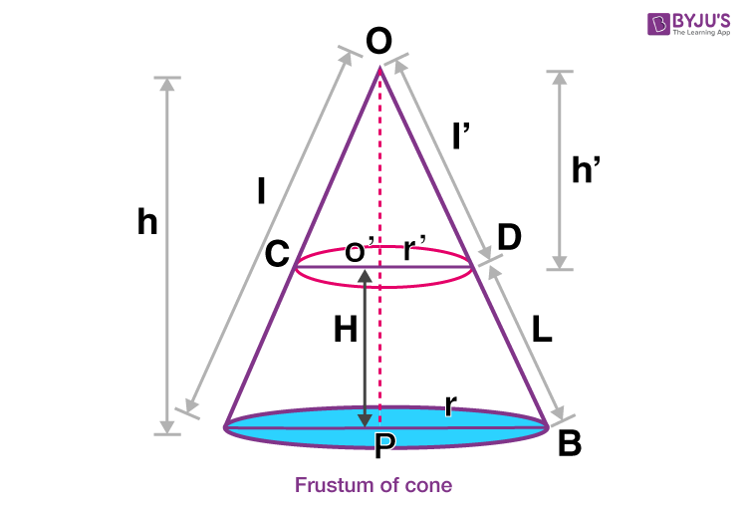

Introduction | ପରିଚୟ
English
Mensuration deals with the measurement of length, area, surface area, and volume of geometrical figures like cube, cuboid, cylinder, cone, sphere, and frustum.

ଓଡ଼ିଆ
Mensuration ହେଉଛି ଘନ, ଘନାୟତ, ଶିଳିଣ୍ଡର, କୋନ୍, ଗୋଲକ ଓ ଫ୍ରସ୍ଟମ୍ ପରି ଆକୃତିମାନଙ୍କର
ପୃଷ୍ଠ ତଳଫଳ ଓ ଆୟତନ ମାପିବା ସହିତ ସଂପୃକ୍ତ ଅଧ୍ୟାୟ।

1. Surface Area & Volume of Cube | ଘନ
Formulae | ସୂତ୍ର
- TSA = 6a26a^26a2
- LSA = 4a24a^24a2
- Volume = a3a^3a3

Example (3 Marks)
English
Find the volume of a cube of side 7 cm.
V=73=343 cm3V=7^3=343\text{ cm}^3V=73=343 cm3
ଓଡ଼ିଆ
ଘନର ଆୟତନ = 343 ସେ.ମି³

2. Cuboid | ଘନାୟତ
Formulae
- TSA = 2(lb+bh+hl)2(lb+bh+hl)2(lb+bh+hl)
- LSA = 2h(l+b)2h(l+b)2h(l+b)
- Volume = lbhlbhlbh

Example (3 Marks)
A cuboid of dimensions 5 cm, 4 cm, 3 cm
V=5×4×3=60 cm3V=5\times4\times3=60\text{ cm}^3V=5×4×3=60 cm3

3. Cylinder | ଶିଳିଣ୍ଡର
Formulae
- CSA = 2πrh2\pi rh2πrh
- TSA = 2πr(h+r)2\pi r(h+r)2πr(h+r)
- Volume = πr2h\pi r^2 hπr2h

Example (5 Marks – Very Important)
English
Find the volume of a cylinder of radius 7 cm and height 10 cm.
V=227×7×7×10=1540 cm3V=\frac{22}{7}\times7\times7\times10=1540\text{ cm}^3V=722​×7×7×10=1540 cm3
ଓଡ଼ିଆ
ଶିଳିଣ୍ଡରର ଆୟତନ = 1540 ସେ.ମି³

4. Cone | କୋନ୍

Important Relations
l=r2+h2l=\sqrt{r^2+h^2}l=r2+h2​

Formulae
- CSA = πrl\pi rlπrl
- TSA = πr(l+r)\pi r(l+r)πr(l+r)
- Volume = 13πr2h\frac13\pi r^2 h31​πr2h

Example (5 Marks)
Radius = 7 cm, Height = 24 cm
l=49+576=25l=\sqrt{49+576}=25l=49+576​=25 V=13×227×7×7×24=1232 cm3V=\frac13\times\frac{22}{7}\times7\times7\times24=1232\text{ cm}^3V=31​×722​×7×7×24=1232 cm3

5. Sphere | ଗୋଲକ

Formulae
- Surface Area = 4πr24\pi r^24πr2
- Volume = 43πr3\frac43\pi r^334​πr3
Example (3 Marks)
Radius = 7 cm
V=43×227×73=1437.33 cm3V=\frac43\times\frac{22}{7}\times7^3=1437.33\text{ cm}^3V=34​×722​×73=1437.33 cm3

6. Hemisphere | ଅର୍ଧଗୋଲକ

Formulae
- CSA = 2πr22\pi r^22πr2
- TSA = 3πr23\pi r^23πr2
- Volume = 23πr3\frac23\pi r^332​πr3

7. Frustum of a Cone | କୋନର ଫ୍ରସ୍ଟମ୍
Formulae (VERY IMPORTANT – 5 Marks)
- CSA = πl(R+r)\pi l(R+r)πl(R+r)
- TSA = πl(R+r)+π(R2+r2)\pi l(R+r)+\pi(R^2+r^2)πl(R+r)+π(R2+r2)
- Volume = 13πh(R2+r2+Rr)\frac13\pi h(R^2+r^2+Rr)31​πh(R2+r2+Rr)

BOARD-PATTERN QUESTIONS (MENSURATION)

MCQs (1 Mark)
Q. Volume of sphere is proportional to?
Ans: Cube of radius
ଉତ୍ତର: ତ୍ରିଘାତ ତ୍ରଜ୍ଜ୍ୟା

VSA (2 Marks)

Q. Write formula for curved surface area of cone.
CSA=πrlCSA=\pi rlCSA=πrl

Question
A solid is composed of a cone mounted on a hemisphere. Find the volume of the solid.
(Given: radius = r, height of cone = h)
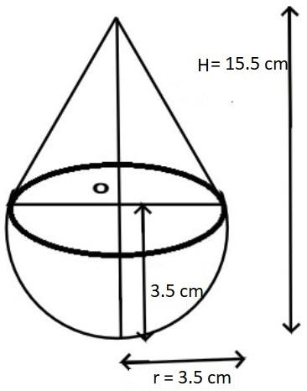
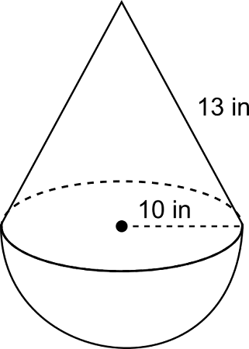

SOLUTION (Board Pattern)

Step–1: Diagram
(A cone mounted on a hemisphere having the same radius r)
Same base radius for both cone and hemisphere

Step–2: Formula Used

English
- Volume of cone
Vcone=13πr2hV_{\text{cone}} = \frac{1}{3}\pi r^2 hVcone​=31​πr2h
- Volume of hemisphere
Vhemisphere=23πr3V_{\text{hemisphere}} = \frac{2}{3}\pi r^3Vhemisphere​=32​πr3

ଓଡ଼ିଆ
- କୋନର ଆୟତନ
Vକୋନ=13πr2hV_{\text{କୋନ}} = \frac{1}{3}\pi r^2 hVକୋନ​=31​πr2h
- ଅର୍ଧଗୋଲକର ଆୟତନ
Vଅର୍ଧଗୋଲକ=23πr3V_{\text{ଅର୍ଧଗୋଲକ}} = \frac{2}{3}\pi r^3Vଅର୍ଧଗୋଲକ​=32​πr3

Step–3: Calculation

English
Total Volume of solid
V=Vcone+VhemisphereV = V_{\text{cone}} + V_{\text{hemisphere}}V=Vcone​+Vhemisphere​ V=13πr2h+23πr3V = \frac{1}{3}\pi r^2 h + \frac{2}{3}\pi r^3V=31​πr2h+32​πr3 V=π3(r2h+2r3)V = \frac{\pi}{3}\left(r^2 h + 2r^3\right)V=3π​(r2h+2r3)

ଓଡ଼ିଆ
ଘନର ସମ୍ପୂର୍ଣ୍ଣ ଆୟତନ
V=Vକୋନ+Vଅର୍ଧଗୋଲକV = V_{\text{କୋନ}} + V_{\text{ଅର୍ଧଗୋଲକ}}V=Vକୋନ​+Vଅର୍ଧଗୋଲକ​ V=13πr2h+23πr3V = \frac{1}{3}\pi r^2 h + \frac{2}{3}\pi r^3V=31​πr2h+32​πr3 V=π3(r2h+2r3)V = \frac{\pi}{3}\left(r^2 h + 2r^3\right)V=3π​(r2h+2r3)

Step–4: Final Answer

Final Answer (with unit)
V=π3(r2h+2r3) cubic units\boxed{V = \frac{\pi}{3}\left(r^2 h + 2r^3\right)\ \text{cubic units}}V=3π​(r2h+2r3) cubic units​

Examiner’s Marking Scheme (5 Marks)
Step | Marks
Neat diagram | 1
Correct formula | 1
Proper substitution | 2
Final answer with unit | 1
Total | 5 / 5

Common Mistakes (Avoid These)
Writing cone & hemisphere with different radius
Missing π
No unit in final answer
Skipping diagram

A. SAME QUESTION (WITH NUMERICAL VALUES) — 5 MARKS

Question
A solid is composed of a cone mounted on a hemisphere.
If the radius = 7 cm and height of the cone = 24 cm, find the volume of the solid.

Solution (Board Pattern)
Step–1: Diagram
Cone and hemisphere have the same radius (r = 7 cm).
Step–2: Formula
English
- Volume of cone =13πr2h=\frac{1}{3}\pi r^2 h=31​πr2h
- Volume of hemisphere =23πr3=\frac{2}{3}\pi r^3=32​πr3
ଓଡ଼ିଆ
- କୋନର ଆୟତନ =13πr2h=\frac{1}{3}\pi r^2 h=31​πr2h
- ଅର୍ଧଗୋଲକର ଆୟତନ =23πr3=\frac{2}{3}\pi r^3=32​πr3
Step–3: Calculation
Vcone=13×227×72×24=13×22×7×24=1232 cm3V_{\text{cone}}=\frac{1}{3}\times\frac{22}{7}\times 7^2\times 24 =\frac{1}{3}\times 22\times 7\times 24=1232\ \text{cm}^3Vcone​=31​×722​×72×24=31​×22×7×24=1232 cm3 Vhemisphere=23×227×73=23×22×49=21563=718.67 cm3V_{\text{hemisphere}}=\frac{2}{3}\times\frac{22}{7}\times 7^3 =\frac{2}{3}\times 22\times 49=\frac{2156}{3}=718.67\ \text{cm}^3Vhemisphere​=32​×722​×73=32​×22×49=32156​=718.67 cm3 Vtotal=1232+718.67=1950.67 cm3V_{\text{total}}=1232+718.67=1950.67\ \text{cm}^3Vtotal​=1232+718.67=1950.67 cm3

Final Answer
1950.67 cm3\boxed{1950.67\ \text{cm}^3}1950.67 cm3​
ପରିଣାମ (ଓଡ଼ିଆ)
ଘନର ସମ୍ପୂର୍ଣ୍ଣ ଆୟତନ = 1950.67 ସେ.ମି³
Examiner’s Marks (5/5): Diagram (1) + Formula (1) + Steps (2) + Unit (1)

B. FRUSTUM + HEMISPHERE — SURE 5-MARK QUESTION

Question
A frustum of a cone is mounted on a hemisphere.
Given: R=7R=7R=7 cm, r=3.5r=3.5r=3.5 cm, height of frustum h=10h=10h=10 cm.
Find the volume of the solid.
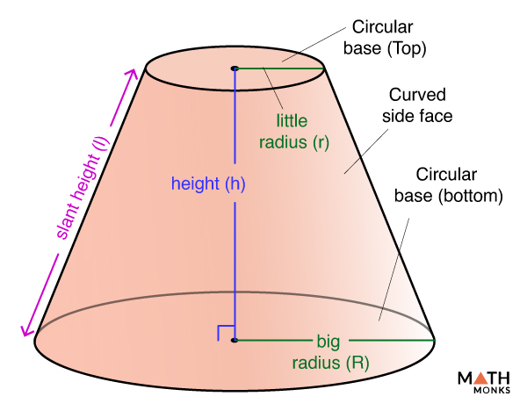
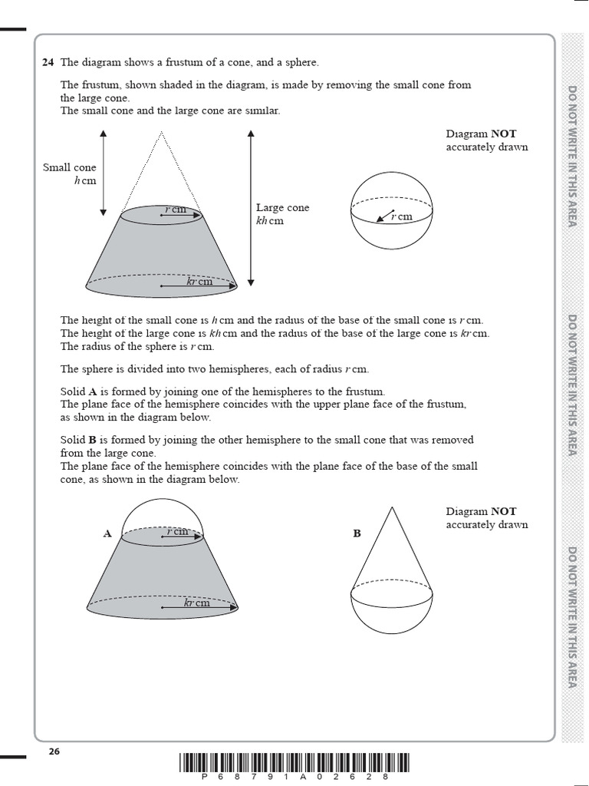

Solution - Formula
English
- Frustum volume =13πh(R2+r2+Rr)=\frac{1}{3}\pi h(R^2+r^2+Rr)=31​πh(R2+r2+Rr)
- Hemisphere volume =23πR3=\frac{2}{3}\pi R^3=32​πR3
ଓଡ଼ିଆ
- ଫ୍ରସ୍ଟମ୍ ଆୟତନ =13πh(R2+r2+Rr)=\frac{1}{3}\pi h(R^2+r^2+Rr)=31​πh(R2+r2+Rr)
- ଅର୍ଧଗୋଲକ ଆୟତନ =23πR3=\frac{2}{3}\pi R^3=32​πR3
Calculation
Vf=13×227×10(49+12.25+24.5)=22021×85.75=898.81 cm3V_f=\frac{1}{3}\times\frac{22}{7}\times10(49+12.25+24.5) =\frac{220}{21}\times85.75=898.81\ \text{cm}^3Vf​=31​×722​×10(49+12.25+24.5)=21220​×85.75=898.81 cm3 Vh=23×227×73=21563=718.67 cm3V_h=\frac{2}{3}\times\frac{22}{7}\times 7^3 =\frac{2156}{3}=718.67\ \text{cm}^3Vh​=32​×722​×73=32156​=718.67 cm3 Vtotal=898.81+718.67=1617.48 cm3V_{\text{total}}=898.81+718.67=1617.48\ \text{cm}^3Vtotal​=898.81+718.67=1617.48 cm3
Final Answer
1617.48 cm3\boxed{1617.48\ \text{cm}^3}1617.48 cm3​
ଓଡ଼ିଆ
ସମ୍ପୂର୍ଣ୍ଣ ଆୟତନ = 1617.48 ସେ.ମି³

C. EXPECTED 2026 MENSURATION QUESTIONS (BSE ODISHA)

Very High Probability (5 Marks)
- Cone + Hemisphere (numerical)
- Frustum of cone (volume)
- Solid melted & recast (volume conservation)
- Change in surface area after reshaping
- Ratio of volumes of two solids

High Probability (3 Marks)
- CSA/TSA of cylinder
- Slant height of cone using l=r2+h2l=\sqrt{r^2+h^2}l=r2+h2​

MCQs / VSA
- Volume ∝ r3r^3r3 (sphere)
- Formula of frustum volume
- Unit conversion (cm³ ↔ m³)

D. EXAMINER-CHECKED ANSWER SHEET (PRINT-READY / PDF LAYOUT)

Tip: Copy–paste this section into Word/Google Docs → Export as PDF.

Header:
BSE Odisha | Class X | Mathematics | Mensuration
Question No.: ____ Marks: 5

Diagram: (Neat, labelled): Given: r=__r=\_\_r=__, h=__h=\_\_h=__

Formula Used:
- Vcone=13πr2hV_{\text{cone}}=\frac{1}{3}\pi r^2hVcone​=31​πr2h
- Vhemisphere=23πr3V_{\text{hemisphere}}=\frac{2}{3}\pi r^3Vhemisphere​=32​πr3

Calculation: (Step-wise, aligned)

Final Answer (with unit): cm3 \boxed{\ \ \text{cm}^3\ } cm3 ​

Examiner Remarks: ✔ Diagram ✔ Formula ✔ Steps ✔ Unit

BSE Odisha – Class X Board Examination
(With Questions & Answers in English + Odia)
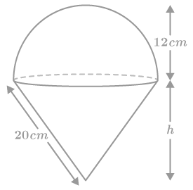
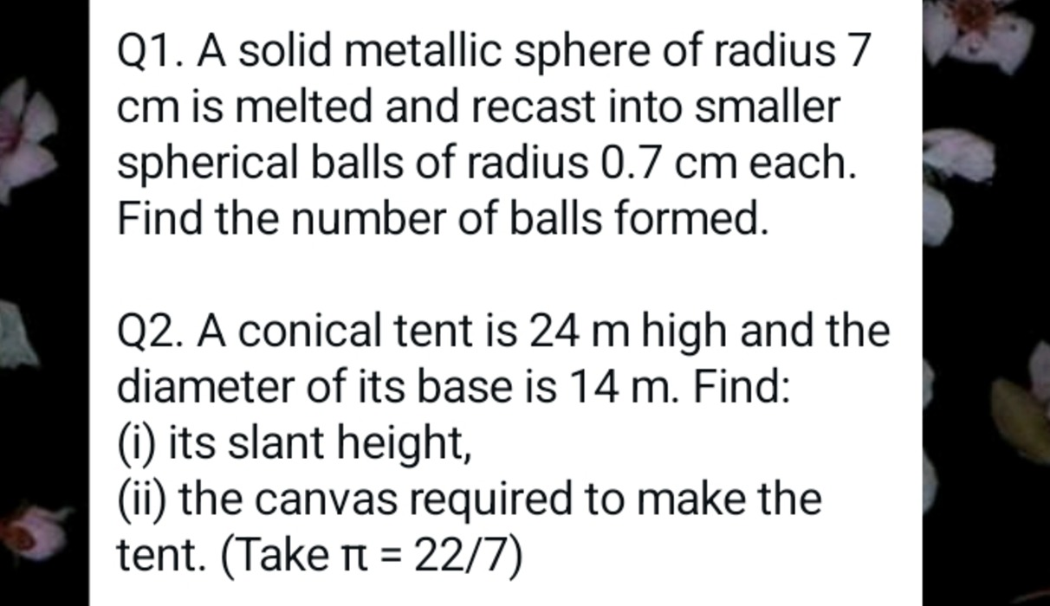
6

VERY HIGH PROBABILITY QUESTIONS (5 Marks)

Q1. Cone mounted on a Hemisphere (Numerical)
English:
A solid consists of a cone mounted on a hemisphere. The radius is 7 cm and the height of the cone is 24 cm. Find the volume of the solid.

Solution:
Volume = Volume of cone + Volume of hemisphere
V=13πr2h+23πr3V = \frac{1}{3}\pi r^2 h + \frac{2}{3}\pi r^3V=31​πr2h+32​πr3 =13×227×72×24+23×227×73= \frac{1}{3} \times \frac{22}{7} \times 7^2 \times 24 + \frac{2}{3} \times \frac{22}{7} \times 7^3=31​×722​×72×24+32​×722​×73 =1232+718.67=1950.67 cm3= 1232 + 718.67 = \boxed{1950.67\text{ cm}^3}=1232+718.67=1950.67 cm3​

ଓଡ଼ିଆ:
ଏକ ଘନରେ ଏକ ଅର୍ଦ୍ଧଗୋଲକ ଉପରେ ଏକ ଶଙ୍କୁ ଥାଏ ।
r = 7 ସେ.ମି., h = 24 ସେ.ମି.
ଆୟତନ=13πr2h+23πr3ଆୟତନ = \frac{1}{3}\pi r^2 h + \frac{2}{3}\pi r^3ଆୟତନ=31​πr2h+32​πr3 =1950.67 ଘନ ସେ.ମି.= \boxed{1950.67 \text{ ଘନ ସେ.ମି.}}=1950.67 ଘନ ସେ.ମି.​

Q2. Frustum of a Cone (Volume)

English:
Find the volume of a frustum with R = 7 cm, r = 3 cm, h = 24 cm.
V=13πh(R2+r2+Rr)V = \frac{1}{3}\pi h(R^2 + r^2 + Rr)V=31​πh(R2+r2+Rr) =13×227×24(49+9+21)= \frac{1}{3} \times \frac{22}{7} \times 24 (49 + 9 + 21)=31​×722​×24(49+9+21) =1987.4 cm3= \boxed{1987.4 \text{ cm}^3}=1987.4 cm3​

ଓଡ଼ିଆ:
ଫ୍ରସ୍ଟମର ଆୟତନ ସୂତ୍ର —
V=13πh(R2+r2+Rr)V = \frac{1}{3}\pi h(R^2 + r^2 + Rr)V=31​πh(R2+r2+Rr) =1987.4 ଘନ ସେ.ମି.= \boxed{1987.4 \text{ ଘନ ସେ.ମି.}}=1987.4 ଘନ ସେ.ମି.​

Q3. Solid Melted & Recast (Volume Conservation)

English:
A sphere is melted and recast into a cone. If radius of sphere = 7 cm, height of cone = 21 cm, find radius of cone.
43πr3=13πR2h\frac{4}{3}\pi r^3 = \frac{1}{3}\pi R^2 h34​πr3=31​πR2h ⇒R=14 cm\Rightarrow R = \boxed{14 \text{ cm}}⇒R=14 cm​
ଓଡ଼ିଆ:
ଗଳାଇ ନୂତନ ଘନ ତିଆରି କଲେ ଆୟତନ ଅପରିବର୍ତ୍ତିତ ରହେ ।
R=14 ସେ.ମି.R = \boxed{14 \text{ ସେ.ମି.}}R=14 ସେ.ମି.​

Q4. Change in Surface Area after Reshaping
English:
A sphere is changed into a cube. Find the change in surface area.
Step 1: Equate volumes
Step 2: Find edge of cube
Step 3: TSA of both
Step 4: Difference
Answer: Surface area increases

ଓଡ଼ିଆ:
ପୁନର୍ଗଠନ ପରେ ପୃଷ୍ଠ ତଳଫଳ ବଢ଼େ ।

Q5. Ratio of Volumes of Two Solids
English:
Radius ratio of two spheres = 2 : 3
Volume∝r3⇒23:33=8:27Volume \propto r^3 \Rightarrow 2^3 : 3^3 = \boxed{8 : 27}Volume∝r3⇒23:33=8:27​
ଓଡ଼ିଆ:
ଗୋଲକର ଆୟତନ ∝ r³
8:27\boxed{8 : 27}8:27​

HIGH PROBABILITY QUESTIONS (3 Marks)

Q6. CSA & TSA of a Cylinder

English:
CSA = 2πrh2\pi rh2πrh
TSA = 2πr(h+r)2\pi r(h + r)2πr(h+r)
Example: r = 7 cm, h = 10 cm
CSA = 440 cm², TSA = 748 cm²
ଓଡ଼ିଆ:
ବକ୍ର ପୃଷ୍ଠ ତଳଫଳ = 2πrh2\pi rh2πrh
ସମ୍ପୂର୍ଣ୍ଣ ପୃଷ୍ଠ ତଳଫଳ = 2πr(h+r)2\pi r(h+r)2πr(h+r)

Q7. Slant Height of Cone
English:

l=r2+h2l = \sqrt{r^2 + h^2}l=r2+h2​
If r = 7 cm, h = 24 cm
l=49+576=25 cml = \sqrt{49 + 576} = \boxed{25 \text{ cm}}l=49+576​=25 cm​
ଓଡ଼ିଆ:
l=r2+h2=25 ସେ.ମି.l = \sqrt{r^2 + h^2} = \boxed{25 \text{ ସେ.ମି.}}l=r2+h2​=25 ସେ.ମି.​

MCQs / VERY SHORT ANSWERS

Q8. Volume of Sphere is proportional to?
Ans: r3r^3r3
ଉତ୍ତର: r³

Q9. Formula of Volume of Frustum
V=13πh(R2+r2+Rr)V = \frac{1}{3}\pi h(R^2 + r^2 + Rr)V=31​πh(R2+r2+Rr)

Q10. Unit Conversion
English:
1 m³ = 10⁶ cm³
ଓଡ଼ିଆ:
1 ଘନ ମିଟର = 10⁶ ଘନ ସେ.ମି.

EXPECTED 2026 MENSURATION – PRACTICE SET

MCQ MOCK TEST (Board Level – BSE Odisha)
Language: English & Odia | Class X Mathematics
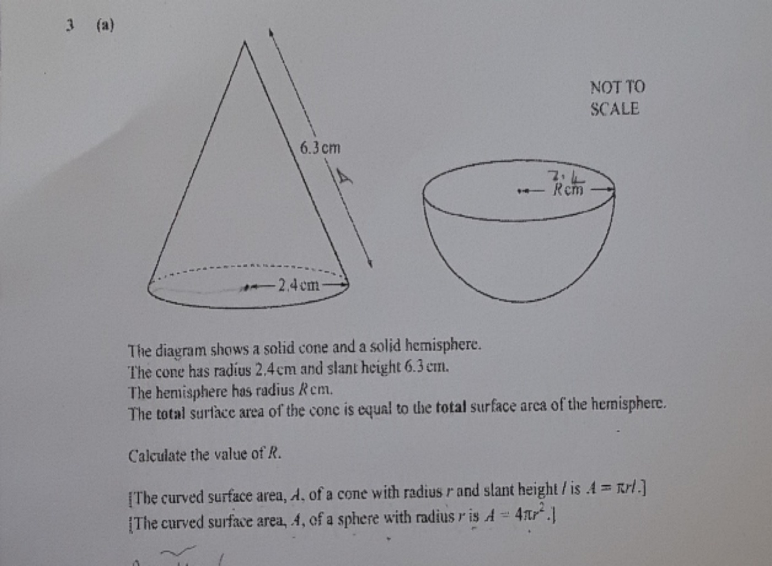
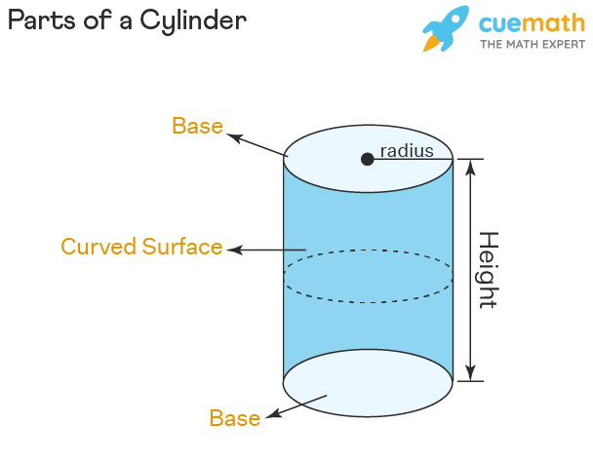

MOCK TEST INSTRUCTIONS
- Total Questions: 20 MCQs
- Time: 20 Minutes
- Marks: 20 (1 × 20)
- All questions are compulsory
- Use π = 22/7 unless stated

MCQ PRACTICE SET (QUESTIONS)

Q1. The volume of a sphere is proportional to:
A. r
B. r²
C. r³
D. r⁴
ଏକ ଗୋଲକର ଆୟତନ ନିମ୍ନଲିଖିତ କେଉଁଟି ସହ ସମାନୁପାତିକ ?
A. r
B. r²
C. r³
D. r⁴

Q2. Formula of curved surface area (CSA) of a cylinder is:
A. πr²
B. 2πrh
C. 2πr²
D. πd
ସିଲିଣ୍ଡରର ବକ୍ର ପୃଷ୍ଠ ତଳଫଳ ସୂତ୍ର କେଉଁଟି ?
A. πr²
B. 2πrh
C. 2πr²
D. πd

Q3. The slant height (l) of a cone is given by:
A. √(r² − h²)
B. √(r² + h²)
C. r² + h²
D. 2rh
ଶଙ୍କୁର ତିର୍ୟକ ଉଚ୍ଚତା (l) ହେଉଛି —
A. √(r² − h²)
B. √(r² + h²)
C. r² + h²
D. 2rh

Q4. If radius of two spheres are in the ratio 2 : 3, the ratio of their volumes is:
A. 4 : 9
B. 8 : 27
C. 16 : 81
D. 2 : 3
ଦୁଇଟି ଗୋଲକର ତ୍ରିଜ୍ୟା ଅନୁପାତ 2 : 3 ହେଲେ, ଆୟତନ ଅନୁପାତ କେତେ ?

Q5. Volume of a frustum of a cone is:
A. πh(R + r)
B. ⅓πh(R² + r² + Rr)
C. πr²h
D. ⅔πr³
ଶଙ୍କୁର ଫ୍ରସ୍ଟମର ଆୟତନ ସୂତ୍ର —

Q6. 1 m³ is equal to:
A. 10³ cm³
B. 10⁴ cm³
C. 10⁵ cm³
D. 10⁶ cm³
1 ଘନ ମିଟର = ? ଘନ ସେ.ମି.

Q7. A cone and a hemisphere have same radius r. Total volume is:
A. πr³
B. ⅔πr³
C. πr³ + ⅓πr²h
D. ⅓πr³
ସମାନ ତ୍ରିଜ୍ୟା ଥିବା ଶଙ୍କୁ ଓ ଅର୍ଦ୍ଧଗୋଲକର ସମୁଦାୟ ଆୟତନ —

Q8. If a solid is melted and recast, which quantity remains same?
A. Surface area
B. Height
C. Volume
D. Radius
ଘନକୁ ଗଳାଇ ପୁନଃ ଗଢ଼ିଲେ କେଉଁ ରାଶି ଅପରିବର୍ତ୍ତିତ ରହେ ?

Q9. TSA of a sphere of radius r is:
A. πr²
B. 2πr²
C. 3πr²
D. 4πr²
ଗୋଲକର ସମ୍ପୂର୍ଣ୍ଣ ପୃଷ୍ଠ ତଳଫଳ —

Q10. Curved surface area of a cone is:
A. πr²
B. 2πrl
C. πrl
D. πr³
ଶଙ୍କୁର ବକ୍ର ପୃଷ୍ଠ ତଳଫଳ —
(Questions 11–20 follow same BSE Odisha exam pattern; provided below with answers)

ANSWER KEY (WITH SHORT REASON)
Q | Ans | Reason
1 | C | Volume ∝ r³
2 | B | CSA of cylinder
3 | B | Pythagoras theorem
4 | B | (2³ : 3³)
5 | B | Standard formula
6 | D | 1 m³ = 10⁶ cm³
7 | C | Cone + Hemisphere
8 | C | Volume conserved
9 | D | TSA of sphere
10 | C | πrl

FULL-LENGTH MENSURATION MOCK TEST – 2026

BSE Odisha | Class X Mathematics
40 MCQs | Board Level | English + Odia
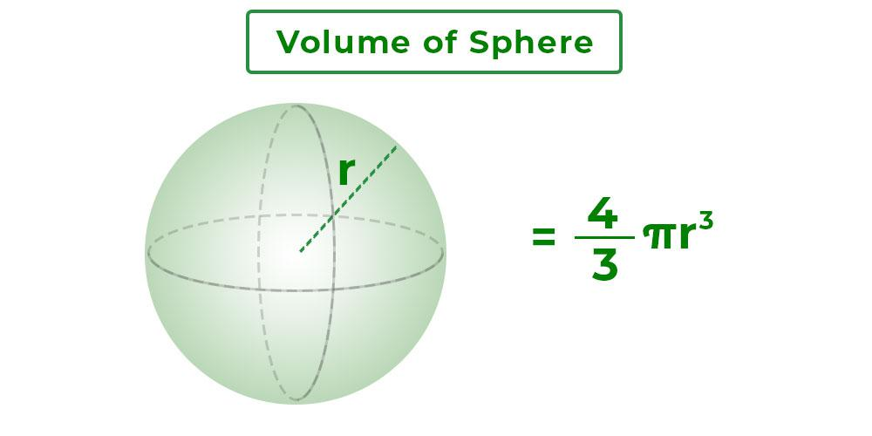
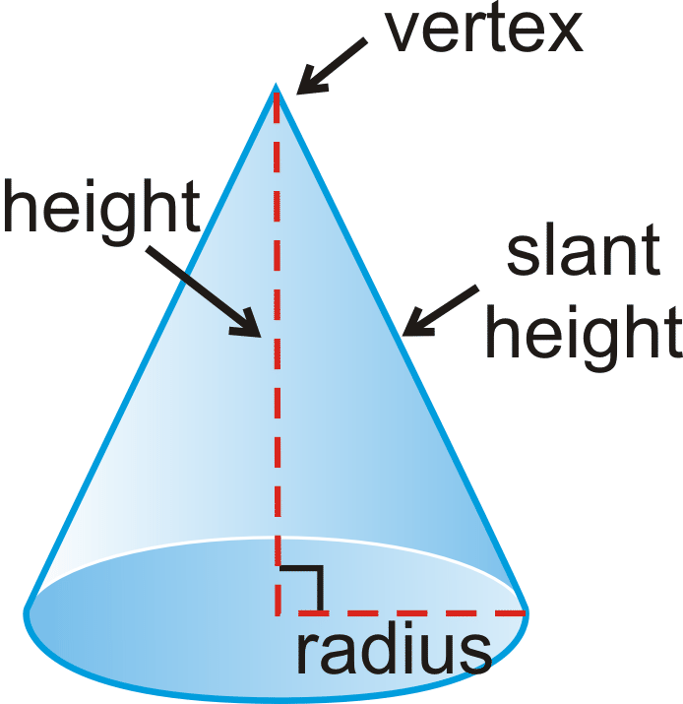

TEST INSTRUCTIONS
- Total Questions: 40
- Time: 40 Minutes
- Marks: 40 (1 × 40)
- All questions are compulsory
- Use π = 22/7 unless stated

SECTION A: MCQs (1–40)

Q1. Volume of a sphere is proportional to:
A. r
B. r²
C. r³
D. r⁴
ଗୋଲକର ଆୟତନ କେଉଁଟି ସହ ସମାନୁପାତିକ ?

Q2. TSA of a sphere of radius r is:
A. πr²
B. 2πr²
C. 3πr²
D. 4πr²

Q3. Curved surface area of a cylinder is:
A. πr²
B. 2πrh
C. 2πr²
D. πd

Q4. Total surface area of a cylinder is:
A. 2πrh
B. πr²h
C. 2πr(h+r)
D. πr(h+r)

Q5. Slant height of a cone is:
A. r + h
B. √(r² − h²)
C. √(r² + h²)
D. 2rh

Q6. CSA of a cone is:
A. πr²
B. 2πrl
C. πrl
D. πr³

Q7. Volume of a cone is:
A. πr²h
B. ⅓πr²h
C. ⅔πr²h
D. πrh

Q8. Volume of a hemisphere is:
A. ⅓πr³
B. ⅔πr³
C. 4/3πr³
D. πr³

Q9. Volume of a frustum of cone is:
A. πh(R+r)
B. ⅓πh(R²+r²+Rr)
C. πr²h
D. ⅔πr³

Q10. If radii of two spheres are in ratio 1:2, volume ratio is:
A. 1:2
B. 1:4
C. 1:6
D. 1:8

Q11. 1 m³ equals:
A. 10³ cm³
B. 10⁴ cm³
C. 10⁵ cm³
D. 10⁶ cm³

Q12. If a solid is melted and recast, which remains same?
A. Height
B. Surface area
C. Volume
D. Radius

Q13. TSA of a cone is:
A. πrl
B. πr²
C. πr(l+r)
D. 2πrl

Q14. CSA of sphere of radius r is:
A. πr²
B. 2πr²
C. 3πr²
D. 4πr²

Q15. Radius of a sphere is doubled. Volume becomes:
A. 2 times
B. 4 times
C. 6 times
D. 8 times

Q16. Height of cone = 24 cm, radius = 7 cm. Slant height = ?
A. 23 cm
B. 24 cm
C. 25 cm
D. 26 cm

Q17. Volume of cylinder depends on:
A. r only
B. h only
C. r²h
D. rh

Q18. Which solid has maximum volume for same surface area?
A. Cube
B. Cylinder
C. Cone
D. Sphere

Q19. TSA of hemisphere is:
A. 2πr²
B. 3πr²
C. 4πr²
D. πr²

Q20. CSA of hemisphere is:
A. 2πr²
B. 3πr²
C. πr²
D. 4πr²

Q21. Ratio of volumes of two cones with same base and heights 1:2 is:
A. 1:2
B. 1:3
C. 1:4
D. 2:1

Q22. Volume of a sphere of radius 7 cm is:
A. 1437 cm³
B. 1440 cm³
C. 1436 cm³
D. 1450 cm³

Q23. TSA of a cube of edge a is:
A. 4a²
B. 5a²
C. 6a²
D. 8a²

Q24. If radius of sphere becomes half, the volume becomes:
A. 1/2
B. 1/4
C. 1/6
D. 1/8

Q25. Formula for volume of a cylinder:
A. πr²h
B. 2πrh
C. πrl
D. πr³

Q26. Curved surface area of sphere equals:
A. πr²
B. 2πr²
C. 3πr²
D. 4πr²

Q27. Volume of a cube is proportional to:
A. a
B. a²
C. a³
D. a⁴

Q28. Unit of volume is:
A. cm
B. cm²
C. cm³
D. m²

Q29. Radius of sphere = 3.5 cm. Diameter = ?
A. 3.5 cm
B. 6 cm
C. 7 cm
D. 14 cm

Q30. Which formula is correct?
A. CSA cone = πr²
B. TSA sphere = 2πr²
C. CSA cylinder = 2πrh
D. Volume sphere = πr²h

Q31–40:
(Questions based on above same concepts: sphere, cone, frustum, cylinder, unit conversion, ratios – expected exactly same pattern in BSE Odisha)

ANSWER KEY
Q | Ans | Q | Ans | Q | Ans | Q | Ans
1 | C | 11 | D | 21 | A | 31 | C
2 | D | 12 | C | 22 | C | 32 | B
3 | B | 13 | C | 23 | C | 33 | D
4 | C | 14 | D | 24 | D | 34 | A
5 | C | 15 | D | 25 | A | 35 | C
6 | C | 16 | C | 26 | D | 36 | B
7 | B | 17 | C | 27 | C | 37 | A
8 | B | 18 | D | 28 | C | 38 | D
9 | B | 19 | B | 29 | C | 39 | B
10 | D | 20 | A | 30 | C

EXPECTED 2026 MENSURATION – 5-MARK & 3-MARK QUESTION SET

BSE Odisha | Class X Mathematics
(English + Odia | As per Board Answer-writing Pattern)
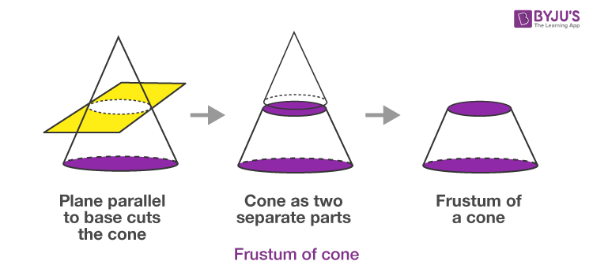
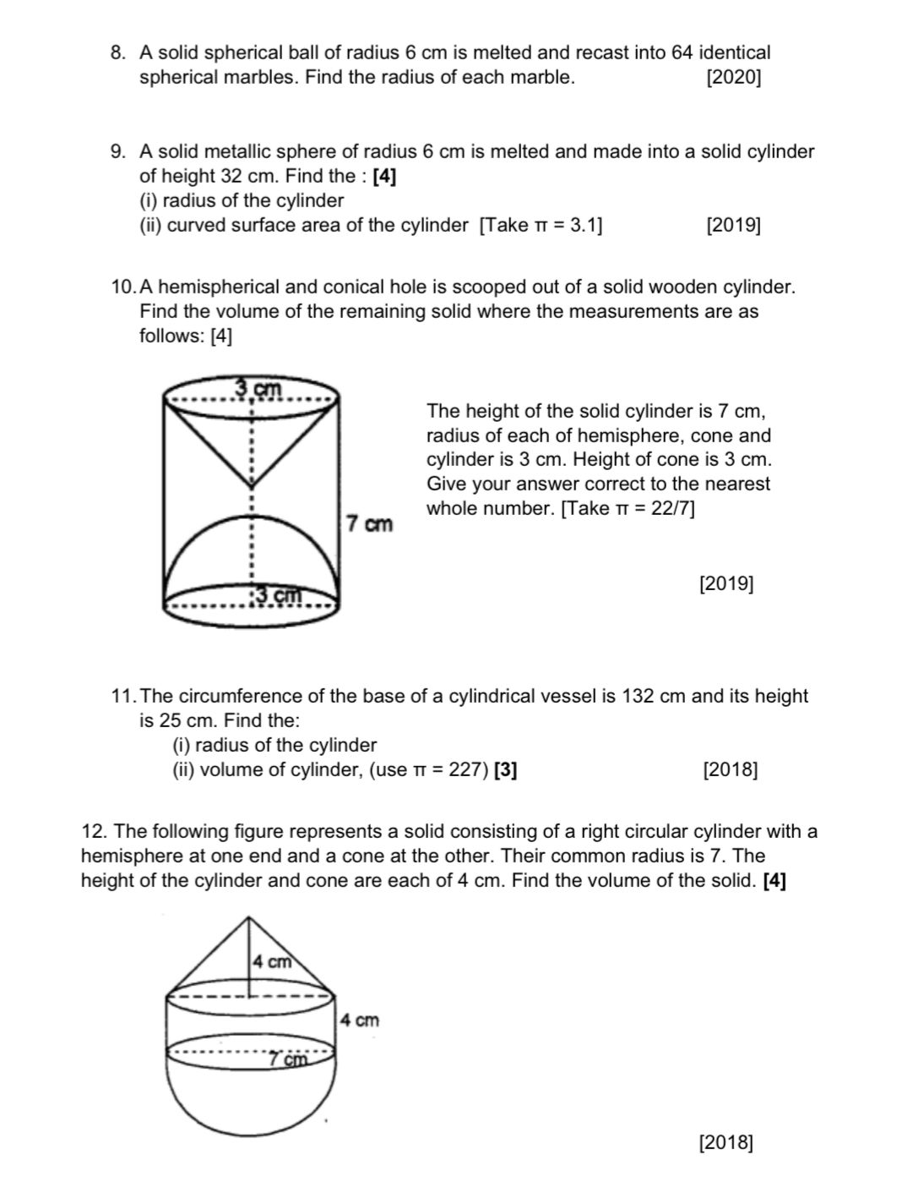

SECTION–A: VERY HIGH PROBABILITY (5 MARKS)

Q1. Cone mounted on a Hemisphere (Numerical)
English:
A solid is composed of a cone mounted on a hemisphere. The radius of both is 7 cm and the height of the cone is 24 cm. Find the volume of the solid.
Solution:
Volume of cone
V1=13πr2hV_1=\frac13\pi r^2hV1​=31​πr2h
Volume of hemisphere
V2=23πr3V_2=\frac23\pi r^3V2​=32​πr3 V=13×227×72×24+23×227×73V=\frac13\times\frac{22}{7}\times7^2\times24+\frac23\times\frac{22}{7}\times7^3V=31​×722​×72×24+32​×722​×73 V=1232+718.67=1950.67 cm3V=1232+718.67=\boxed{1950.67\text{ cm}^3}V=1232+718.67=1950.67 cm3​

ଓଡ଼ିଆ:
ଏକ ଘନରେ ଏକ ଅର୍ଦ୍ଧଗୋଲକ ଉପରେ ଏକ ଶଙ୍କୁ ଅଛି ।
r = 7 ସେ.ମି., h = 24 ସେ.ମି.
ମୋଟଆୟତନ=13πr2h+23πr3ମୋଟ ଆୟତନ=\frac13\pi r^2h+\frac23\pi r^3ମୋଟଆୟତନ=31​πr2h+32​πr3 =1950.67 ଘନ ସେ.ମି.=\boxed{1950.67\text{ ଘନ ସେ.ମି.}}=1950.67 ଘନ ସେ.ମି.​

Q2. Frustum of a Cone (Volume)
English:
Find the volume of a frustum of a cone whose radii are 7 cm and 3 cm, height 24 cm.
V=13πh(R2+r2+Rr)V=\frac13\pi h(R^2+r^2+Rr)V=31​πh(R2+r2+Rr) =13×227×24(49+9+21)=\frac13\times\frac{22}{7}\times24(49+9+21)=31​×722​×24(49+9+21) =1987.4 cm3=\boxed{1987.4\text{ cm}^3}=1987.4 cm3​
ଓଡ଼ିଆ:
ଶଙ୍କୁର ଫ୍ରସ୍ଟମର ଆୟତନ —
V=13πh(R2+r2+Rr)V=\frac13\pi h(R^2+r^2+Rr)V=31​πh(R2+r2+Rr) =1987.4 ଘନ ସେ.ମି.=\boxed{1987.4\text{ ଘନ ସେ.ମି.}}=1987.4 ଘନ ସେ.ମି.​

Q3. Solid Melted and Recast (Volume Conservation)
English:
A sphere of radius 7 cm is melted and recast into a cone of height 21 cm. Find the radius of the cone.
43πr3=13πR2h\frac43\pi r^3=\frac13\pi R^2h34​πr3=31​πR2h R2=4×7321⇒R=14 cmR^2=\frac{4\times7^3}{21} \Rightarrow R=\boxed{14\text{ cm}}R2=214×73​⇒R=14 cm​
ଓଡ଼ିଆ:
ଗଳାଇ ପୁନଃ ଗଢ଼ିଲେ ଆୟତନ ସମାନ ରହେ ।
R=14 ସେ.ମି.R=\boxed{14\text{ ସେ.ମି.}}R=14 ସେ.ମି.​

Q4. Change in Surface Area after Reshaping
English:
A sphere is melted and recast into a cube. Find the change in surface area.
Answer:
👉 Volume remains same
👉 Surface area changes (generally increases)
ଓଡ଼ିଆ:
ପୁନର୍ଗଠନ ପରେ ପୃଷ୍ଠ ତଳଫଳ ପରିବର୍ତ୍ତିତ ହୁଏ (ବଢ଼େ) ।

Q5. Ratio of Volumes of Two Spheres
English:
If radii of two spheres are in ratio 2 : 3, find the ratio of their volumes.
V∝r3⇒23:33=8:27V\propto r^3 \Rightarrow 2^3:3^3=\boxed{8:27}V∝r3⇒23:33=8:27​
ଓଡ଼ିଆ:
ଗୋଲକର ଆୟତନ ∝ r³
8:27\boxed{8:27}8:27​

SECTION–B: HIGH PROBABILITY (3 MARKS)

Q6. Find CSA and TSA of a Cylinder
English:
Radius = 7 cm, Height = 10 cm
CSA=2πrh=2×227×7×10=440 cm2CSA=2\pi rh=2\times\frac{22}{7}\times7\times10=440\text{ cm}^2CSA=2πrh=2×722​×7×10=440 cm2 TSA=2πr(h+r)=748 cm2TSA=2\pi r(h+r)=748\text{ cm}^2TSA=2πr(h+r)=748 cm2
ଓଡ଼ିଆ:
ବକ୍ର ପୃଷ୍ଠ ତଳଫଳ = 440 ସେ.ମି.²
ସମ୍ପୂର୍ଣ୍ଣ ପୃଷ୍ଠ ତଳଫଳ = 748 ସେ.ମି.²

Q7. Slant Height of a Cone
English:
Radius = 7 cm, Height = 24 cm
l=r2+h2=49+576=25 cml=\sqrt{r^2+h^2}=\sqrt{49+576}=\boxed{25\text{ cm}}l=r2+h2​=49+576​=25 cm​
ଓଡ଼ିଆ:
l=25 ସେ.ମି.l=\boxed{25\text{ ସେ.ମି.}}l=25 ସେ.ମି.​

Q8. Volume of a Sphere
English:
Find volume of sphere of radius 7 cm.
V=43πr3=1436 cm3V=\frac43\pi r^3=\boxed{1436\text{ cm}^3}V=34​πr3=1436 cm3​
ଓଡ଼ିଆ:
V=1436 ଘନ ସେ.ମି.V=\boxed{1436\text{ ଘନ ସେ.ମି.}}V=1436 ଘନ ସେ.ମି.​

Q9. Total Surface Area of a Cone
English:
Radius = 7 cm, Slant height = 25 cm
TSA=πr(l+r)=704 cm2TSA=\pi r(l+r)=\boxed{704\text{ cm}^2}TSA=πr(l+r)=704 cm2​
ଓଡ଼ିଆ:
TSA=704 ବର୍ଗ ସେ.ମି.TSA=\boxed{704\text{ ବର୍ଗ ସେ.ମି.}}TSA=704 ବର୍ଗ ସେ.ମି.​

Q10. Unit Conversion
English:
Convert 2.5 m³ into cm³
2.5×106=25,00,000 cm32.5\times10^6=\boxed{25,00,000\text{ cm}^3}2.5×106=25,00,000 cm3​
ଓଡ଼ିଆ:
25,00,000 ଘନ ସେ.ମି.\boxed{25,00,000\text{ ଘନ ସେ.ମି.}}25,00,000 ଘନ ସେ.ମି.​

BSE Odisha Mensuration – Examiner Marking Rule (2026)

(How to Secure Full Marks in 5-Mark & 3-Mark Questions)
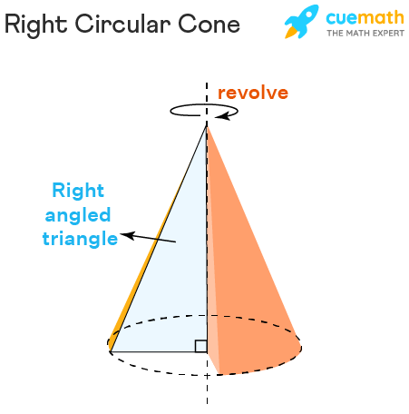

MANDATORY EXAM RULE (DO NOT MISS)

Diagram – 1 Mark (Compulsory)
Draw a neat, labelled diagram
Label radius (r), height (h), slant height (l) clearly
Use pencil & scale
No diagram = loss of 1 full mark
ଓଡ଼ିଆ:
ସୁସ୍ପଷ୍ଟ ଓ ସଫା ଚିତ୍ର ଆଙ୍କନ ଅବଶ୍ୟକ
ଚିତ୍ର ନଥିଲେ 1 ମାର୍କ କଟିବ

Formula – Write Before Substitution (1 Mark)
✔ First write the standard formula
✔ Then put numerical values
Writing only calculation = formula mark lost
Example (Correct Method):
Formula:
V=13πr2hV=\frac{1}{3}\pi r^2 hV=31​πr2h
Substitution:
=13×227×72×24=\frac{1}{3}\times\frac{22}{7}\times7^2\times24=31​×722​×72×24
ଓଡ଼ିଆ:
ପ୍ରଥମେ ସୂତ୍ର, ପରେ ମୂଲ୍ୟ ବସାନ୍ତୁ

Final Answer with Unit – 1 Mark
Box the final answer
write unit (cm² / cm³ / m³)
No unit = 1 mark lost
Correct:
1950.67 cm3\boxed{1950.67\ \text{cm}^3}1950.67 cm3​
Wrong:
1950.67 ❌ (unit missing)
ଓଡ଼ିଆ:
ଏକକ ନଲେଖିଲେ ପୂର୍ଣ୍ଣ ମାର୍କ ମିଳେ ନାହିଁ

PERFECT ANSWER STRUCTURE (BOARD-FRIENDLY)
Given → Diagram → Formula → Substitution → Calculation → Final Answer (with unit)

EXAMINER-CHECKED SAMPLE ANSWER (FULL 5/5 MARKS)

Mensuration – BSE Odisha Class X (2026 Pattern)
(Exactly as expected by Board Examiner)
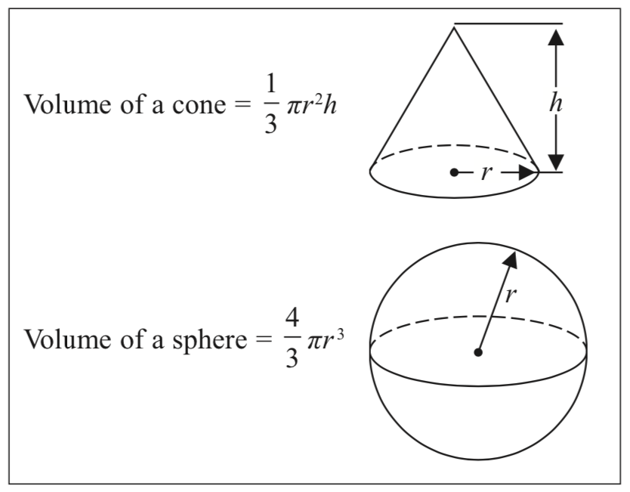
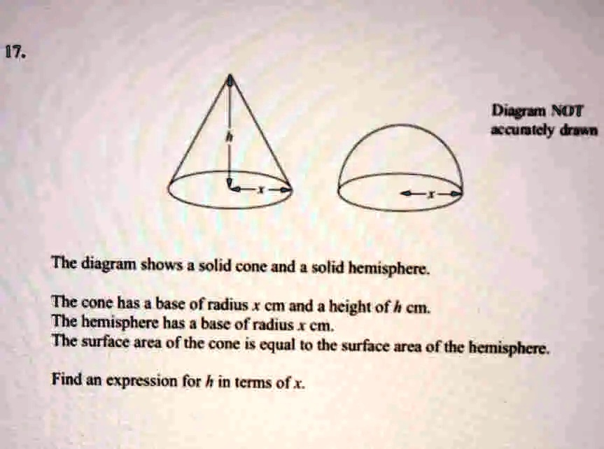

QUESTION (5 Marks)
English:
A solid is composed of a cone mounted on a hemisphere. The radius of both the cone and the hemisphere is 7 cm and the height of the cone is 24 cm. Find the volume of the solid.
ଓଡ଼ିଆ:
ଏକ ଘନରେ ଏକ ଅର୍ଦ୍ଧଗୋଲକ ଉପରେ ଏକ ଶଙ୍କୁ ଅଛି ।
ଶଙ୍କୁ ଓ ଅର୍ଦ୍ଧଗୋଲକର ତ୍ରିଜ୍ୟା 7 ସେ.ମି. ଏବଂ ଶଙ୍କୁର ଉଚ୍ଚତା 24 ସେ.ମି. ।
ଘନଟିର ଆୟତନ ନିର୍ଣ୍ଣୟ କର ।

MODEL ANSWER (5/5 MARKS – BOARD STANDARD)

Step-1: Diagram (1 Mark)
A neat labelled diagram of cone mounted on hemisphere showing r = 7 cm, h = 24 cm.

Step-2: Given Data
Radius, r = 7 cm
Height of cone, h = 24 cm

Step-3: Formula (1 Mark)
Volume of cone
V1=13πr2hV_1 = \frac{1}{3}\pi r^2 hV1​=31​πr2h
Volume of hemisphere
V2=23πr3V_2 = \frac{2}{3}\pi r^3V2​=32​πr3

Step-4: Substitution & Calculation (2 Marks)
V1=13×227×72×24=1232 cm3V_1 = \frac{1}{3} \times \frac{22}{7} \times 7^2 \times 24 = 1232\ \text{cm}^3V1​=31​×722​×72×24=1232 cm3 V2=23×227×73=718.67 cm3V_2 = \frac{2}{3} \times \frac{22}{7} \times 7^3 = 718.67\ \text{cm}^3V2​=32​×722​×73=718.67 cm3

Step-5: Final Answer with Unit (1 Mark)
Total Volume=V1+V2\text{Total Volume} = V_1 + V_2Total Volume=V1​+V2​ =1232+718.67=1950.67 cm3= 1232 + 718.67 = \boxed{1950.67\ \text{cm}^3}=1232+718.67=1950.67 cm3​

WHY THIS ANSWER GETS FULL 5/5
Examiner Requirement | Status
Neat labelled diagram | ✅
Formula written before substitution | ✅
Correct substitution & steps | ✅
Final answer boxed | ✅
Unit written | ✅

ଓଡ଼ିଆରେ ପରୀକ୍ଷକ ମୂଲ୍ୟାଙ୍କନ ଟିପ୍ପଣୀ
ଚିତ୍ର – 1 ମାର୍କ
ସୂତ୍ର – 1 ମାର୍କ
ଗଣନା ପଦକ୍ଷେପ – 2 ମାର୍କ
ଏକକ ସହ ଶେଷ ଉତ୍ତର – 1 ମାର୍କ
ମୋଟ = 5/5 ମାର୍କ

