Geometry – Chapter 6 | Class X | BSE Odisha

6.1 Introduction | ପରିଚୟ

English
Construction is the method of drawing accurate geometrical figures using ruler, compass and protractor. This chapter focuses on constructing triangles, circles, tangents, regular figures, and dividing line segments based on given conditions.

ଓଡ଼ିଆ
(Construction) ମାନେ ରୁଲର, କମ୍ପାସ ଓ ପ୍ରୋଟ୍ରାକ୍ଟର ସହାୟତାରେ ନିର୍ଦ୍ଦିଷ୍ଟ ନିୟମ ଅନୁସାରେ ନିଖୁତ ଆକୃତି ଅଙ୍କନ। ଏହି ଅଧ୍ୟାୟରେ ତ୍ରିଭୁଜ, ବୃତ୍ତ, ସ୍ପର୍ଶକ, ନିୟମିତ ଆକୃତି ଓ ରେଖାଖଣ୍ଡ ବିଭାଜନ ରହିଛି।

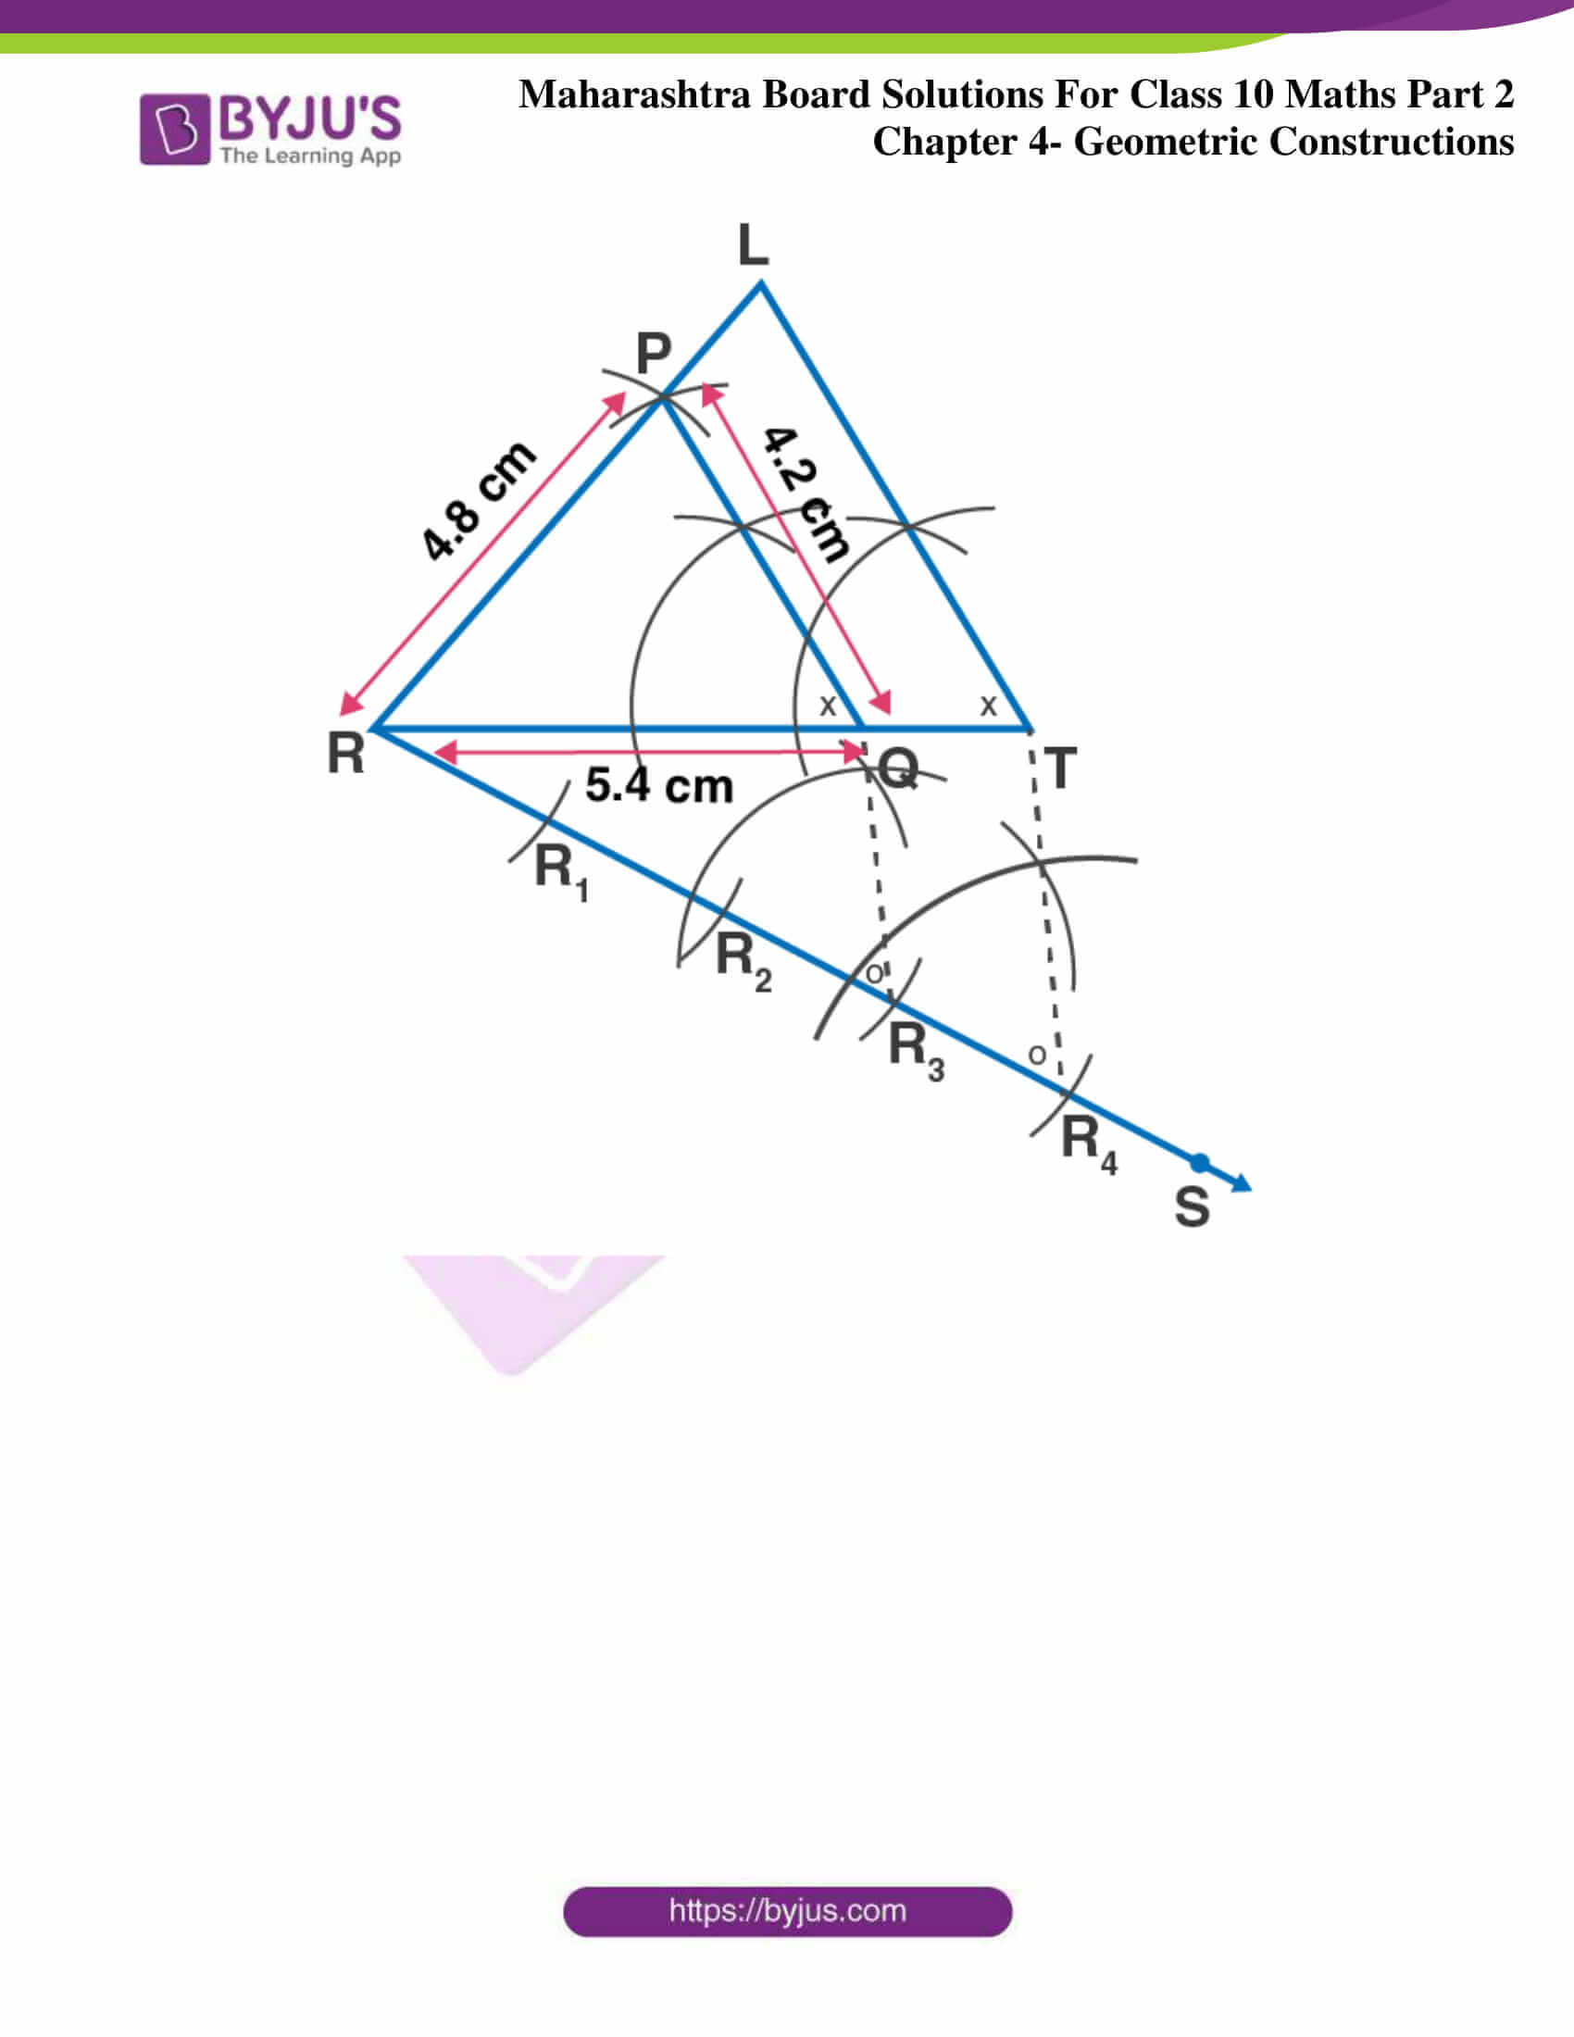
6.2 Construction–1
Circumcircle of a Triangle
(Given one side and the angle opposite to it)
ଏକ ବାହୁ ଓ ସମ୍ମୁଖ କୋଣ ଦିଆଯାଇଥିଲେ ପରିବୃତ୍ତ
Idea | ଧାରଣା
The centre of the circumcircle is found using the relation between the central angle and the inscribed angle.
Steps (English)
- Draw the given side BCBCBC.
- Construct the given angle at the appropriate vertex.
- Find the centre OOO using angle relations.
- With OOO as centre and radius OBOBOB, draw the circle.
ପଦକ୍ରମ (ଓଡ଼ିଆ)
- ଦିଆଯାଇଥିବା ବାହୁ BCBCBC ଅଙ୍କନ।
- ଦିଆଯାଇଥିବା କୋଣ ଅଙ୍କନ।
- କୋଣ ସମ୍ବନ୍ଧରୁ କେନ୍ଦ୍ର OOO ନିର୍ଣ୍ଣୟ।
- OOO କେନ୍ଦ୍ର ଓ OBOBOB ତ୍ରଜ୍ଜ୍ୟା ନେଇ ବୃତ୍ତ ଅଙ୍କନ।

6.3 Construction–2

Tangent to a Circle at a Given Point

ଦିଆଯାଇଥିବା ବିନ୍ଦୁରେ ବୃତ୍ତର ସ୍ପର୍ଶକ

Key Fact | ମୁଖ୍ୟ ସତ୍ୟ
The tangent at any point on a circle is perpendicular to the radius at that point.

Steps (English)

- Draw the circle and mark the point PPP.
- Join centre OOO with PPP.
- Draw a line perpendicular to OPOPOP at PPP.
→ Required tangent.
ଓଡ଼ିଆ
- ବୃତ୍ତ ଓ PPP ବିନ୍ଦୁ ଚିହ୍ନଟ।
- OPOPOP ଅଙ୍କନ।
- PPP ରେ OPOPOP ପ୍ରତି ଲମ୍ବ ରେଖା → ସ୍ପର୍ଶକ।
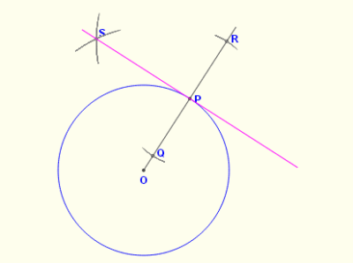
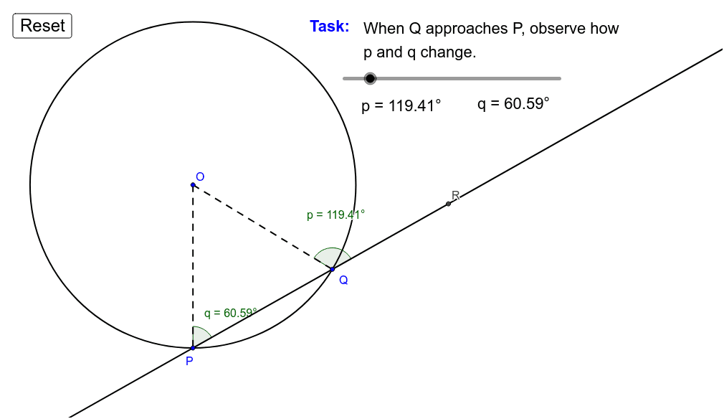

6.4 Construction–3
Tangents from an External Point to a Circle
ବୃତ୍ତର ବାହାରୁ ସ୍ପର୍ଶକ

Steps (English)

- Join the external point with centre.
- Draw a circle with midpoint as centre.
- Join points of contact → two tangents.
ଓଡ଼ିଆ
- ବାହ୍ୟ ବିନ୍ଦୁ ଓ କେନ୍ଦ୍ରକୁ ଯୋଡ଼।
- ମଧ୍ୟବିନ୍ଦୁ କେନ୍ଦ୍ରରେ ନୂତନ ବୃତ୍ତ।
- ସ୍ପର୍ଶ ବିନ୍ଦୁଗୁଡ଼ିକୁ ଯୋଡ଼ → 2 ସ୍ପର୍ଶକ।
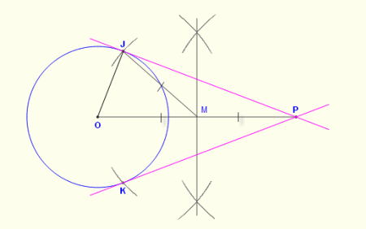
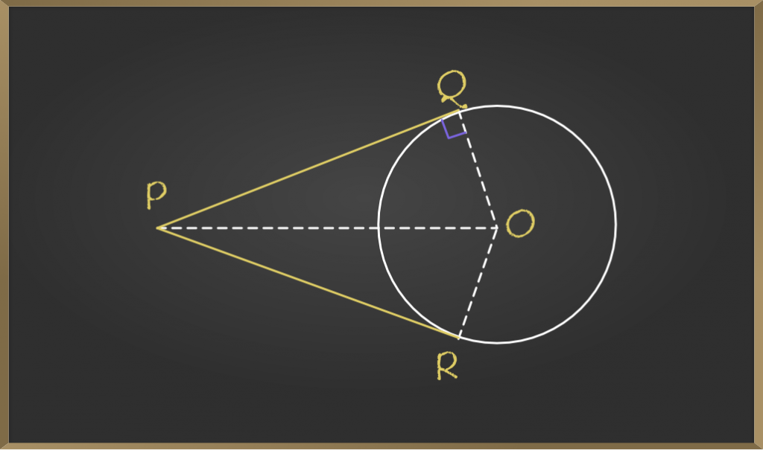

6.5 Construction–4
Inscribing in a Circle

(Equilateral Triangle, Square, Regular Hexagon)
ବୃତ୍ତ ଭିତରେ ନିୟମିତ ଆକୃତି
Key Angles | କେନ୍ଦ୍ରୀୟ କୋଣ
- Equilateral Triangle → 120∘120^\circ120∘
- Square → 90∘90^\circ90∘
- Regular Hexagon → 60∘60^\circ60∘
Method (English)
Divide the circle using equal central angles and join successive points.
ପଦ୍ଧତି (ଓଡ଼ିଆ)
କେନ୍ଦ୍ରରେ ସମାନ କୋଣ ବାଣ୍ଟି ବିନ୍ଦୁଗୁଡ଼ିକୁ କ୍ରମରେ ଯୋଡ଼।
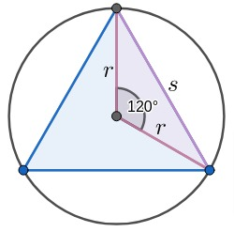
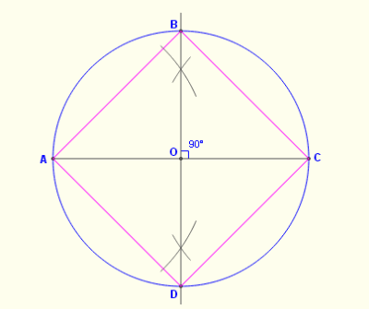
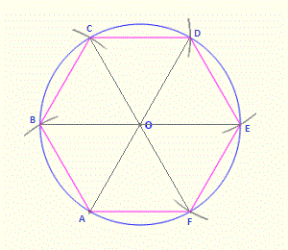

6.6 Construction–5
Circumscribing about a Circle
(Equilateral Triangle, Square, Regular Hexagon)
ବୃତ୍ତକୁ ଘେରି ଆକୃତି
Idea | ଧାରଣା
Draw tangents at equal angular intervals around the circle.
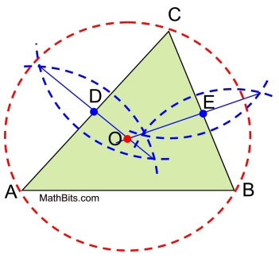
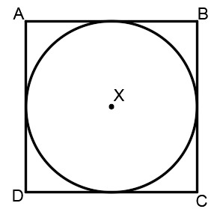

6.7 Construction–6
Circumcircle & Incircle of a Square
ବର୍ଗର ପରିବୃତ୍ତ ଓ ଅନ୍ତର୍ବୃତ୍ତ
- Circumcircle: Diagonals intersect at centre.
- Incircle: Perpendicular from centre to side gives radius.
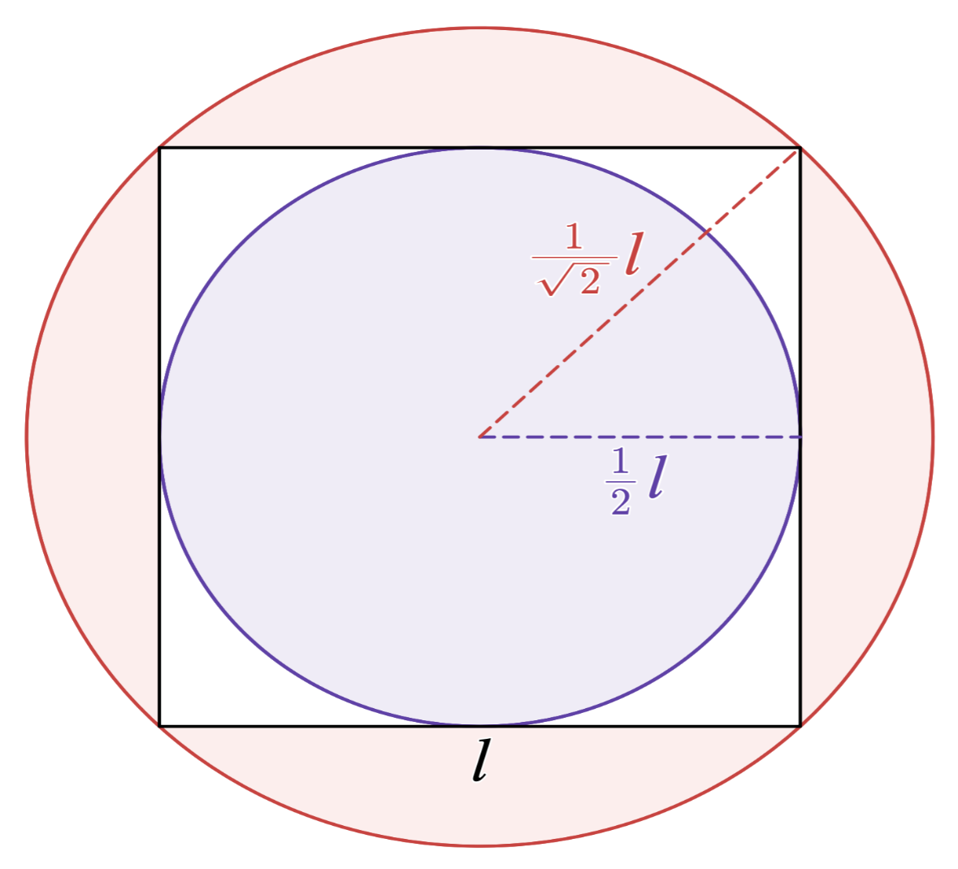

6.8 Construction–7
Division of a Line Segment
- Equal parts
- Given ratio (Internal & External)
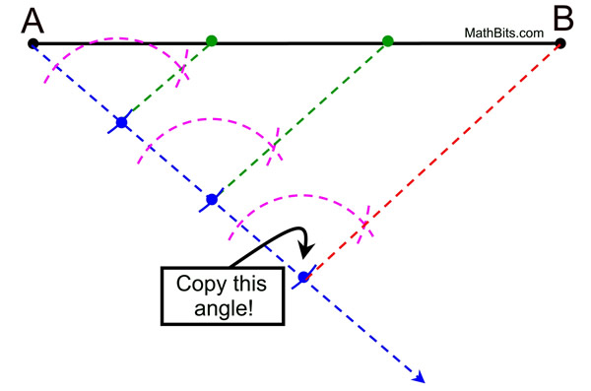
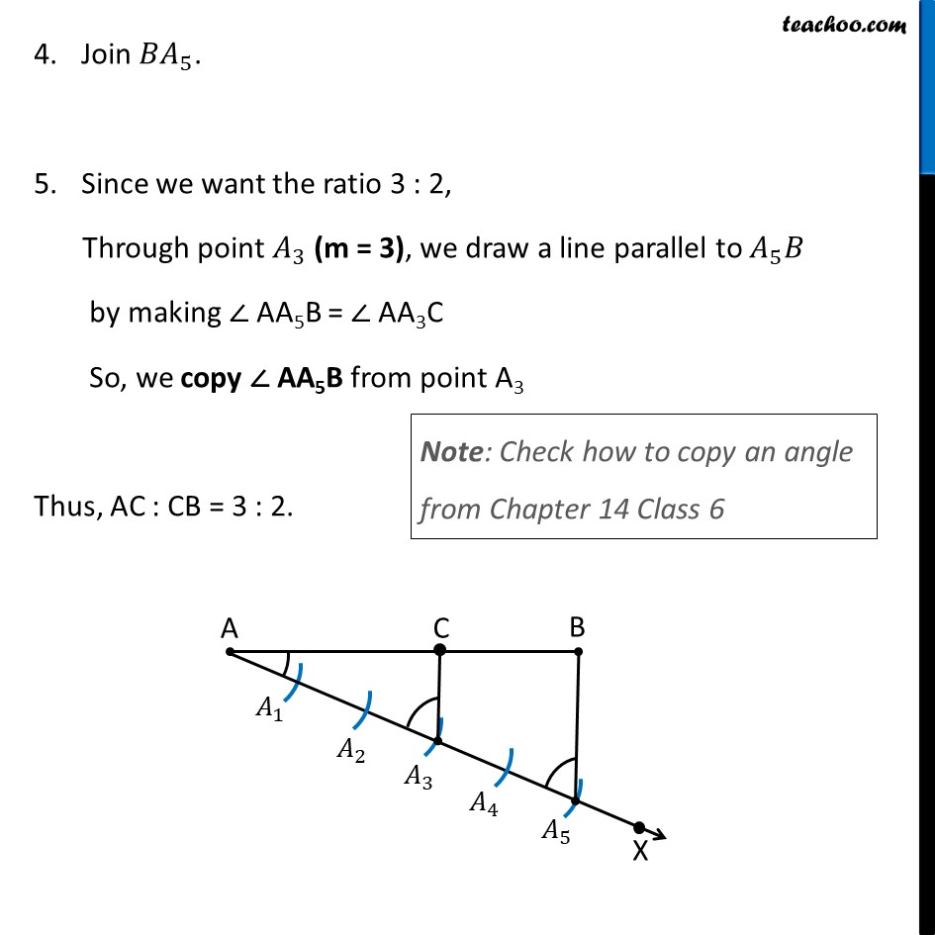
BOARD-PATTERN QUESTIONS (Examples)

VSA (2 Marks)

Q. State one property of tangent.
Ans: Tangent is perpendicular to radius at point of contact.
ଓଡ଼ିଆ: ସ୍ପର୍ଶକ ତ୍ରଜ୍ଜ୍ୟା ପ୍ରତି ଲମ୍ବ।

SA (3 Marks)

Q. Construct a tangent at a given point on a circle.
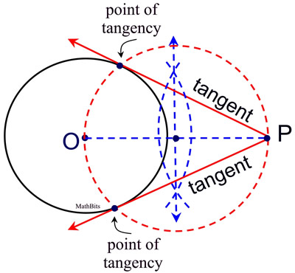

Given:
A circle with centre O and a point P on the circle.

Construction Steps:
- Join the centre O to the point P.
- Through point P, draw a line perpendicular to OP.
- The perpendicular line at P is the required tangent to the circle.

Reason (Write in exam):
A tangent at any point of a circle is perpendicular to the radius at the point of contact.

LA (5 Marks – Very Important)

Q. Construct a triangle when one side and the angle opposite to it are given and draw its circumcircle.
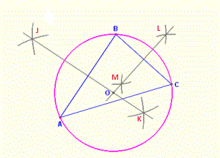

Given:
One side BC and the angle ∠A opposite to side BC.

Step–I: Construction of Triangle
- Draw the given line segment BC.
- At point B, draw a ray BX making an angle equal to ∠A with BC.
- At point C, draw a ray CY making the same angle ∠A with CB on the same side of BC.
- Let rays BX and CY intersect at point A.
- Join AB and AC.
→ ΔABC is the required triangle.

Step–II: Construction of Circumcircle
- Draw the perpendicular bisector of side AB.
- Draw the perpendicular bisector of side AC.
- Let them intersect at O (circumcentre).
- With O as centre and OA as radius, draw a circle passing through A, B, and C.

Result:
The circle drawn is the circumcircle of ΔABC.

Marking Tip (Examiner’s View):
Neat labelled diagram – 1 mark
Correct construction steps – 3 marks
Proper reason / result – 1 mark

