Geometry Chapter–1 (BSE Odisha):
SIMILARITY OF TRIANGLES
ଜ୍ୟାମିତି ଅଧ୍ୟାୟ–1 : ତ୍ରିଭୁଜର ସଦୃଶତା
(As prescribed by Board of Secondary Education Odisha)

CLASS X – GEOMETRY
CHAPTER–1 : SIMILARITY OF TRIANGLES
ତ୍ରିଭୁଜର ସଦୃଶତା

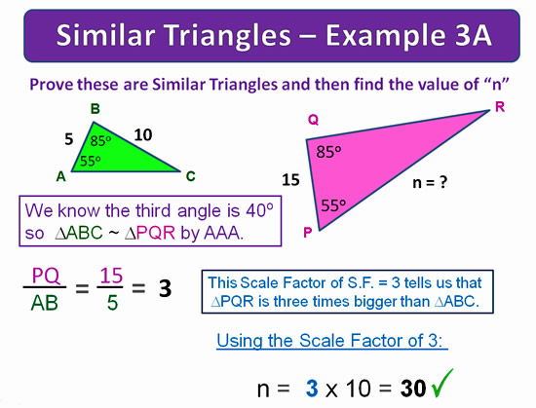
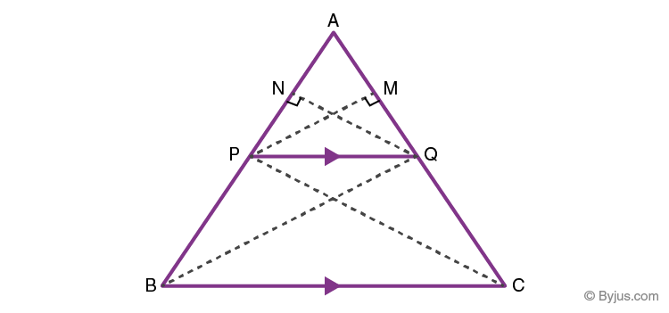
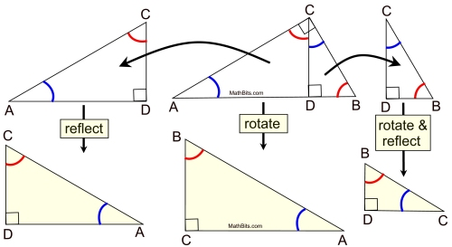

1. INTRODUCTION

Introduction | ପରିଚୟ

English

Two triangles are said to be similar if:
- Their corresponding angles are equal
- Their corresponding sides are in the same ratio
Similar triangles have the same shape but may differ in size.

ଓଡ଼ିଆ

ଦୁଇଟି ତ୍ରିଭୁଜକୁ ସଦୃଶ କୁହାଯାଏ ଯଦି—
- ସମ୍ବନ୍ଧିତ କୋଣଗୁଡ଼ିକ ସମାନ ହୁଏ
- ସମ୍ବନ୍ଧିତ ପାର୍ଶ୍ୱଗୁଡ଼ିକ ଏକେ ଅନୁପାତରେ ରହେ

2. CRITERIA FOR SIMILARITY
Conditions of Similarity | ସଦୃଶତାର ନିୟମ
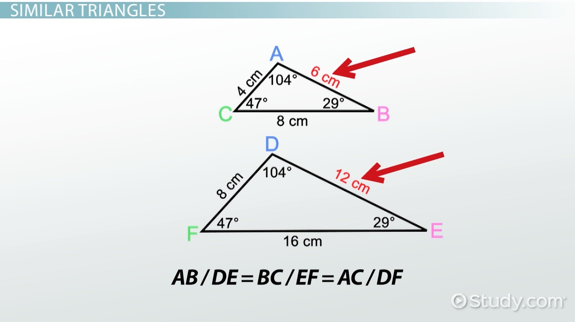
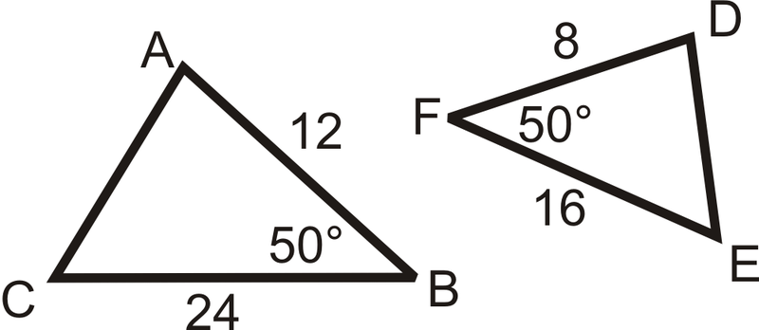
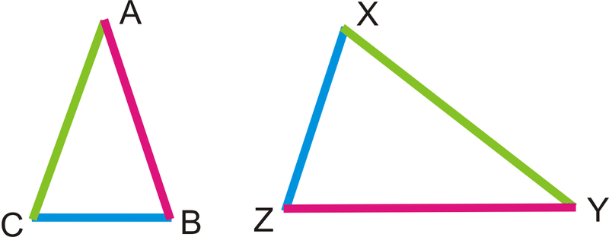

(A) AA Similarity Theorem
Angle–Angle Similarity | କୋଣ–କୋଣ ସଦୃଶତା
Statement (English)

If two angles of one triangle are equal to two angles of another triangle, then the triangles are similar.

ଓଡ଼ିଆ

ଯଦି ଦୁଇଟି ତ୍ରିଭୁଜର ଦୁଇଟି କୋଣ ସମାନ ହୁଏ, ତେବେ ସେମାନେ ସଦୃଶ।

Example
If ∠A = ∠D and ∠B = ∠E
⇒ ΔABC ~ ΔDEF

(B) SAS Similarity Theorem
Side–Angle–Side Similarity | ପାର୍ଶ୍ୱ–କୋଣ–ପାର୍ଶ୍ୱ

Statement

If two sides of one triangle are proportional to two sides of another triangle and the included angle is equal, then the triangles are similar.

ଓଡ଼ିଆ
ଦୁଇଟି ପାର୍ଶ୍ୱର ଅନୁପାତ ସମାନ ଏବଂ ମଧ୍ୟବର୍ତ୍ତୀ କୋଣ ସମାନ ହେଲେ, ତ୍ରିଭୁଜ ସଦୃଶ।

(C) SSS Similarity Theorem
Side–Side–Side Similarity | ପାର୍ଶ୍ୱ–ପାର୍ଶ୍ୱ–ପାର୍ଶ୍ୱ
Statement

If corresponding sides of two triangles are proportional, then the triangles are similar.
ଓଡ଼ିଆ
ତିନୋଟି ସମ୍ବନ୍ଧିତ ପାର୍ଶ୍ୱର ଅନୁପାତ ସମାନ ହେଲେ, ତ୍ରିଭୁଜ ସଦୃଶ।

3. BASIC PROPORTIONALITY THEOREM (BPT)
Thales Theorem | ଥେଲସ ନିୟମ
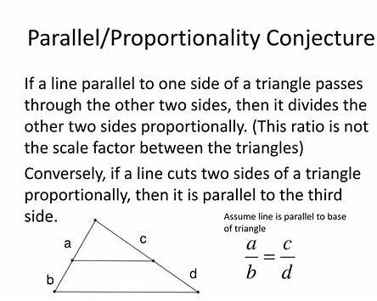

Statement (English)

If a line is drawn parallel to one side of a triangle, it divides the other two sides in the same ratio.

ଓଡ଼ିଆ

ଯଦି ତ୍ରିଭୁଜର ଗୋଟିଏ ପାର୍ଶ୍ୱ ସହ ସମାନ୍ତର ରେଖା ଅନ୍ୟ ଦୁଇ ପାର୍ଶ୍ୱକୁ କାଟେ, ତେବେ ସେମାନେ ସମାନ ଅନୁପାତରେ ବିଭକ୍ତ ହୁଅନ୍ତି।

Result
ADDB=AEEC\frac{AD}{DB} = \frac{AE}{EC}DBAD​=ECAE​

4. AREAS OF SIMILAR TRIANGLES
Area Relation | କ୍ଷେତ୍ରଫଳ ସମ୍ପର୍କ
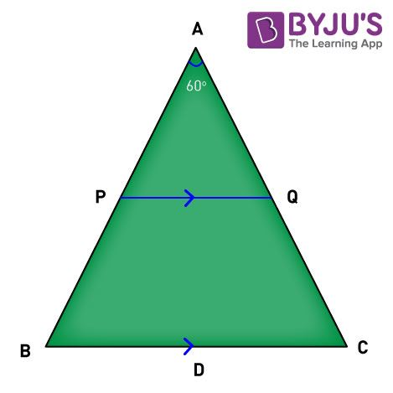
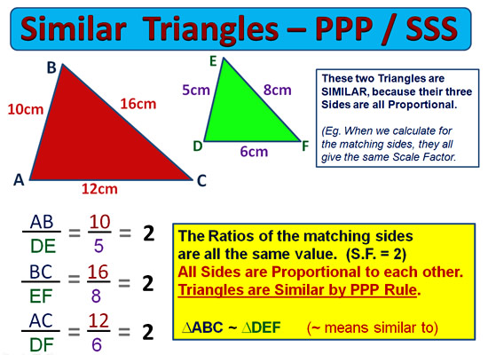
Formula
Area of △1Area of △2=(Side1Side2)2\frac{\text{Area of } \triangle 1}{\text{Area of } \triangle 2} = \left(\frac{\text{Side}_1}{\text{Side}_2}\right)^2Area of △2Area of △1​=(Side2​Side1​​)2
ଓଡ଼ିଆ
ସଦୃଶ ତ୍ରିଭୁଜର କ୍ଷେତ୍ରଫଳର ଅନୁପାତ =
(ସମ୍ବନ୍ଧିତ ପାର୍ଶ୍ୱର ଅନୁପାତ)²

Solved Example | ସମାଧାନ

Question
Ratio of sides = 3 : 5
Find area ratio.
Solution
(3:5)2=9:25(3:5)^2 = 9:25(3:5)2=9:25
Answer | ଉତ୍ତର: 9 : 25

5. RIGHT TRIANGLE & SIMILARITY
Special Case | ସମକୋଣ ତ୍ରିଭୁଜ
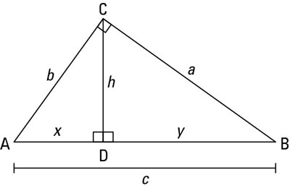
Statement
In a right triangle, the perpendicular drawn from the right angle to the hypotenuse divides the triangle into two smaller triangles which are similar to the original triangle.
ଓଡ଼ିଆ
ସମକୋଣ ତ୍ରିଭୁଜର କର୍ଣ୍ଣ ଉପରେ ଆଙ୍କା ଲମ୍ବ ଦ୍ୱାରା ଗଠିତ ଦୁଇ ତ୍ରିଭୁଜ ମୂଳ ତ୍ରିଭୁଜ ସହ ସଦୃଶ।

MOST REPEATED QUESTION (COMPULSORY – 5 MARKS)

Basic Proportionality Theorem (BPT)

ଥେଲସ୍ ସିଦ୍ଧାନ୍ତ
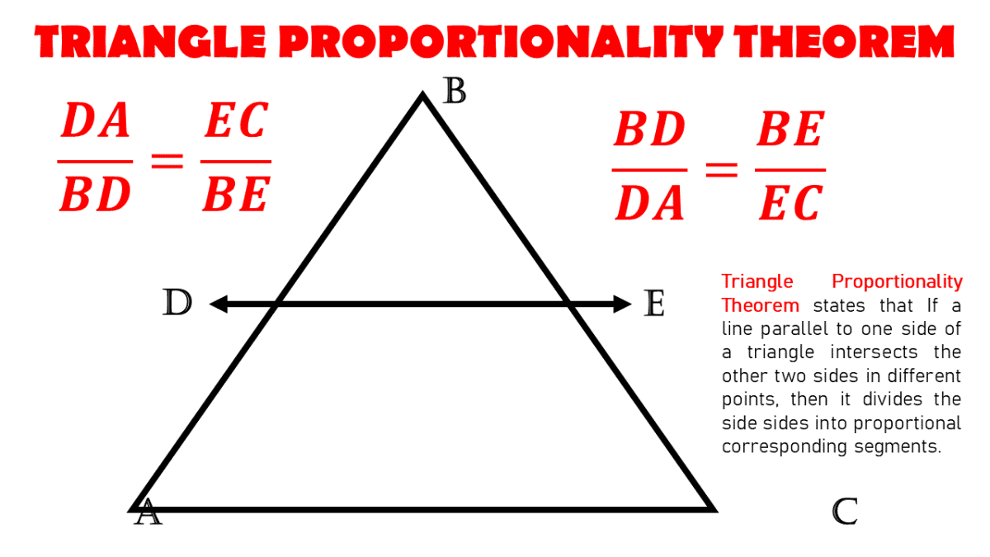

STATEMENT (English)
If a line is drawn parallel to one side of a triangle to intersect the other two sides, then it divides those sides in the same ratio.

ବକ୍ତବ୍ୟ (ଓଡ଼ିଆ)
ଯଦି ଗୋଟିଏ ତ୍ରିଭୁଜର ଗୋଟିଏ ପାର୍ଶ୍ୱ ସହ ସମାନ୍ତର ଏକ ରେଖା ଅନ୍ୟ ଦୁଇ ପାର୍ଶ୍ୱକୁ କାଟେ, ତେବେ ସେ ଦୁଇ ପାର୍ଶ୍ୱକୁ ସମାନ ଅନୁପାତରେ ବିଭାଜନ କରେ।

PREVIOUS-YEAR BOARD QUESTION (5 MARKS)

Question (English)
In ΔABC, a line DE is drawn parallel to BC intersecting AB and AC in D and E respectively.
Prove that
ADDB=AEEC\frac{AD}{DB}=\frac{AE}{EC}DBAD​=ECAE​

ପ୍ରଶ୍ନ (ଓଡ଼ିଆ)
ΔABC ରେ DE, BC ସହ ସମାନ୍ତର।
D ଓ E ବିନ୍ଦୁ AB ଓ AC ଉପରେ ଅବସ୍ଥିତ।
ପ୍ରମାଣ କର—
ADDB=AEEC\frac{AD}{DB}=\frac{AE}{EC}DBAD​=ECAE​

PROOF / ପ୍ରମାଣ (BOARD-PERFECT)

Construction / ନିର୍ମାଣ
DE ∥ BC, D ∈ AB, E ∈ AC

Proof (English)
Since DE ∥ BC,
∠ADE = ∠ABC (Corresponding angles)
∠AED = ∠ACB (Corresponding angles)
Therefore,
ΔADE ~ ΔABC (By AA similarity)
⇒ADAB=AEAC\Rightarrow \frac{AD}{AB}=\frac{AE}{AC}⇒ABAD​=ACAE​ ⇒ADDB=AEEC\Rightarrow \frac{AD}{DB}=\frac{AE}{EC}⇒DBAD​=ECAE​
Hence proved.

ପ୍ରମାଣ (ଓଡ଼ିଆ)
DE ∥ BC ଥିବାରୁ,
∠ADE = ∠ABC (ସମ୍ବନ୍ଧିତ କୋଣ)
∠AED = ∠ACB (ସମ୍ବନ୍ଧିତ କୋଣ)
ଏହେତୁ,
ΔADE ~ ΔABC (AA ସଦୃଶତା)
⇒ADAB=AEAC\Rightarrow \frac{AD}{AB}=\frac{AE}{AC}⇒ABAD​=ACAE​ ⇒ADDB=AEEC\Rightarrow \frac{AD}{DB}=\frac{AE}{EC}⇒DBAD​=ECAE​
ଏହା ପ୍ରମାଣିତ।

MARKING SCHEME (5 MARKS)
Step | Marks
Diagram | 1
Angle relation | 1
Similarity statement | 1
Ratio derivation | 1
Conclusion | 1

PREVIOUS-YEAR NUMERICAL (BPT APPLICATION – 5 MARKS)

Question (English)
In ΔABC, DE ∥ BC.
AD = 3 cm, DB = 5 cm and AE = x cm, EC = 10 cm.
Find x.

ପ୍ରଶ୍ନ (ଓଡ଼ିଆ)
ΔABC ରେ DE ∥ BC।
AD = 3 ସେ.ମି., DB = 5 ସେ.ମି., AE = x ସେ.ମି., EC = 10 ସେ.ମି.
x ର ମୂଲ୍ୟ ନିର୍ଣ୍ଣୟ କର।

Solution / ସମାଧାନ
By BPT,
ADDB=AEEC\frac{AD}{DB}=\frac{AE}{EC}DBAD​=ECAE​ 35=x10\frac{3}{5}=\frac{x}{10}53​=10x​ x=3×105=6x=\frac{3×10}{5}=6x=53×10​=6

Answer / ଉତ୍ତର: x = 6 cm

JAI HIND! BINAYA

