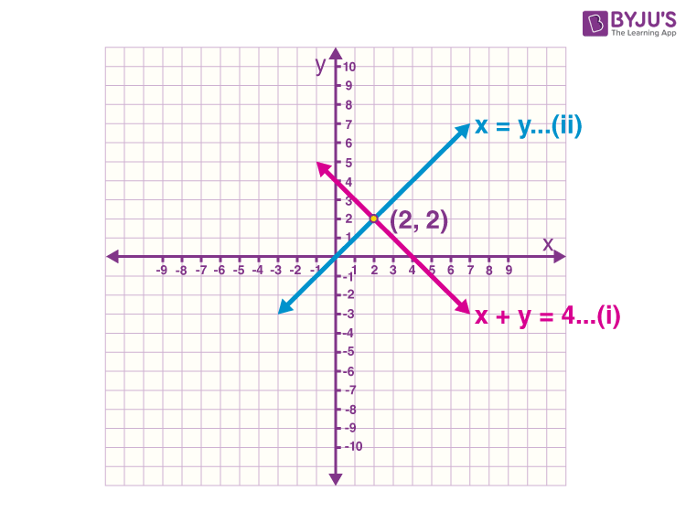
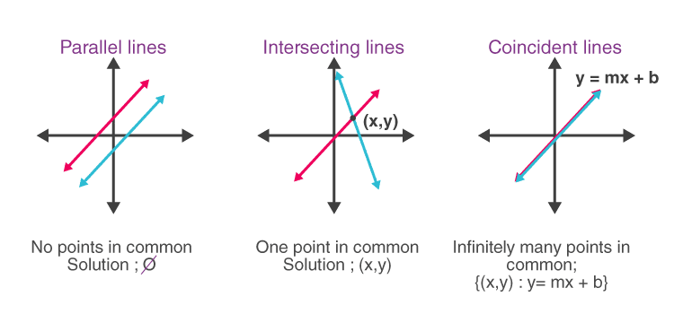
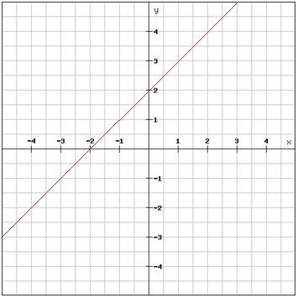

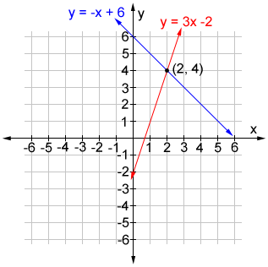

Chapter 1: Linear Simultaneous Equations

Introduction | ଅଧ୍ୟାୟ ପରିଚୟ

English:
Linear Simultaneous Equations form the foundation of coordinate geometry in Class 10 Mathematics.
ଓଡ଼ିଆ:
ରେଖୀୟ ସମକାଳୀନ ସମୀକରଣ ଦଶମ ଶ୍ରେଣୀ ଗଣିତର ଗୁରୁତ୍ୱପୂର୍ଣ୍ଣ ଅଧ୍ୟାୟ।
ଏଠାରେ ଦୁଇଟି ଚଳକ ଥିବା ସମୀକରଣ ଏବଂ ସେମାନଙ୍କର ଗ୍ରାଫିକାଲ ଉପସ୍ଥାପନ ବିଷୟରେ ଶିଖାଯାଏ।
ବୋର୍ଡ ପରୀକ୍ଷାରେ ଏହି ଅଧ୍ୟାୟ ଅଧିକ ମାର୍କ ଆଣିଦିଏ।

Linear Equation in Two Variables

(ଦୁଇ ଚଳକ ଥିବା ରେଖୀୟ ସମୀକରଣ)

English:
A linear equation in two variables is expressed as:
ax+by+c=0ax + by + c = 0ax+by+c=0
where a, b, c are real numbers and a ≠ 0, b ≠ 0.
Each equation represents a straight line on the coordinate plane.

ଓଡ଼ିଆ:
ଦୁଇଟି ଚଳକ ଥିବା ରେଖୀୟ ସମୀକରଣର ସାଧାରଣ ରୂପ—
ax+by+c=0ax + by + c = 0ax+by+c=0
ଯେଉଁଠାରେ a, b, c ବାସ୍ତବ ସଂଖ୍ୟା ଓ a ≠ 0, b ≠ 0।
ଏହା ଗ୍ରାଫରେ ଏକ ସରଳ ରେଖା ଦର୍ଶାଏ।

Graphical Solution Using Coordinate Geometry

(ସମନ୍ୱୟ ଜ୍ୟାମିତି ଦ୍ୱାରା ଗ୍ରାଫିକାଲ ସମାଧାନ)

English – Steps:
- Convert equation into y = mx + c form
- Find two solution points
- Plot points on graph paper
- Intersection point gives the solution

ଓଡ଼ିଆ – ପଦକ୍ରମ:
- ସମୀକରଣକୁ y = mx + c ରୂପରେ ପରିବର୍ତ୍ତନ କରନ୍ତୁ
- ଦୁଇଟି ସମାଧାନ ବିନ୍ଦୁ ନିର୍ଣ୍ଣୟ କରନ୍ତୁ
- ଗ୍ରାଫ ପେପରରେ ଅଙ୍କନ କରନ୍ତୁ
- ଯେଉଁଠାରେ ଦୁଇ ରେଖା କଟେ, ସେଠାରେ ସମାଧାନ ମିଳେ

Conditions of Solutions

(ସମାଧାନର ଅବସ୍ଥା)
Lines | Condition | Result | ଓଡ଼ିଆ ଅର୍ଥ
Intersecting | a₁/a₂ ≠ b₁/b₂ | One solution | ଏକ ନିଶ୍ଚିତ ସମାଧାନ
Parallel | a₁/a₂ = b₁/b₂ ≠ c₁/c₂ | No solution | କୌଣସି ସମାଧାନ ନାହିଁ
Coincident | a₁/a₂ = b₁/b₂ = c₁/c₂ | Infinite solutions | ଅସୀମ ସମାଧାନ

Key Learning Outcomes

English:
- Understand equations of the form ax + by + c = 0
- Solve equations graphically
- Identify unique, no solution, and infinite solution cases

ଓଡ଼ିଆ:
- ax + by + c = 0 ରୂପର ସମୀକରଣ ବୁଝିବା
- ଗ୍ରାଫ ମାଧ୍ୟମରେ ସମାଧାନ
- ସମାଧାନର ପ୍ରକାର ଚିହ୍ନଟ

Important MCQs (Board-Type)

MCQ-1:
If two lines intersect at one point, the system has:
A) No solution
B) Infinite solutions
C) One solution
D) Two solutions
Answer: C – One solution ଉତ୍ତର: ଏକ ନିଶ୍ଚିତ ସମାଧାନ

MCQ-2:
The graph of ax + by + c = 0 is always a:
A) Curve
B) Circle
C) Straight line
D) Triangle
Answer: C – Straight line ଉତ୍ତର: ସରଳ ରେଖା

MCQ-3:
Parallel lines represent:
A) One solution
B) No solution
C) Infinite solutions
D) Two solutions
Answer: B – No solution, ଉତ୍ତର: କୌଣସି ସମାଧାନ ନାହିଁ

Introduction to Linear Simultaneous Equations
A linear equation in two variables has the general form:
ax+by+c=0(a≠0,b≠0)ax + by + c = 0 \quad (a \neq 0, b \neq 0)ax+by+c=0(a=0,b=0)
Where:
- a, b → coefficients
- c → constant
- x, y → variables

Two linear equations together form a pair of simultaneous equations:
{a1x+b1y+c1=0a2x+b2y+c2=0\begin{cases} a_1x + b_1y + c_1 = 0 \\ a_2x + b_2y + c_2 = 0 \end{cases}{a1​x+b1​y+c1​=0a2​x+b2​y+c2​=0​

Geometrical Representation (Very Important for Board)
Each linear equation represents a straight line on the XY-plane.

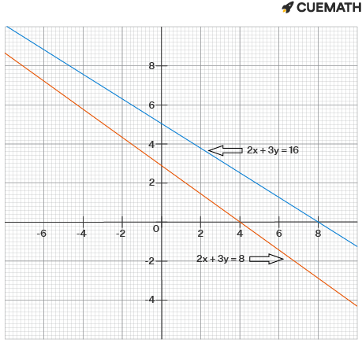

Graphical Problems – 4 to 5 Marks

Chapter 1: Linear Simultaneous Equations

Importance in Board Examination

(ବୋର୍ଡ ପରୀକ୍ଷାରେ ଗୁରୁତ୍ୱ)

English:
Graphical problems carry 4 to 5 marks in the BSE Odisha Class 10 Mathematics examination. These questions test:
- Conceptual clarity
- Accuracy of graph drawing
- Proper labeling and scale
- Correct identification of solution

ଓଡ଼ିଆ:
ଗ୍ରାଫିକାଲ ପ୍ରଶ୍ନଗୁଡ଼ିକ 4–5 ମାର୍କ ଆଣିଦିଏ।
ଏଥିରେ—
- ଧାରଣା ସ୍ପଷ୍ଟତା
- ଗ୍ରାଫ ଅଙ୍କନର ସଠିକତା
- ମାପ ଓ ଲେବେଲିଂ
- ସମାଧାନ ବିନ୍ଦୁର ଚିହ୍ନଟ
ମୂଲ୍ୟାୟନ କରାଯାଏ।

Standard Board Question Pattern

(ବୋର୍ଡ ପ୍ରଶ୍ନ ଢଞ୍ଚା)

English:
Solve the following pair of linear equations graphically and find the solution.

ଓଡ଼ିଆ:
ନିମ୍ନଲିଖିତ ଦୁଇଟି ରେଖୀୟ ସମୀକରଣକୁ ଗ୍ରାଫ ମାଧ୍ୟମରେ ସମାଧାନ କରନ୍ତୁ।

Step-wise Graphical Method

(ଧାପ ଧାପରେ ଗ୍ରାଫିକାଲ ପଦ୍ଧତି)

✔️ Step 1: Convert into y = mx + c form

English:
Rewrite both equations in slope-intercept form.

ଓଡ଼ିଆ:
ସମୀକରଣଗୁଡ଼ିକୁ y = mx + c ରୂପରେ ପରିବର୍ତ୍ତନ କରନ୍ତୁ।

Step 2: Find two solution points

English:
Substitute two values of x to get corresponding y values.

ଓଡ଼ିଆ:
x ର ଦୁଇଟି ମୂଲ୍ୟ ନେଇ y ର ମୂଲ୍ୟ ନିର୍ଣ୍ଣୟ କରନ୍ତୁ।

Step 3: Draw neat graph

English:
Plot the points accurately using proper scale.

ଓଡ଼ିଆ:
ଯଥାଯଥ ମାପ ବ୍ୟବହାର କରି ସଫା ଗ୍ରାଫ ଅଙ୍କନ କରନ୍ତୁ।

Step 4: Identify point of intersection

English:
The intersection point gives the required solution.

ଓଡ଼ିଆ:
ଦୁଇ ରେଖା ଯେଉଁଠାରେ କଟେ, ସେଇ ବିନ୍ଦୁ ହେଉଛି ସମାଧାନ।

Board-Level Solved Graphical Problem (5 Marks)

Question:
Solve graphically:
x+y=4andx−y=2x + y = 4 \quad \text{and} \quad x - y = 2x+y=4andx−y=2

English Solution:
Convert into y-form:
y=4−xandy=x−2y = 4 - x \quad \text{and} \quad y = x - 2y=4−xandy=x−2
x | y (Eqn 1) | y (Eqn 2)
2 | 2 | 0
4 | 0 | 2
After plotting, both lines intersect at (3, 1).
✔️ Required Solution:
x=3,y=1x = 3,\quad y = 1x=3,y=1

ଓଡ଼ିଆ ସମାଧାନ:
ସମୀକରଣକୁ y ରୂପରେ ଲେଖିବା—
y=4−xଓy=x−2y = 4 - x \quad \text{ଓ} \quad y = x - 2y=4−xଓy=x−2
ଗ୍ରାଫ ଅଙ୍କନ କଲେ ଦୁଇ ରେଖା (3,1) ବିନ୍ଦୁରେ କଟେ।
✔️ ସମାଧାନ:
x=3,y=1x = 3,\quad y = 1x=3,y=1

Types of Graphical Results (Very Important)

Graph Type | Result | Marks Impact
Intersecting Lines | One solution | Full marks
Parallel Lines | No solution | Concept-based
Coincident Lines | Infinite solutions | High scorer

Common Mistakes to Avoid

(ସାଧାରଣ ଭୁଲ)
- Wrong scale
Improper labeling of axes
Incomplete graph
No final answer written
- ସଠିକ ମାପ ବ୍ୟବହାର କରନ୍ତୁ
X ଓ Y ଧୁରା ଲେବେଲ କରନ୍ତୁ
ସମାଧାନ ବିନ୍ଦୁ ସ୍ପଷ୍ଟ ଦର୍ଶାନ୍ତୁ

Examiner’s Tip (Marks Booster)
Neat graph = +1 mark advantage
Clear intersection point = Full marks
Box the final answer
ସଫା ଗ୍ରାଫ ଅଙ୍କନ କଲେ ଅଧିକ ମାର୍କ ମିଳେ

Question 1 (5 Marks) — Intersecting Lines

English:
Solve graphically:
x+y=4,x−y=2x + y = 4,\quad x - y = 2x+y=4,x−y=2

Odia:
ନିମ୍ନଲିଖିତ ସମୀକରଣଗୁଡ଼ିକୁ ଗ୍ରାଫ ମାଧ୍ୟମରେ ସମାଧାନ କରନ୍ତୁ—
x+y=4,x−y=2x + y = 4,\quad x - y = 2x+y=4,x−y=2

Solution:
Convert to yyy-form:
y=4−x,y=x−2y = 4 - x,\quad y = x - 2y=4−x,y=x−2
x | y (Eqn 1) | y (Eqn 2)
2 | 2 | 0
4 | 0 | 2
Intersection: (3,1)(3,1)(3,1)
Answer / ଉତ୍ତର: x=3, y=1x=3,\; y=1x=3,y=1
Board Tip: Clear intersection point = full marks.

Question 2 (4 Marks) — Parallel Lines (No Solution)

English:
Solve graphically:
2x+y=4,4x+2y=102x + y = 4,\quad 4x + 2y = 102x+y=4,4x+2y=10

Odia:
ଗ୍ରାଫ ଦ୍ୱାରା ସମାଧାନ କରନ୍ତୁ—
2x+y=4,4x+2y=102x + y = 4,\quad 4x + 2y = 102x+y=4,4x+2y=10

Solution:
Convert to yyy-form:
y=4−2x,y=5−2xy = 4 - 2x,\quad y = 5 - 2xy=4−2x,y=5−2x
Both lines have same slope but different intercepts ⇒ Parallel.
Answer / ଉତ୍ତର: No solution / କୌଣସି ସମାଧାନ ନାହିଁ
Board Tip: Write the conclusion explicitly.

Question 3 (4 Marks) — Coincident Lines (Infinite Solutions)

English:
Solve graphically:
x+2y=6,2x+4y=12x + 2y = 6,\quad 2x + 4y = 12x+2y=6,2x+4y=12

Odia:
ଗ୍ରାଫ ମାଧ୍ୟମରେ ସମାଧାନ କରନ୍ତୁ—
x+2y=6,2x+4y=12x + 2y = 6,\quad 2x + 4y = 12x+2y=6,2x+4y=12

Solution:
Both equations reduce to the same line.
Graph Result: Lines coincide.
Answer / ଉତ୍ତର: Infinite solutions / ଅସୀମ ସମାଧାନ
Board Tip: Mention “coincident lines” to secure marks.

Question 4 (5 Marks) — Standard Board Pattern

English:
Solve graphically:
3x−y=1,x+y=53x - y = 1,\quad x + y = 53x−y=1,x+y=5

Odia:
ଗ୍ରାଫ ଦ୍ୱାରା ସମାଧାନ କରନ୍ତୁ—
3x−y=1,x+y=53x - y = 1,\quad x + y = 53x−y=1,x+y=5

Solution:
Convert to yyy-form:
y=3x−1,y=5−xy = 3x - 1,\quad y = 5 - xy=3x−1,y=5−x
x | y (Eqn 1) | y (Eqn 2)
2 | 5 | 3
1 | 2 | 4
Intersection: (32,72)(\tfrac{3}{2}, \tfrac{7}{2})(23​,27​)
Answer / ଉତ୍ତର: x=32, y=72x=\tfrac{3}{2},\; y=\tfrac{7}{2}x=23​,y=27​

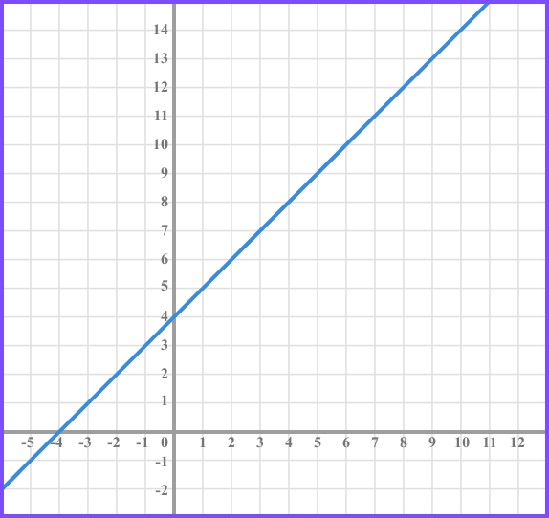

Graph Practice Worksheet (Odia–English)

Chapter 1: Linear Simultaneous Equations
BSE Odisha Class 10 Mathematics | Board Exam Focus (4–5 Marks)
This practice worksheet is designed exactly as per BSE Odisha Board pattern to help students score full marks in graphical questions.

Instructions | ନିର୍ଦ୍ଦେଶ

English:
- Use graph paper
- Take proper scale
- Label X-axis & Y-axis
- Show intersection point clearly

ଓଡ଼ିଆ:
- ଗ୍ରାଫ ପେପର ବ୍ୟବହାର କରନ୍ତୁ
- ଯଥାଯଥ ମାପ ନିଅନ୍ତୁ
- X ଓ Y ଧୁରା ଲେବେଲ କରନ୍ତୁ
- କଟିବା ବିନ୍ଦୁ ସ୍ପଷ୍ଟ ଦର୍ଶାନ୍ତୁ

PRACTICE SET – A (5 Marks Each)

Q1.
English: Solve graphically:
x+y=5,x−y=1x + y = 5,\quad x - y = 1x+y=5,x−y=1
ଓଡ଼ିଆ:
ଗ୍ରାଫ ମାଧ୍ୟମରେ ସମାଧାନ କରନ୍ତୁ—
x+y=5,x−y=1x + y = 5,\quad x - y = 1x+y=5,x−y=1

Q2.
English: Solve graphically and find the nature of solution:
2x+y=6,4x+2y=122x + y = 6,\quad 4x + 2y = 122x+y=6,4x+2y=12
ଓଡ଼ିଆ:
ଗ୍ରାଫ ଦ୍ୱାରା ସମାଧାନ କରି ସମାଧାନର ପ୍ରକାର ଲେଖନ୍ତୁ—
2x+y=6,4x+2y=122x + y = 6,\quad 4x + 2y = 122x+y=6,4x+2y=12

PRACTICE SET – B (4 Marks Each)

Q3.
3x−y=3,x+y=53x - y = 3,\quad x + y = 53x−y=3,x+y=5

Q4.
x+2y=4,x+2y=8x + 2y = 4,\quad x + 2y = 8x+2y=4,x+2y=8

PRACTICE SET – C (Identify Nature Only)

Q5.
Without solving, identify the nature of solution:
x−y=2,2x−2y=6x - y = 2,\quad 2x - 2y = 6x−y=2,2x−2y=6
Answer space:
One solution ☐ No solution ☐ Infinite solutions

EXAMINER’S MARKING SCHEME (For Self-Check)
Criteria | Marks
Correct table of values | 1
Neat graph with scale & labels | 2
Correct conclusion | 1–2

Q1.

Solve graphically
x+y=5,x−y=1x + y = 5,\quad x - y = 1x+y=5,x−y=1

✔️ English Solution:
Convert into y-form:
- y=5−xy = 5 - xy=5−x
- y=x−1y = x - 1y=x−1
x | y (Eq-1) | y (Eq-2)
2 | 3 | 1
3 | 2 | 2
The two lines intersect at (3, 2).
Final Answer:
x=3, y=2x = 3,\; y = 2x=3,y=2

ଓଡ଼ିଆ ସମାଧାନ:
- y=5−xy = 5 - xy=5−x
- y=x−1y = x - 1y=x−1
ଗ୍ରାଫ ଅଙ୍କନ କଲେ ଦୁଇ ରେଖା (3, 2) ବିନ୍ଦୁରେ କଟେ।
ଉତ୍ତର:
x=3, y=2x = 3,\; y = 2x=3,y=2

Q2.

Solve graphically & find nature of solution
2x+y=6,4x+2y=122x + y = 6,\quad 4x + 2y = 122x+y=6,4x+2y=12

✔️ English Solution:
Convert into y-form:
- y=6−2xy = 6 - 2xy=6−2x
- y=6−2xy = 6 - 2xy=6−2x
Both equations represent the same straight line.
Nature: Infinite solutions
(Coincident Lines)

ଓଡ଼ିଆ ସମାଧାନ:
ଦୁଇଟି ସମୀକରଣ ଏକେ ରେଖାକୁ ଦର୍ଶାଏ।
ଫଳାଫଳ:
ଅସୀମ ସମାଧାନ (Coincident Lines)

Q3.

Solve graphically
3x−y=3,x+y=53x - y = 3,\quad x + y = 53x−y=3,x+y=5

✔️ English Solution:
Convert into y-form:
- y=3x−3y = 3x - 3y=3x−3
- y=5−xy = 5 - xy=5−x
x | y (Eq-1) | y (Eq-2)
2 | 3 | 3
1 | 0 | 4
Lines intersect at (2, 3).
Final Answer:
x=2, y=3x = 2,\; y = 3x=2,y=3

ଓଡ଼ିଆ ସମାଧାନ:
ଗ୍ରାଫ ଅଙ୍କନ କଲେ ରେଖାଦୁଇଟି (2, 3) ବିନ୍ଦୁରେ କଟେ।
ଉତ୍ତର:
x=2, y=3x = 2,\; y = 3x=2,y=3

Q4.

Solve graphically
x+2y=4,x+2y=8x + 2y = 4,\quad x + 2y = 8x+2y=4,x+2y=8

✔️ English Solution:
Convert into y-form:
- y=2−x2y = 2 - \frac{x}{2}y=2−2x​
- y=4−x2y = 4 - \frac{x}{2}y=4−2x​
Both lines have:
- Same slope
- Different intercepts
Nature: No solution
(Parallel Lines)

ଓଡ଼ିଆ ସମାଧାନ:
ଦୁଇ ରେଖା ସମାନାନ୍ତର ହେଉଥିବାରୁ—
ଫଳାଫଳ:
କୌଣସି ସମାଧାନ ନାହିଁ

Q5.

Identify nature without solving
x−y=2,2x−2y=6x - y = 2,\quad 2x - 2y = 6x−y=2,2x−2y=6

✔️ English Solution:
Compare coefficients:
a1a2=12,b1b2=−1−2,c1c2≠\frac{a_1}{a_2} = \frac{1}{2},\quad \frac{b_1}{b_2} = \frac{-1}{-2},\quad \frac{c_1}{c_2} \neqa2​a1​​=21​,b2​b1​​=−2−1​,c2​c1​​=
Nature: No solution
(Parallel Lines)

ଓଡ଼ିଆ ସମାଧାନ:
ସମୀକରଣ ଅନୁପାତ ସମାନ ହେଲେ ମଧ୍ୟ ଧ୍ରୁବକ ଅସମାନ।
ଫଳାଫଳ:
କୌଣସି ସମାଧାନ ନାହିଁ

JAI HIND! - BINAYA

