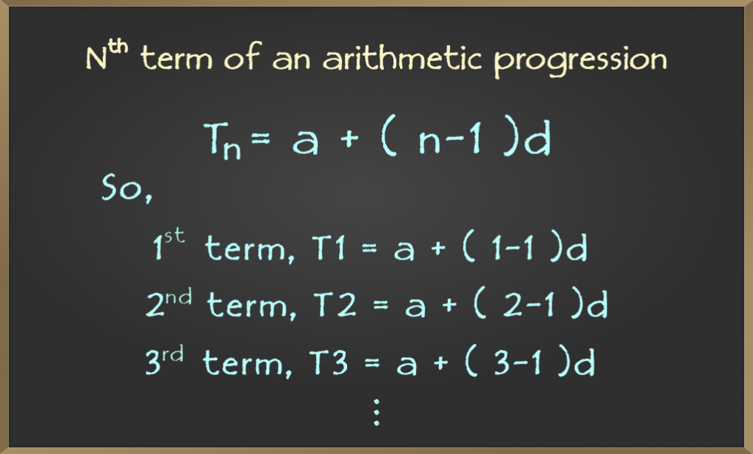
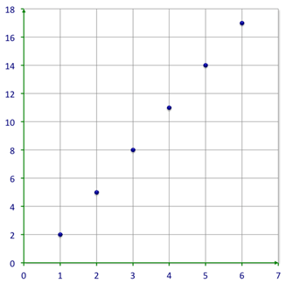
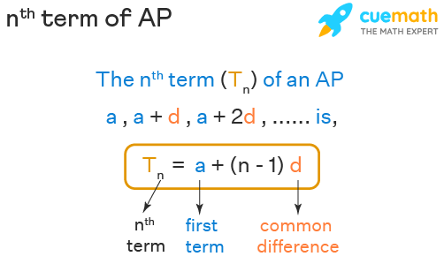

CHAPTER 3: ARITHMETIC PROGRESSION (AP)

Introduction | ପରିଚୟ

English:

An Arithmetic Progression (AP) is a sequence of numbers in which the difference between consecutive terms remains constant.
Arithmetic Progression is not only important for the Board exam but also forms the foundation for higher mathematics and competitive examinations.

ଓଡ଼ିଆ:
ଯେଉଁ ସଂଖ୍ୟାମାଳାରେ ପରପରା ଦୁଇଟି ପଦର ତାରତମ୍ୟ ସମାନ ଥାଏ, ସେହି ସଂଖ୍ୟାମାଳାକୁ ସାମାନ୍ତର ପ୍ରଗତି (Arithmetic Progression – AP) କୁହାଯାଏ।
Arithmetic Progression – Definition

(ସାମାନ୍ତର ପ୍ରଗତିର ପରିଭାଷା)

English:
An arithmetic progression is a sequence like:
a, a+d, a+2d, a+3d, …a,\; a+d,\; a+2d,\; a+3d,\; \dotsa,a+d,a+2d,a+3d,…
where
- a = first term
- d = common difference

ଓଡ଼ିଆ:

ସାମାନ୍ତର ପ୍ରଗତିର ସାଧାରଣ ରୂପ—
a, a+d, a+2d, a+3d, …a,\; a+d,\; a+2d,\; a+3d,\; \dotsa,a+d,a+2d,a+3d,…
ଯେଉଁଠାରେ—
- a = ପ୍ରଥମ ପଦ
- d = ସାଧାରଣ ତାରତମ୍ୟ

Key Formulae | ମୁଖ୍ୟ ସୂତ୍ର

nth Term of an AP
(n-ତମ ପଦ)

English:
The nth term of an arithmetic progression is:
an=a+(n−1)da_n = a + (n - 1)dan​=a+(n−1)d
Where:
- ana_nan​ = nth term
- aaa = first term
- ddd = common difference
- nnn = term number

ଓଡ଼ିଆ:

ସାମାନ୍ତର ପ୍ରଗତିର n-ତମ ପଦ—
n-ତମ ପଦ=ପ୍ରଥମ ପଦ+(n−1)×ତାରତମ୍ୟ\text{n-ତମ ପଦ} = \text{ପ୍ରଥମ ପଦ} + (n-1) \times \text{ତାରତମ୍ୟ}n-ତମ ପଦ=ପ୍ରଥମ ପଦ+(n−1)×ତାରତମ୍ୟ

Sum of n Terms of an AP
(n-ଟି ପଦର ଯୋଗ)

English:
The sum of first n terms of an AP is:
Sn=n2[2a+(n−1)d]S_n = \frac{n}{2}[2a + (n - 1)d]Sn​=2n​[2a+(n−1)d]

ଓଡ଼ିଆ:
ସାମାନ୍ତର ପ୍ରଗତିର ପ୍ରଥମ n-ଟି ପଦର ଯୋଗ—
Sn=n2[2a+(n−1)d]S_n = \frac{n}{2}[2a + (n - 1)d]Sn​=2n​[2a+(n−1)d]

Board-Type Solved Example

Example:
Find the 10th term of the AP:
2, 5, 8, 11, …2,\; 5,\; 8,\; 11,\; \dots2,5,8,11,…

English Solution:
- First term, a=2a = 2a=2
- Common difference, d=3d = 3d=3
- n=10n = 10n=10
a10=2+(10−1)×3=2+27=29a_{10} = 2 + (10 - 1) \times 3 = 2 + 27 = 29a10​=2+(10−1)×3=2+27=29

Answer:
29\boxed{29}29​

ଓଡ଼ିଆ ସମାଧାନ:
- ପ୍ରଥମ ପଦ a=2a = 2a=2
- ତାରତମ୍ୟ d=3d = 3d=3
- n=10n = 10n=10
a10=2+(10−1)×3=29a_{10} = 2 + (10 - 1) \times 3 = 29a10​=2+(10−1)×3=29

ଉତ୍ତର:
29\boxed{29}29​

Board Examination Focus
(ବୋର୍ଡ ପରୀକ୍ଷା ଗୁରୁତ୍ୱ)

English:

nth term problems (3–4 marks)
Sum of AP questions (4–5 marks)
Word problems based on real-life situations

ଓଡ଼ିଆ:
n-ତମ ପଦ ଗଣନା
AP ର ଯୋଗ ସମସ୍ୟା
ଜୀବନ ଆଧାରିତ ପ୍ରଶ୍ନ

Important MCQs (AP)

MCQ 1:
What is the common difference of the AP:
3, 7, 11, 15, … ?
A) 2
B) 3
C) 4
D) 5
Answer: C – 4 ଉତ୍ତର: 4

MCQ 2:
The nth term of an AP is given by:
A) a+nda + nda+nd
B) a+(n−1)da + (n - 1)da+(n−1)d
C) a−nda - nda−nd
D) a+da + da+d
Answer: B ଉତ୍ତର: B

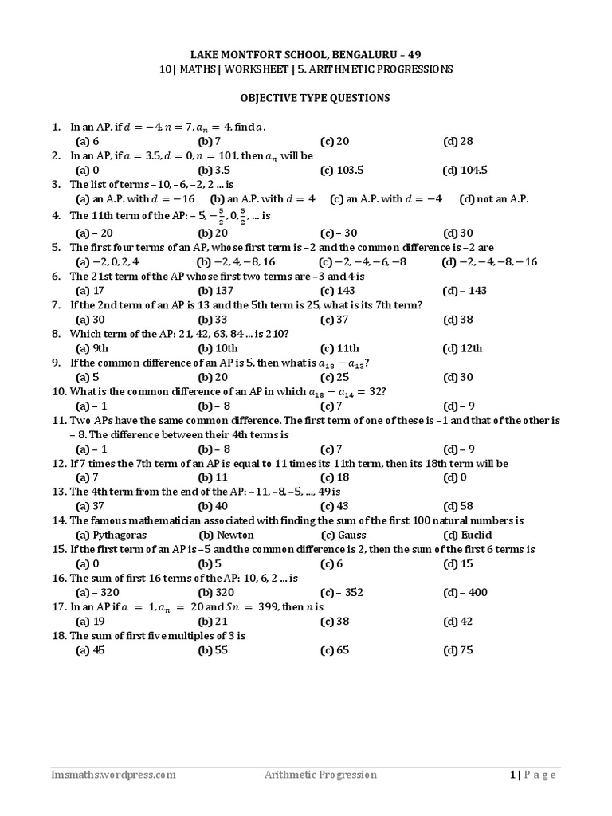

Chapter 3: Arithmetic Progression (AP)

AP Practice Worksheet + Solved Answers + Previous Year BSE Odisha Questions

PART–A: AP PRACTICE WORKSHEET

Instructions | ନିର୍ଦ୍ଦେଶ
English:
Write formula first
Show all steps
Put final answer in a box
ଓଡ଼ିଆ:
ପ୍ରଥମେ ସୂତ୍ର ଲେଖନ୍ତୁ
ସମସ୍ତ ଧାପ ଦର୍ଶାନ୍ତୁ
ଶେଷ ଉତ୍ତରକୁ ବାକ୍ସରେ ଲେଖନ୍ତୁ

Worksheet – Set A (3–4 Marks Each)

Q1. Find the 15th term of the AP:
7, 10, 13, 16, …7,\; 10,\; 13,\; 16,\; \dots7,10,13,16,…

Q2. Find the nth term of the AP:
5, 8, 11, …5,\; 8,\; 11,\; \dots5,8,11,…

Q3. How many terms are there in the AP:
3, 7, 11, …, 407?3,\; 7,\; 11,\; \dots,\; 407?3,7,11,…,407?

Worksheet – Set B (5 Marks Each)

Q4. Find the sum of first 20 terms of the AP:
2, 5, 8, …2,\; 5,\; 8,\; \dots2,5,8,…

Q5. Find the sum of first 30 natural numbers using AP method.

PART–B: SOLVED ANSWERS (Step-wise)

Solution 1
AP: 7, 10, 13, …
a=7, d=3, n=15a = 7,\; d = 3,\; n = 15a=7,d=3,n=15
a15=a+(n−1)d=7+14×3=49a_{15} = a + (n-1)d = 7 + 14 \times 3 = 49a15​=a+(n−1)d=7+14×3=49
Answer / ଉତ୍ତର:
49\boxed{49}49​

Solution 2
AP: 5, 8, 11, …
a=5, d=3a = 5,\; d = 3a=5,d=3
an=a+(n−1)d=5+(n−1)3a_n = a + (n-1)d = 5 + (n-1)3an​=a+(n−1)d=5+(n−1)3
Answer:
an=3n+2\boxed{a_n = 3n + 2}an​=3n+2​

Solution 3
AP: 3, 7, 11, …, 407
a=3, d=4a = 3,\; d = 4a=3,d=4
407=3+(n−1)4407 = 3 + (n-1)4407=3+(n−1)4 404=4(n−1)⇒n=102404 = 4(n-1) \Rightarrow n = 102404=4(n−1)⇒n=102
Answer / ଉତ୍ତର:
102 terms\boxed{102\text{ terms}}102 terms​

Solution 4
AP: 2, 5, 8, …
a=2, d=3, n=20a = 2,\; d = 3,\; n = 20a=2,d=3,n=20
S20=202[2(2)+19×3]S_{20} = \frac{20}{2}[2(2) + 19 \times 3]S20​=220​[2(2)+19×3] =10(4+57)=610= 10(4 + 57) = 610=10(4+57)=610
Answer:
610\boxed{610}610​

Solution 5
Natural numbers: 1, 2, 3, …
a=1, d=1, n=30a = 1,\; d = 1,\; n = 30a=1,d=1,n=30
S30=302[2+29]=15×31=465S_{30} = \frac{30}{2}[2 + 29] = 15 \times 31 = 465S30​=230​[2+29]=15×31=465
Answer:
465\boxed{465}465​

PART–C: Previous Year BSE Odisha AP Questions (Solved)

PYQ–1 (BSE Odisha – 5 Marks)

Question:
Find the sum of first 25 terms of the AP:
6, 13, 20, …6,\; 13,\; 20,\; \dots6,13,20,…
Solution:
a=6, d=7, n=25a = 6,\; d = 7,\; n = 25a=6,d=7,n=25
S25=252[12+168]=252×180=2250S_{25} = \frac{25}{2}[12 + 168] = \frac{25}{2} \times 180 = 2250S25​=225​[12+168]=225​×180=2250
Answer:
2250\boxed{2250}2250​

PYQ–2 (BSE Odisha – 4 Marks)
Question:
Find the 20th term of the AP:
−3, −7, −11, …-3,\; -7,\; -11,\; \dots−3,−7,−11,…

Solution:
a=−3, d=−4, n=20a = -3,\; d = -4,\; n = 20a=−3,d=−4,n=20
a20=−3+19(−4)=−79a_{20} = -3 + 19(-4) = -79a20​=−3+19(−4)=−79
Answer:
−79\boxed{-79}−79​

PYQ–3 (BSE Odisha – 5 Marks)

Question: How many terms of the AP
18, 15, 12, …18,\; 15,\; 12,\; \dots18,15,12,… must be taken so that their sum is 0?

Solution:
a=18, d=−3a = 18,\; d = -3a=18,d=−3
Sn=n2[36−3(n−1)]=0⇒39−3n=0⇒n=13S_n = \frac{n}{2}[36 - 3(n-1)] = 0 \Rightarrow 39 - 3n = 0 \Rightarrow n = 13Sn​=2n​[36−3(n−1)]=0⇒39−3n=0⇒n=13
Answer: 13 terms
Q: Find the 20th term of the AP:
−3, −7, −11, …-3,\; -7,\; -11,\; \dots−3,−7,−11,…

Solution (English):
a=−3, d=−4, n=20a=-3,\;d=-4,\;n=20a=−3,d=−4,n=20
a20=a+(n−1)d=−3+19(−4)=−79a_{20} = a+(n-1)d = -3+19(-4)=-79a20​=a+(n−1)d=−3+19(−4)=−79
ଓଡ଼ିଆ:
ଅନୁଷ୍ଠାନ: a=−3, d=−4a=-3,\;d=-4a=−3,d=−4
a20=−3+19(−4)=−79a_{20} = -3+19(-4)=-79a20​=−3+19(−4)=−79
✔️ Answer: −79-79−79

Chapter 3: Arithmetic Progression (AP)

Step-by-Step Solutions (BSE Odisha Board Pattern)

Question – 1 (BSE Odisha 2019 - 24)

Find the 10th term of the AP:
3, 7, 11, …3,\; 7,\; 11,\; \dots3,7,11,…

✔️ Step-by-Step Solution (English)

Step 1: Identify values

a=3,d=7−3=4,n=10a = 3,\quad d = 7 - 3 = 4,\quad n = 10a=3,d=7−3=4,n=10

Step 2: Write formula

an=a+(n−1)da_n = a + (n - 1)dan​=a+(n−1)d

Step 3: Substitute values

a10=3+(10−1)×4a_{10} = 3 + (10 - 1)\times4a10​=3+(10−1)×4

Step 4: Simplify

a10=3+36=39a_{10} = 3 + 36 = 39a10​=3+36=39

Final Answer:
39\boxed{39}39​

ଧାପ-ଧାପ ସମାଧାନ (ଓଡ଼ିଆ)

ଧାପ-1:
a=3, d=4, n=10a = 3,\; d = 4,\; n = 10a=3,d=4,n=10
ଧାପ-2:
n-ତମ ପଦ=a+(n−1)dn\text{-ତମ ପଦ} = a + (n - 1)dn-ତମ ପଦ=a+(n−1)d
ଧାପ-3:
a10=3+9×4=39a_{10} = 3 + 9 \times 4 = 39a10​=3+9×4=39

ଉତ୍ତର:
39\boxed{39}39​

Question – 2 (BSE Odisha 2020)

Find the sum of first 20 terms of the AP:
2, 5, 8, …2,\; 5,\; 8,\; \dots2,5,8,…

✔️ Step-by-Step Solution (English)

Step 1:
a=2, d=3, n=20a = 2,\; d = 3,\; n = 20a=2,d=3,n=20

Step 2: Formula for sum
Sn=n2[2a+(n−1)d]S_n = \frac{n}{2}[2a + (n - 1)d]Sn​=2n​[2a+(n−1)d]

Step 3: Substitute
S20=202[4+19×3]S_{20} = \frac{20}{2}[4 + 19 \times 3]S20​=220​[4+19×3]

Step 4: Simplify
S20=10×61=610S_{20} = 10 \times 61 = 610S20​=10×61=610

Final Answer:
610\boxed{610}610​

ଓଡ଼ିଆ ସମାଧାନ
a=2, d=3, n=20a = 2,\; d = 3,\; n = 20a=2,d=3,n=20 S20=202[4+57]=10×61=610S_{20} = \frac{20}{2}[4 + 57] = 10 \times 61 = 610S20​=220​[4+57]=10×61=610

ଉତ୍ତର:
610\boxed{610}610​

Question – 3 (BSE Odisha 2021)

How many terms of the AP
18, 15, 12, …18,\; 15,\; 12,\; \dots18,15,12,…
have sum = 0?

✔️ Step-by-Step Solution (English)
Step 1:
a=18, d=−3a = 18,\; d = -3a=18,d=−3

Step 2: Use sum formula
Sn=n2[2a+(n−1)d]S_n = \frac{n}{2}[2a + (n - 1)d]Sn​=2n​[2a+(n−1)d]

Step 3: Given Sn=0S_n = 0Sn​=0
n2[36−3(n−1)]=0\frac{n}{2}[36 - 3(n - 1)] = 02n​[36−3(n−1)]=0

Step 4: Solve
36−3n+3=0⇒39=3n⇒n=1336 - 3n + 3 = 0 \Rightarrow 39 = 3n \Rightarrow n = 1336−3n+3=0⇒39=3n⇒n=13

Final Answer:

13 terms\boxed{13\text{ terms}}13 terms​

ଓଡ଼ିଆ ସମାଧାନ
a=18, d=−3a = 18,\; d = -3a=18,d=−3 Sn=0⇒39−3n=0⇒n=13S_n = 0 \Rightarrow 39 - 3n = 0 \Rightarrow n = 13Sn​=0⇒39−3n=0⇒n=13

ଉତ୍ତର:
13\boxed{13}13​

Question – 4 (BSE Odisha 2022)

Find the 20th term of the AP:
−3, −7, −11, …-3,\; -7,\; -11,\; \dots−3,−7,−11,…

✔️ Step-by-Step Solution (English)
a=−3, d=−4, n=20a = -3,\; d = -4,\; n = 20a=−3,d=−4,n=20 a20=a+(n−1)da_{20} = a + (n - 1)da20​=a+(n−1)d a20=−3+19(−4)=−79a_{20} = -3 + 19(-4) = -79a20​=−3+19(−4)=−79

Final Answer:
−79\boxed{-79}−79​

Question – 5 (BSE Odisha 2023)

Find the sum of first 25 terms of the AP:
6, 13, 20, …6,\; 13,\; 20,\; \dots6,13,20,…

Step-by-Step Solution (English)
a=6, d=7, n=25a = 6,\; d = 7,\; n = 25a=6,d=7,n=25 S25=252[12+168]S_{25} = \frac{25}{2}[12 + 168]S25​=225​[12+168] S25=252×180=2250S_{25} = \frac{25}{2} \times 180 = 2250S25​=225​×180=2250

Final Answer:
2250\boxed{2250}2250​

JAI HIND! - BINAYA

