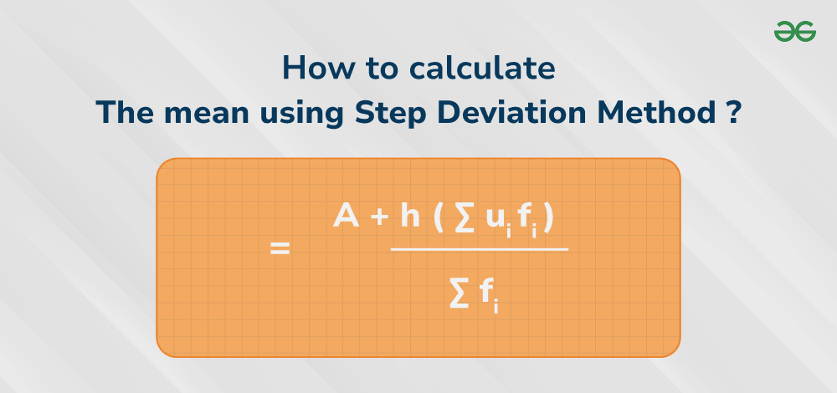
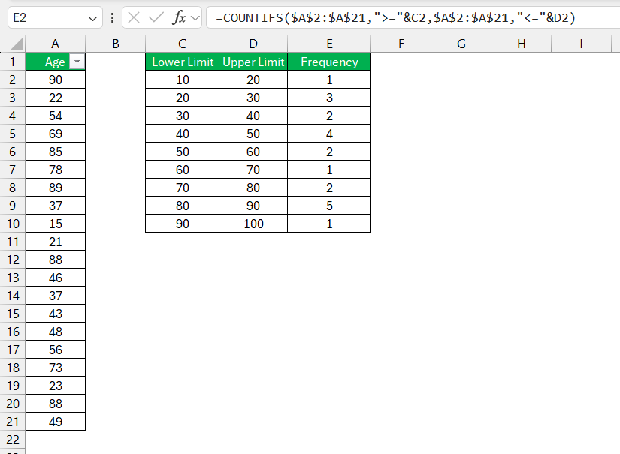
CHAPTER 4 – STATISTICS

Introduction | ପରିଚୟ

English:

Statistics is the branch of mathematics that deals with the collection, organisation, representation, and analysis of numerical data.
ଓଡ଼ିଆ:
ସାଂଖ୍ୟିକୀ (Statistics) ହେଉଛି ଗଣିତର ସେହି ଅଂଶ, ଯେଉଁଠାରେ ତଥ୍ୟ ସଂଗ୍ରହ, ବିନ୍ୟାସ, ଉପସ୍ଥାପନ ଏବଂ ବିଶ୍ଳେଷଣ କରାଯାଏ।
ଯଥାଯଥ ଗଣନା କଲେ ଏହା ଏକ ଉଚ୍ଚ ମାର୍କ ଆଣିଦେଇଥିବା ଅଧ୍ୟାୟ।

Meaning of Statistics
(ସାଂଖ୍ୟିକୀର ଅର୍ଥ)

English:
Statistics helps us to:
- Understand large data easily
- Compare numerical information
- Draw conclusions from data

ଓଡ଼ିଆ:
ସାଂଖ୍ୟିକୀ ଦ୍ୱାରା—
- ବହୁ ତଥ୍ୟ ସହଜରେ ବୁଝିପାରିବା
- ସଂଖ୍ୟାତ୍ମକ ତଥ୍ୟର ତୁଳନା
- ତଥ୍ୟରୁ ନିଷ୍କର୍ଷ ନିକାଳିବା
ସମ୍ଭବ ହୁଏ।

Measures of Central Tendency
(ମଧ୍ୟମ ପ୍ରବୃତ୍ତିର ମାପ)

In Class 10, we mainly study Mean.
Mean (ମାଧ୍ୟମ):

English:
Mean is the average value of the given data.

ଓଡ଼ିଆ:
ଦିଆଯାଇଥିବା ତଥ୍ୟର ମଧ୍ୟମ ମୂଲ୍ୟକୁ ମାଧ୍ୟମ (Mean) କୁହାଯାଏ।
Methods of Finding Mean
(ମାଧ୍ୟମ ନିର୍ଣ୍ଣୟର ପଦ୍ଧତି)

Direct Method
(ସିଧାସଳଖ ପଦ୍ଧତି)

Formula:
Mean=∑fx∑f\text{Mean} = \frac{\sum f x}{\sum f}Mean=∑f∑fx​

English:
Used when calculations are simple and frequencies are small.

ଓଡ଼ିଆ:
ଯେତେବେଳେ ତଥ୍ୟ ସରଳ ଓ ତାରମାଣ ଛୋଟ ଥାଏ, ସେତେବେଳେ ଏହି ପଦ୍ଧତି ବ୍ୟବହାର କରାଯାଏ।

Assumed Mean Method
(ଧାରଣା ମାଧ୍ୟମ ପଦ୍ଧତି)

Formula:
Mean=a+∑fd∑f\text{Mean} = a + \frac{\sum f d}{\sum f}Mean=a+∑f∑fd​
Where:
- aaa = assumed mean
- d=x−ad = x - ad=x−a

English:
This method simplifies lengthy calculations.
ଓଡ଼ିଆ:
ଏହି ପଦ୍ଧତି ଦ୍ୱାରା ଦୀର୍ଘ ଗଣନାକୁ ସହଜ କରାଯାଏ।

Step Deviation Method
(ଧାପ ବିଚଳନ ପଦ୍ଧତି)
Formula:

Mean=a+∑fu∑f×h\text{Mean} = a + \frac{\sum f u}{\sum f} \times hMean=a+∑f∑fu​×h
Where:
- u=x−ahu = \frac{x - a}{h}u=hx−a​
- hhh = class width
English:

This is the most important method for Board exams.
ଓଡ଼ିଆ:
ଏହା ବୋର୍ଡ ପରୀକ୍ଷା ପାଇଁ ସବୁଠାରୁ ଗୁରୁତ୍ୱପୂର୍ଣ୍ଣ ପଦ୍ଧତି।

Board-Type Solved Example
Example:

Find the mean of the following data:
Class Interval | Frequency
0–10 | 5
10–20 | 10
20–30 | 15

English Solution (Direct Method):
∑f=30,∑fx=550\sum f = 30,\quad \sum fx = 550∑f=30,∑fx=550 Mean=55030=18.33\text{Mean} = \frac{550}{30} = 18.33Mean=30550​=18.33

Answer:
18.33\boxed{18.33}18.33​

ଓଡ଼ିଆ ସମାଧାନ:

ମାଧ୍ୟମ=∑fx∑f=18.33\text{ମାଧ୍ୟମ} = \frac{\sum fx}{\sum f} = 18.33ମାଧ୍ୟମ=∑f∑fx​=18.33
ଉତ୍ତର:
18.33\boxed{18.33}18.33​

Previous Year BSE Odisha

Chapter 4 – Statistics (Solved Questions)

Question 1 — BSE Odisha 2019

Q:
Find the mean of the following data using Direct Method:
Class Interval | Frequency
0–10 | 5
10–20 | 8
20–30 | 7

English Solution (Step-by-Step)

Step 1: Find class marks (x):
0–10 → 5 | 10–20 → 15 | 20–30 → 25

Step 2: Prepare table:

Class | f | x | fx
0–10 | 5 | 5 | 25
10–20 | 8 | 15 | 120
20–30 | 7 | 25 | 175
∑f=20,∑fx=320\sum f = 20,\quad \sum fx = 320∑f=20,∑fx=320

Step 3: Apply Direct Method:

Mean=∑fx∑f=32020=16\text{Mean} = \frac{\sum fx}{\sum f} = \frac{320}{20} = 16Mean=∑f∑fx​=20320​=16
Final Answer:
16\boxed{16}16​

ଓଡ଼ିଆ ସମାଧାନ

ପଦକ୍ରମ-1:
ମଧ୍ୟମ ବିନ୍ଦୁ (x):
0–10 → 5, 10–20 → 15, 20–30 → 25
ପଦକ୍ରମ-2:
∑f=20, ∑fx=320\sum f = 20,\ \sum fx = 320∑f=20, ∑fx=320
ମାଧ୍ୟମ:
32020=16\frac{320}{20} = 1620320​=16
ଉତ୍ତର:
16\boxed{16}16​

Question 2 — BSE Odisha 2020

Q:
Find the mean using Assumed Mean Method:
Class Interval | Frequency
5–15 | 6
15–25 | 10
25–35 | 14

English Solution

Step 1: Class marks (x)
5–15 → 10; 15–25 → 20; 25–35 → 30
Assume mean a=20a = 20a=20
Compute d=x−ad = x - ad=x−a:
x | f | d | fd
10 | 6 | -10 | -60
20 | 10 | 0 | 0
30 | 14 | 10 | 140
∑f=30,∑fd=80\sum f = 30,\quad \sum fd = 80∑f=30,∑fd=80

Step 2: Use formula:
Mean=a+∑fd∑f=20+8030=20+2.67=22.67\text{Mean} = a + \frac{\sum fd}{\sum f} = 20 + \frac{80}{30} = 20 + 2.67 = 22.67Mean=a+∑f∑fd​=20+3080​=20+2.67=22.67
Final Answer:
22.67\boxed{22.67}22.67​

ଓଡ଼ିଆ ସମାଧାନ
Assumed mean = 20
∑f=30, ∑fd=80\sum f = 30,\ \sum fd = 80∑f=30, ∑fd=80
ମାଧ୍ୟମ=20+8030=22.67\text{ମାଧ୍ୟମ} = 20 + \frac{80}{30} = 22.67ମାଧ୍ୟମ=20+3080​=22.67
ଉତ୍ତର:
22.67\boxed{22.67}22.67​

Question 3 — BSE Odisha 2021

Q:
Find the mean using Step Deviation Method:
Class Interval | Frequency
10–20 | 8
20–30 | 12
30–40 | 10

English Solution
Choose class width h=10h = 10h=10
Class marks: 15, 25, 35
Assumed mean a=25a = 25a=25
Compute u=x−ahu = \frac{x - a}{h}u=hx−a​:
x | f | u | fu
15 | 8 | -1 | -8
25 | 12 | 0 | 0
35 | 10 | 1 | 10
∑f=30,∑fu=2\sum f = 30,\quad \sum fu = 2∑f=30,∑fu=2
Use formula:
Mean=a+∑fu∑f×h=25+230×10=25+2030=25+0.67=25.67\text{Mean} = a + \frac{\sum fu}{\sum f} \times h = 25 + \frac{2}{30}\times10 = 25 + \frac{20}{30} = 25 + 0.67 = 25.67Mean=a+∑f∑fu​×h=25+302​×10=25+3020​=25+0.67=25.67
Final Answer:
25.67\boxed{25.67}25.67​

ଓଡ଼ିଆ ସମାଧାନ
∑f=30, ∑fu=2\sum f = 30,\ \sum fu = 2∑f=30, ∑fu=2
ମାଧ୍ୟମ=25+2×1030=25.67\text{ମାଧ୍ୟମ} = 25 + \frac{2\times10}{30} = 25.67ମାଧ୍ୟମ=25+302×10​=25.67
ଉତ୍ତର:
25.67\boxed{25.67}25.67​

Question 4 — BSE Odisha 2022

Q:
Calculate the mean of the grouped data:
Class Interval | Frequency
0–20 | 4
20–40 | 6
40–60 | 10
60–80 | 10

English Solution
Class marks: 10, 30, 50, 70
x | f | fx
10 | 4 | 40
30 | 6 | 180
50 | 10 | 500
70 | 10 | 700
∑f=30, ∑fx=1420\sum f = 30,\ \sum fx = 1420∑f=30, ∑fx=1420 Mean=142030=47.33\text{Mean} = \frac{1420}{30} = 47.33Mean=301420​=47.33
Final Answer:
47.33\boxed{47.33}47.33​

ଓଡ଼ିଆ ସମାଧାନ
∑f=30, ∑fx=1420\sum f = 30,\ \sum fx = 1420∑f=30, ∑fx=1420
ମାଧ୍ୟମ=47.33\text{ମାଧ୍ୟମ} = 47.33ମାଧ୍ୟମ=47.33
ଉତ୍ତର:
47.33\boxed{47.33}47.33​

Question 5 — BSE Odisha 2023

Q:
Find the mean marks of students:
Marks Range | Frequency
0–10 | 4
10–20 | 8
20–30 | 13
30–40 | 5

English Solution
Class marks: 5, 15, 25, 35
x | f | fx
5 | 4 | 20
15 | 8 | 120
25 | 13 | 325
35 | 5 | 175
∑f=30,∑fx=640\sum f = 30,\quad \sum fx = 640∑f=30,∑fx=640 Mean=64030=21.33\text{Mean} = \frac{640}{30} = 21.33Mean=30640​=21.33
Final Answer:
21.33\boxed{21.33}21.33​

ଓଡ଼ିଆ ସମାଧାନ
∑f=30, ∑fx=640\sum f = 30,\ \sum fx = 640∑f=30, ∑fx=640
ମାଧ୍ୟମ=21.33\text{ମାଧ୍ୟମ} = 21.33ମାଧ୍ୟମ=21.33
ଉତ୍ତର: 21.33\boxed{21.33}21.33​

JAI HIND! - BINAYA

