Class X Mathematics
Chapter–5 : STATISTICS (ପରିସଂଖ୍ୟାନ)

(Textbook Pages: 77–100)

5.1 INTRODUCTION | ପରିଚୟ
English

Statistics is a branch of Mathematics which deals with the collection, organisation, presentation, analysis and interpretation of numerical data.
In daily life, we come across data like marks, height, weight, income, rainfall, population, etc. Statistics helps us to understand such large data easily.

ଓଡ଼ିଆ

ପରିସଂଖ୍ୟାନ ହେଉଛି ଗଣିତର ଏକ ଶାଖା, ଯାହା ସଂଖ୍ୟାତ୍ମକ ତଥ୍ୟର ସଂଗ୍ରହ, ବିନ୍ୟାସ, ପ୍ରଦର୍ଶନ, ବିଶ୍ଳେଷଣ ଓ ବ୍ୟାଖ୍ୟା ସହିତ ସଂପୃକ୍ତ।
ଦୈନନ୍ଦିନ ଜୀବନରେ ଆମେ ପରୀକ୍ଷା ମାର୍କ, ଉଚ୍ଚତା, ଓଜନ, ଆୟ ଇତ୍ୟାଦି ତଥ୍ୟ ସହିତ ସମ୍ମୁଖୀନ ହୁଅ। ପରିସଂଖ୍ୟାନ ଏହି ବଡ଼ ତଥ୍ୟକୁ ସହଜରେ ବୁଝିବାରେ ସାହାଯ୍ୟ କରେ।

Types of Data | ତଥ୍ୟର ପ୍ରକାର

English | ଓଡ଼ିଆ
Numerical Data | ସଂଖ୍ୟାତ୍ମକ ତଥ୍ୟ
Primary Data | ପ୍ରାଥମିକ ତଥ୍ୟ
Secondary Data | ଦ୍ୱିତୀୟିକ ତଥ୍ୟ

Presentation of Data | ତଥ୍ୟ ପ୍ରଦର୍ଶନ

- Frequency Distribution Table (ବାରମ୍ବାରତା ସାରଣୀ)
- Histogram
- Frequency Polygon
- Pie Chart
- Pictograph
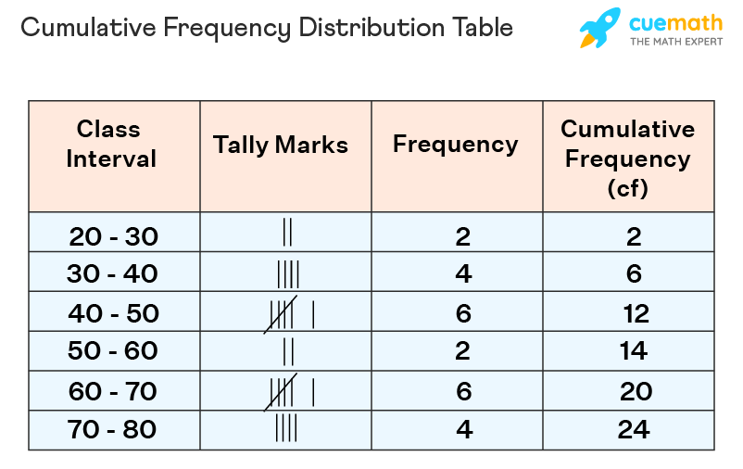
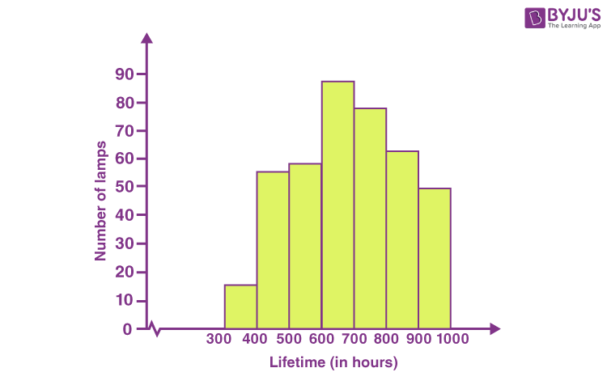
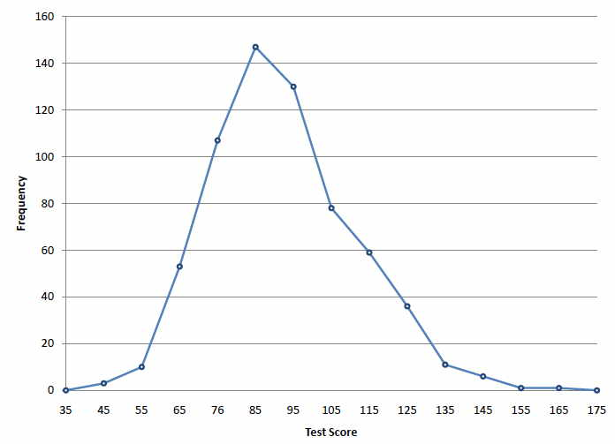

Objective of the Chapter | ଅଧ୍ୟାୟର ଉଦ୍ଦେଶ୍ୟ

- English: To represent a large data set by one representative value.
- ଓଡ଼ିଆ: ବଡ଼ ପରିମାଣର ତଥ୍ୟକୁ ଗୋଟିଏ ପ୍ରତିନିଧି ସଂଖ୍ୟା ଦ୍ୱାରା ପ୍ରଦର୍ଶନ କରିବା।

5.2 CENTRAL TENDENCY | କେନ୍ଦ୍ରୀୟ ପ୍ରବଣତା

Measures | ମାପ

- Mean (ମାନ)
- Median (ମଧ୍ୟକ)
- Mode (ମୋଡ୍)

5.2.1 MEAN (ମାନ)

Definition | ସଂଜ୍ଞା

- English: Mean is the average of all observations.
- ଓଡ଼ିଆ: ମାନ ହେଉଛି ସମସ୍ତ ତଥ୍ୟର ହାରାହାରି ମୂଲ୍ୟ।

(A) Mean of Individual Series

ବ୍ୟକ୍ତିଗତ ଶ୍ରେଣୀର ମାନ

Formula / ସୂତ୍ର

M=∑xnM = \frac{\sum x}{n}M=n∑x​

Example / ଉଦାହରଣ

Marks: 65, 67, 85, 78, 69, 78
∑x=442, n=6⇒M=73.67\sum x = 442,\; n = 6 \Rightarrow M = 73.67∑x=442,n=6⇒M=73.67

(B) Mean of Discrete Frequency Distribution

ବାରମ୍ବାରତା ଶ୍ରେଣୀର ମାନ
M=∑fx∑fM = \frac{\sum fx}{\sum f}M=∑f∑fx​
Example
Mean = 70.5

(C) Shortcut / Deviation Method

ସଂକ୍ଷିପ୍ତ / ବିଚ୍ୟୁତି ପଦ୍ଧତି
M=A+∑fy∑fM = A + \frac{\sum fy}{\sum f}M=A+∑f∑fy​
Where
- A = Assumed Mean (ଧାରଣା ମାନ)
- y = x − A

(D) Step Deviation Method (Board Favourite)
ପଦକ୍ରମ ବିଚ୍ୟୁତି ପଦ୍ଧତି

M=A+∑fy′∑f×cM = A + \frac{\sum fy'}{\sum f} \times cM=A+∑f∑fy′​×c

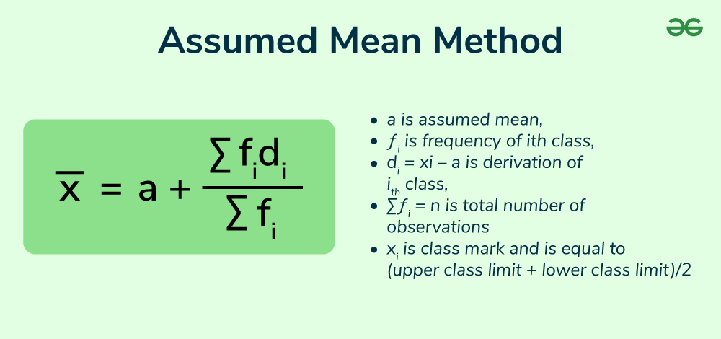

Properties of Mean | ମାନର ଗୁଣଧର୍ମ

- ∑(x−M)=0\sum (x - M) = 0∑(x−M)=0
- Adding a number increases mean by same number
- Multiplying data multiplies mean

5.2.2 MEDIAN (ମଧ୍ୟକ)

Definition | ସଂଜ୍ଞା

- English: Median is the middle value of arranged data.
- ଓଡ଼ିଆ: ସଜାଯାଇଥିବା ତଥ୍ୟର ମଧ୍ୟ ମୂଲ୍ୟକୁ ମଧ୍ୟକ କୁହାଯାଏ।

(A) Individual Data | ବ୍ୟକ୍ତିଗତ ତଥ୍ୟ

- Odd: n+12\frac{n+1}{2}2n+1​th term
- Even: Average of two middle terms

(B) Grouped Data | ବର୍ଗୀକୃତ ତଥ୍ୟ

Median=l+(n2−cf)×i\text{Median} = l + \left(\frac{\frac{n}{2}-c}{f}\right)\times iMedian=l+(f2n​−c​)×i
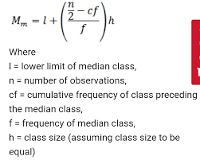

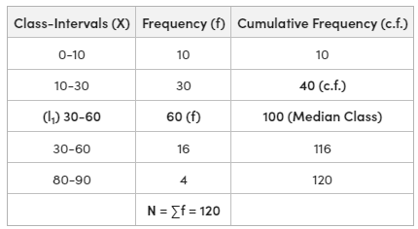

(C) Median by Ogive

ଓଜାଇଭ୍ ଦ୍ୱାରା ମଧ୍ୟକ

Steps (English + Odia):
- Prepare cumulative frequency table
- Ogive ଚିତ୍ର ଆଙ୍କ
- n/2n/2n/2 ଚିହ୍ନଟ କର
- X-axis ଉପରେ ମଧ୍ୟକ ପାଓ
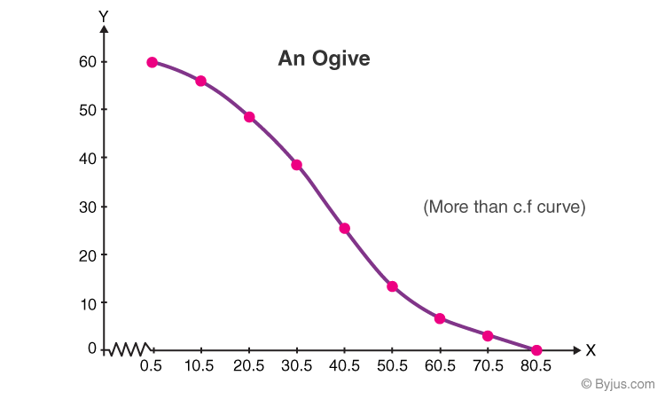
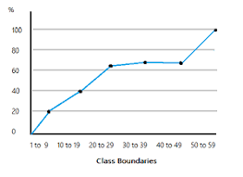

5.2.3 MODE (ମୋଡ୍)

Definition | ସଂଜ୍ଞା

- English: Mode is the value with highest frequency.
- ଓଡ଼ିଆ: ସର୍ବାଧିକ ବାର ଆସୁଥିବା ମୂଲ୍ୟକୁ ମୋଡ୍ କୁହାଯାଏ।

Example

Data: 19, 20, 21, 21, 22, 22, 22, 24
Mode = 22

Empirical Relation | ଅନୁଭୂତିକ ସମ୍ବନ୍ଧ

Mode=3(Median)−2(Mean)\text{Mode} = 3(\text{Median}) - 2(\text{Mean})Mode=3(Median)−2(Mean)

BOARD-PATTERN QUESTIONS & ANSWERS

ପରୀକ୍ଷା ଆଧାରିତ ପ୍ରଶ୍ନୋତ୍ତର

1 Mark
Q: What is Mean?
Ans: Mean is the average of observations.
ଉ: ମାନ ହେଉଛି ହାରାହାରି।

2 Marks
Q: Write median formula for grouped data.
Ans:
Median=l+(n2−cf)×i\text{Median} = l + \left(\frac{\frac{n}{2}-c}{f}\right)\times iMedian=l+(f2n​−c​)×i

3 Marks
Q: Find mean of 6, 8, 5, 7, 4.
Ans: Mean = 6

5 Marks
Q: Find median of grouped data.
Ans: Median = 25.5

SECTION – A

MCQs (1 Mark Each)
1. The arithmetic mean of 5, 10, 15, 20 is
5, 10, 15, 20 ର ମାନ କେତେ?
(a) 10 (b) 12.5 (c) 15 (d) 20
Ans: (b)
2. Which of the following is a measure of central tendency?
ନିମ୍ନଲିଖିତ ମଧ୍ୟରୁ କେଉଁଟି କେନ୍ଦ୍ରୀୟ ପ୍ରବଣତାର ମାପ?
(a) Range (b) Variance (c) Mean (d) Frequency
Ans: (c)
3. If mean = 10, then ∑(x − mean) equals
ଯଦି ମାନ = 10, ତେବେ ∑(x − ମାନ) କେତେ?
(a) 10 (b) −10 (c) 0 (d) 1
Ans: (c)
4. The middle value of arranged data is called
ସଜାଯାଇଥିବା ତଥ୍ୟର ମଧ୍ୟ ମୂଲ୍ୟକୁ କୁହାଯାଏ
(a) Mean (b) Mode (c) Median (d) Range
Ans: (c)
5. Mode is the value which
ମୋଡ୍ ହେଉଛି ଯେଉଁ ମୂଲ୍ୟ
(a) Comes first
(b) Comes last
(c) Has highest frequency
(d) Is average
Ans: (c)
6. The empirical relation is
ଅନୁଭୂତିକ ସମ୍ବନ୍ଧ ହେଉଛି
(a) Mean = Median
(b) Mode = Mean + Median
(c) Mode = 3Median − 2Mean
(d) Median = Mean − Mode
Ans: (c)
7. If 3 is added to each observation, mean will
ପ୍ରତ୍ୟେକ ମୂଲ୍ୟରେ 3 ଯୋଗ କଲେ, ମାନ
(a) Increase by 3 (b) Decrease by 3 (c) Same (d) Zero
Ans: (a)
8. Median of 7 observations lies at
7ଟି ମୂଲ୍ୟର ମଧ୍ୟକ ରହିଥାଏ
(a) 3rd (b) 4th (c) 5th (d) 7th
Ans: (b)

SECTION – B

VSA (Very Short Answer) – 1 Mark
1. Define Statistics.
Statistics is the study of collection, organisation, analysis and interpretation of numerical data.
ପରିସଂଖ୍ୟାନ: ସଂଖ୍ୟା
ତ୍ମକ ତଥ୍ୟର ସଂଗ୍ରହ, ବିନ୍ୟାସ, ବିଶ୍ଳେଷଣ ଓ ବ୍ୟାଖ୍ୟା।
2. Write the formula of Mean.
Mean=∑xn\displaystyle \text{Mean}=\frac{\sum x}{n}Mean=n∑x​
3. What is Median?
Median is the middle value of arranged data.
ମଧ୍ୟକ: ସଜାଯାଇଥିବା ତଥ୍ୟର ମଧ୍ୟ ମୂଲ୍ୟ।

4. What is Mode?
Mode is the value with highest frequency.
ମୋଡ୍: ସର୍ବାଧିକ ବାର ଆସୁଥିବା ମୂଲ୍ୟ।
5. Name one graphical representation of data.
Histogram / Pie chart / Ogive
ଚିତ୍ରାତ୍ମକ ପ୍ରଦର୍ଶନ: ହିଷ୍ଟୋଗ୍ରାମ / ପାଇ ଚାର୍ଟ / ଓଜାଇଭ୍

SECTION – C

SA (Short Answer) – 2–3 Marks
1. Find the mean of 6, 8, 5, 7, 4.
∑x=30, n=5⇒Mean=6\sum x=30,\ n=5 \Rightarrow \text{Mean}=6∑x=30, n=5⇒Mean=6
ଉତ୍ତର: 6
2. Write the median formula for grouped data.
Median=l+(n2−cf)×i\text{Median}=l+\left(\frac{\frac{n}{2}-c}{f}\right)\times iMedian=l+(f2n​−c​)×i
ଓଡ଼ିଆ: lll=ମଧ୍ୟକ ଶ୍ରେଣୀର ନିମ୍ନ ସୀମା, ccc=ପୂର୍ବ ସଂଚୟିତ ବାରମ୍ବାରତା, fff=ମଧ୍ୟକ ଶ୍ରେଣୀର ବାରମ୍ବାରତା, iii=ଶ୍ରେଣୀ ପ୍ରସ୍ଥ।
3. Find the median of: 4, 7, 9, 10, 12
Median = 9
ଉତ୍ତର: 9
4. State any two properties of Mean.
- ∑(x−Mean)=0\sum(x-\text{Mean})=0∑(x−Mean)=0
- Adding a constant increases mean by the same constant.
ଓଡ଼ିଆ: ମାନର ଦୁଇଟି ଗୁଣଧର୍ମ ଲେଖ।

5. Distinguish between Mean and Mode (any two).
Mean (ମାନ) | Mode (ମୋଡ୍)
Average | Most frequent
Affected by extremes | Not affected

SECTION – D

LA (Long Answer) – 5 Marks
1. Find the Mean using Step Deviation Method.
Class | Frequency
0–10 | 5
10–20 | 7
20–30 | 10
30–40 | 8
40–50 | 5
Answer: Mean = 25.5
ଓଡ଼ିଆ: ପଦକ୍ରମ ବିଚ୍ୟୁତି ପଦ୍ଧତି ଦ୍ୱାରା ମାନ = 25.5
2. Find the Median of the following distribution.
Class | Frequency
0–10 | 5
10–20 | 7
20–30 | 10
30–40 | 8
40–50 | 5
Answer: Median = 25.5
ଓଡ଼ିଆ: ମଧ୍ୟକ = 25.5
3. Draw an Ogive and find the Median.
Class | Frequency
0–10 | 7
10–20 | 12
20–30 | 18
30–40 | 22
40–50 | 24
Answer: Median ≈ 32
ଓଡ଼ିଆ: ଓଜାଇଭ୍ ଚିତ୍ର ଆଙ୍କି ମଧ୍ୟକ ≈ 32
4. Find the Mode using empirical relation if Mean = 20 and Median = 22.
Mode=3(22)−2(20)=26\text{Mode}=3(22)-2(20)=26Mode=3(22)−2(20)=26
Answer: 26
ଓଡ଼ିଆ: ମୋଡ୍ = 26
5. The mean of 10 observations is 15. If each observation is multiplied by 2, find the new mean.
New Mean = 30
ଓଡ଼ିଆ: ନୂତନ ମାନ = 30

JAI HIND! - BINAYA

